Order Management > View Orders
Accessing the Order Module
- From the main menu, select "Orders".
- Then, click on "View Orders" to access the order module.

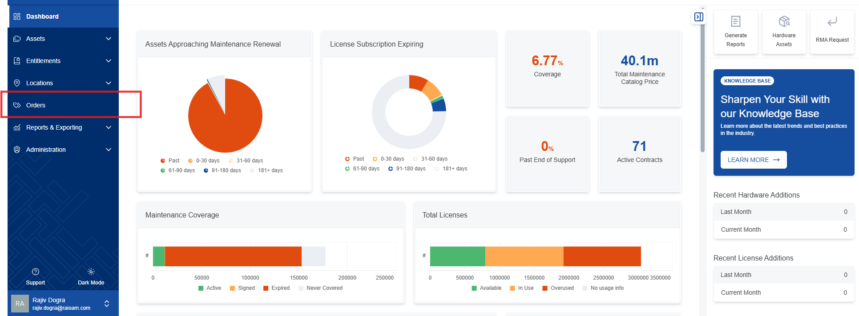

- The order module displays a table of all tracked orders.
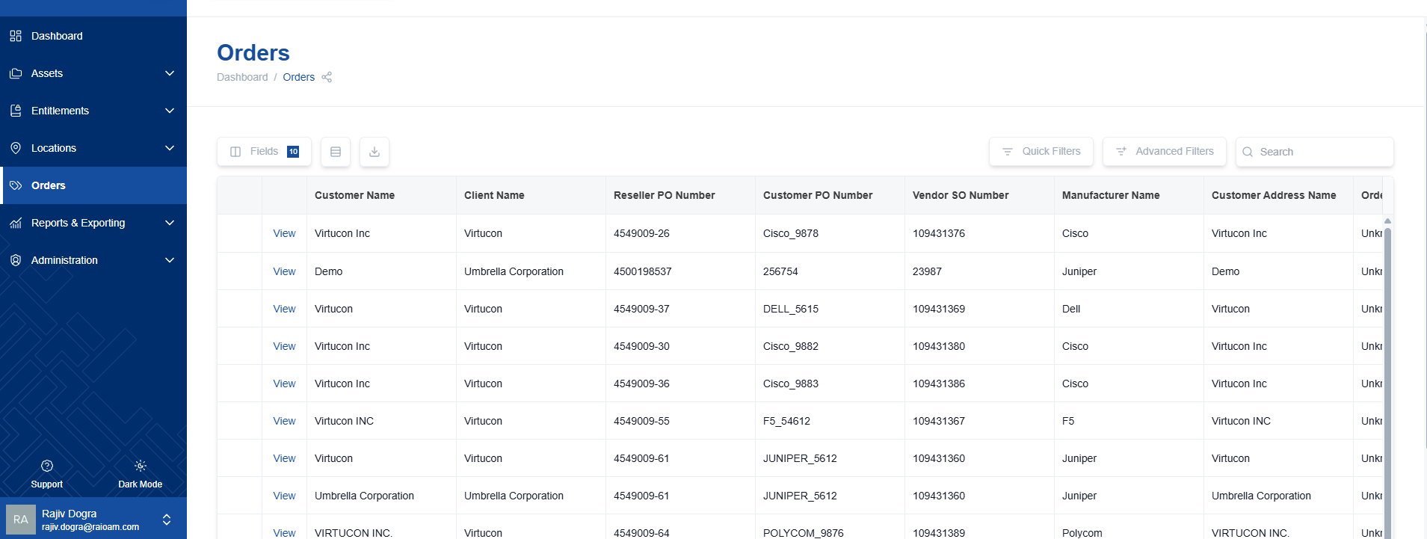

Customizing the Order Table
Users can customize the table view to display the most relevant information by selecting different fields to be visible or hidden.
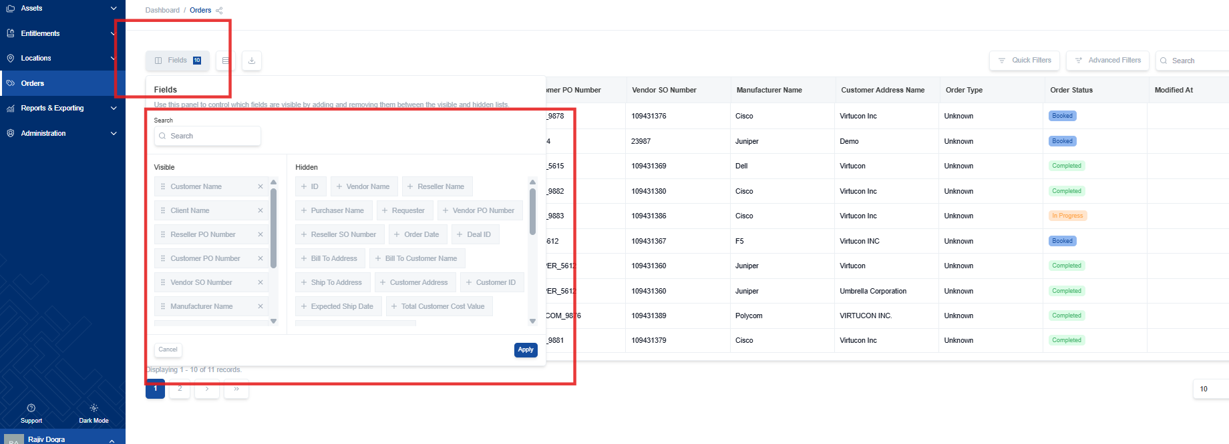
- Choose from available options to tailor the displayed information, ensuring you see only what you need.

Exporting Order Data
Order data can be exported for external use and analysis in Excel or CSV formats.

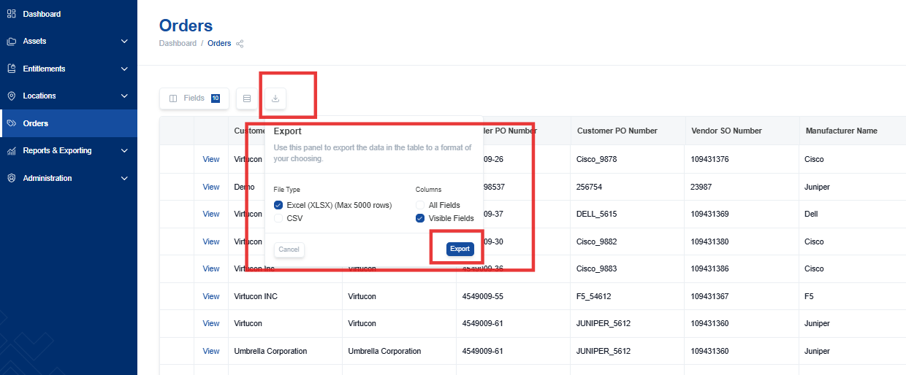

Filtering Orders
Apply filters to quickly find specific orders based on your criteria.
- Use quick filters for common searches.
  - Quick filters provide pre-defined options for fast and easy filtering.
- Utilize advanced filters for more specific and complex criteria.
  - Advanced filters allow you to combine multiple criteria and create highly targeted searches.
[Detailed, fully explained actions and steps for improving the filtering and viewing of specific data sets are available in another section of this manual: “Quick and Advanced Filters.”]

