Order Management > View Orders > Details
To view detailed information about a specific order, click the "View" button next to the desired order in the table.
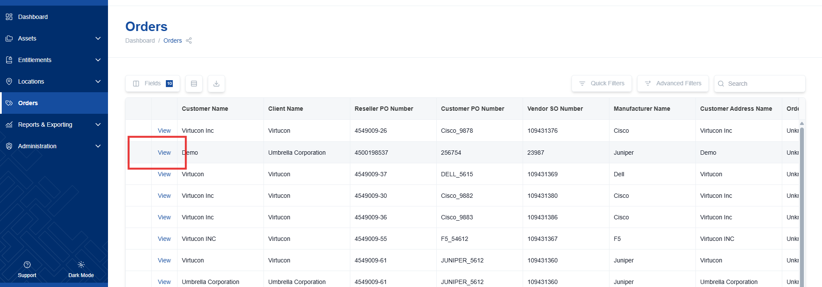

Order Information
The order details page provides comprehensive information about the selected order. Key information includes:
- PO (Purchase Order) and SO (Sales Order) numbers.
- Order dates.
- Current order status.

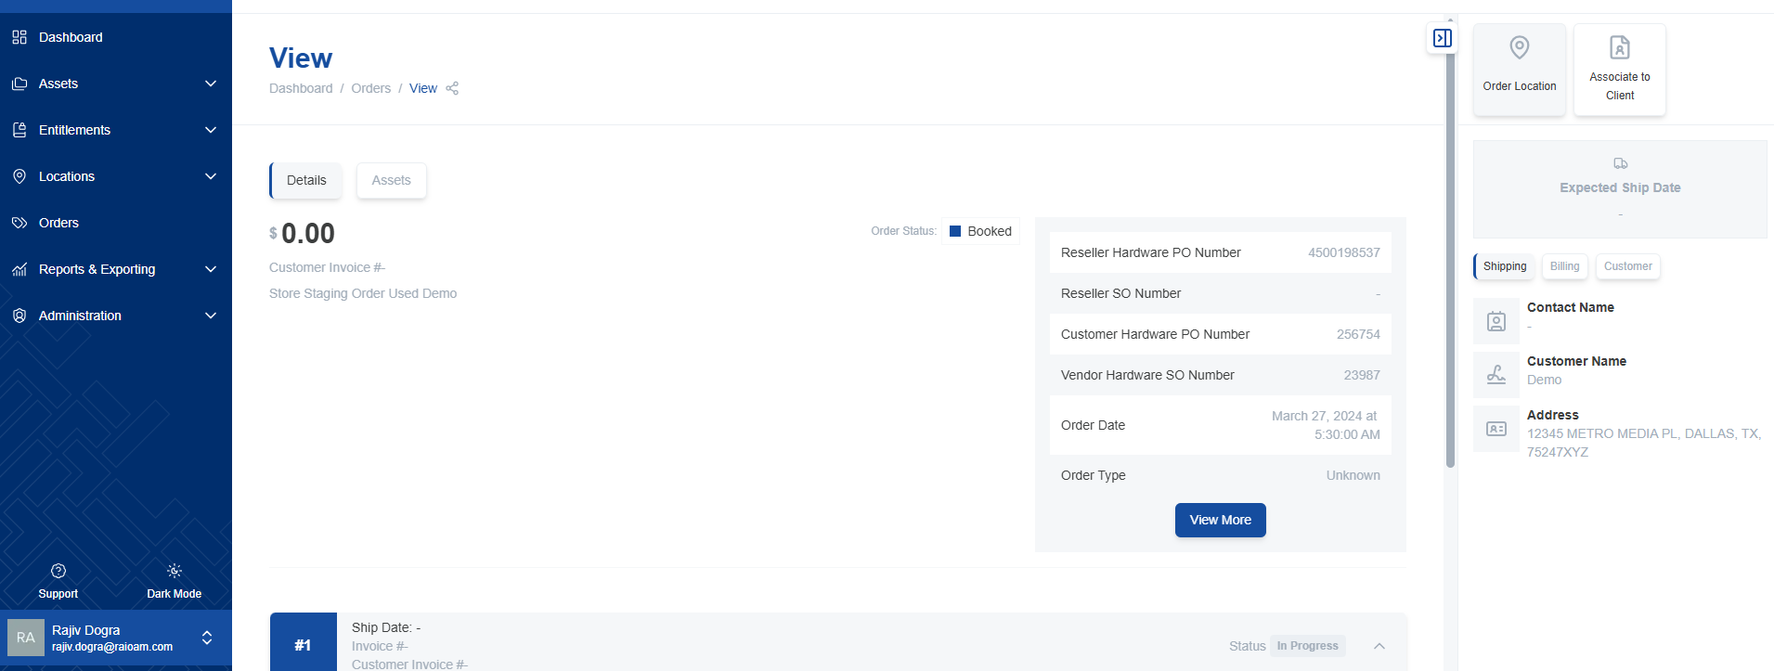

Expanding/Collapsing Order Details
Use "View More" to expand the displayed order information and "View Less" to collapse it for a cleaner view.
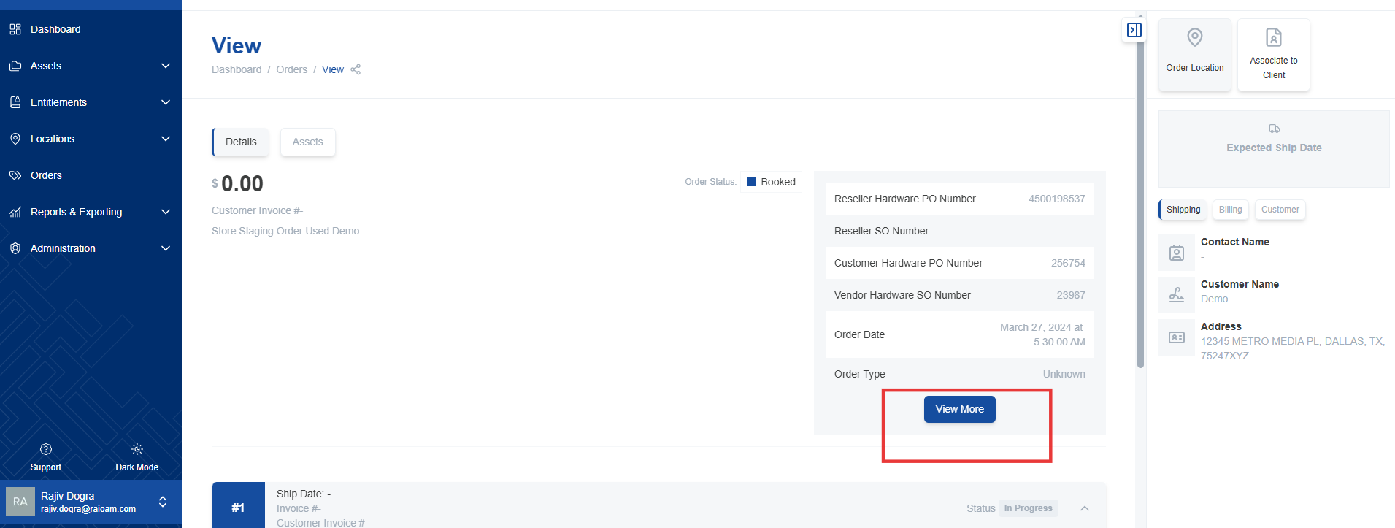

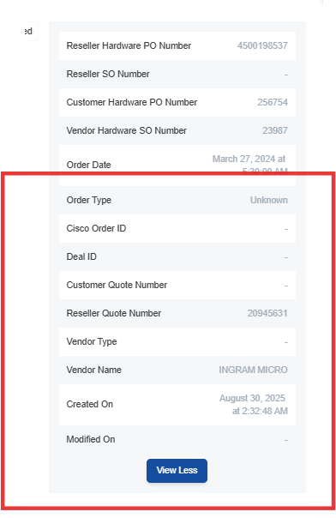

Line Items
Explore the individual line items within the order to access detailed information about each asset or software license included. Line-item numbers are displayed to facilitate straightforward identification.
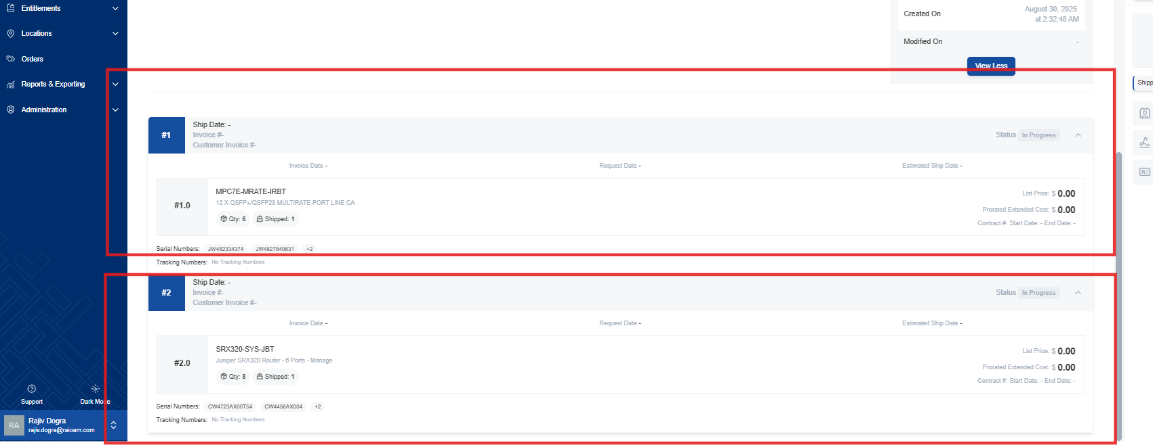

- You can access serial numbers and tracking numbers, if available, for each line item.
  - These numbers allow you to track the shipment and identify the specific product.
  - Click on serial/tracking numbers for more details about the specific item or shipment.
