Order Management > View Orders > Details > Order Locations
This section provides an overview of how to access and interpret location information within an order. It explains where to find shipping, billing, and customer address details and how to navigate between them using the location panel.
Location Information
Location details, including shipping, billing, and customer addresses, are available in the contextual panel on the right side of the screen.
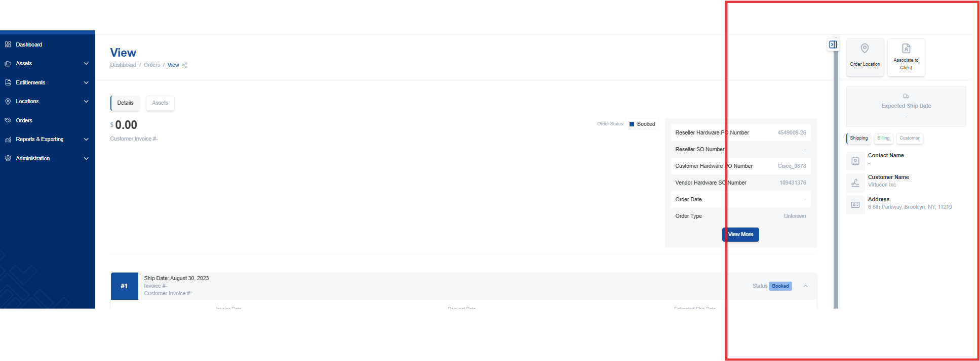
Address Details
Different types of address information are available within the location panel.
- Shipping address: Where the order will be shipped.
- Billing address: The address associated with the payment method.
- Customer address: The customer's primary address.
Select the appropriate tab to view the desired address type.

