Order Management > View Orders > Details > Assets
Assets Tab
To view assets generated as a result of placing the order – such as licenses or hardware – select the "Assets" tab, which is located adjacent to the "Details" tab withing the order view.
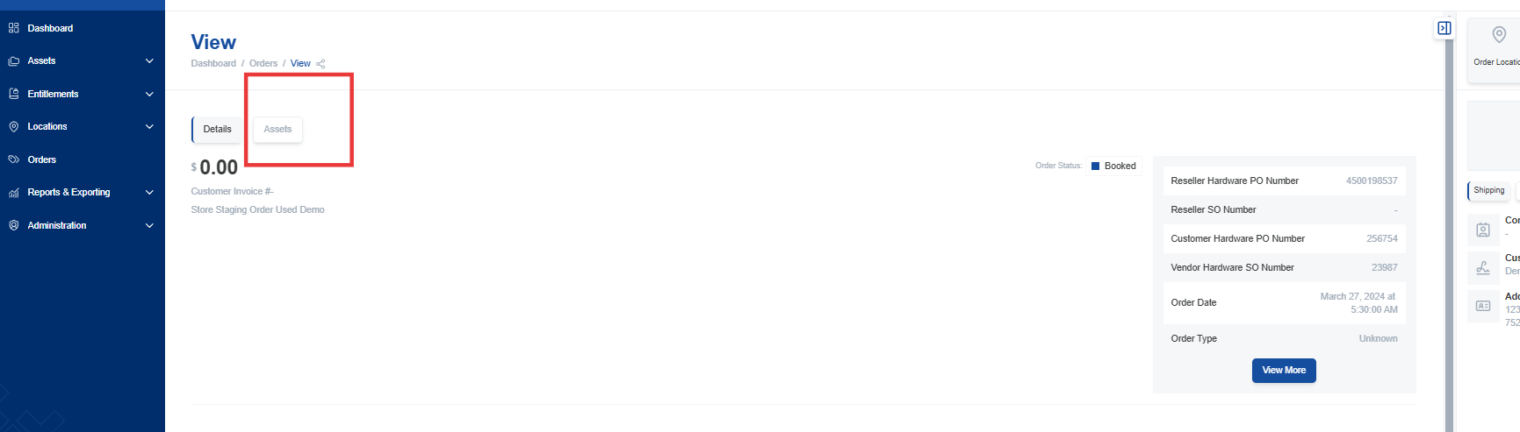

The Assets tab displays a list of all generated assets associated with the order. The key information displayed for each asset includes:
- Originating order and line number: Indicates the specific order and line where the asset information was sourced.
- Tracking information: Information for tracking the shipment or delivery of the asset.
- Shipping information: Details about the shipping address and shipping method used for the asset.

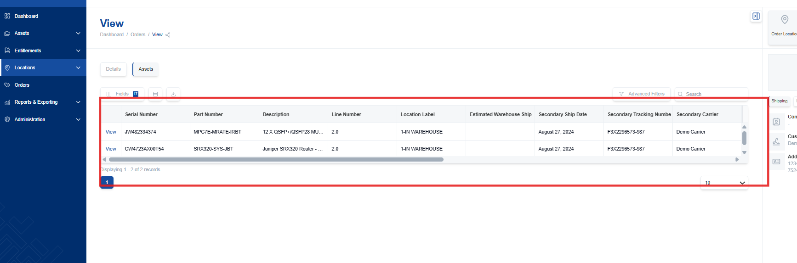

Exporting Asset Data
Export asset data to a CSV or Excel file using the export button located within the Assets tab.
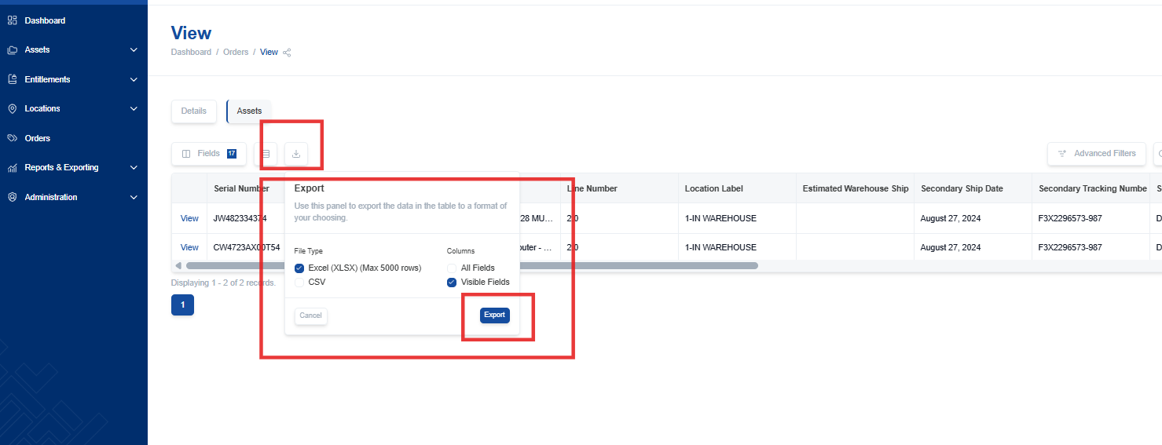

Viewing Individual Assets
Click the "View" button next to a specific asset to access the asset listing and view detailed information about the asset. This will take you directly to the asset's individual page.
