Reports: Cisco EA Maintenance Report
This guide covers how to access the Cisco EA Maintenance Report from Reports and Exporting section.

Access Cisco EA Maintenance Report
Go to Reports and Exporting and then Generate reports.
Two new reports are available there: Cisco EA Maintenance Report and Cisco EA License Report. To open a report, pick the appropriate report, the EA Maintenance Report.
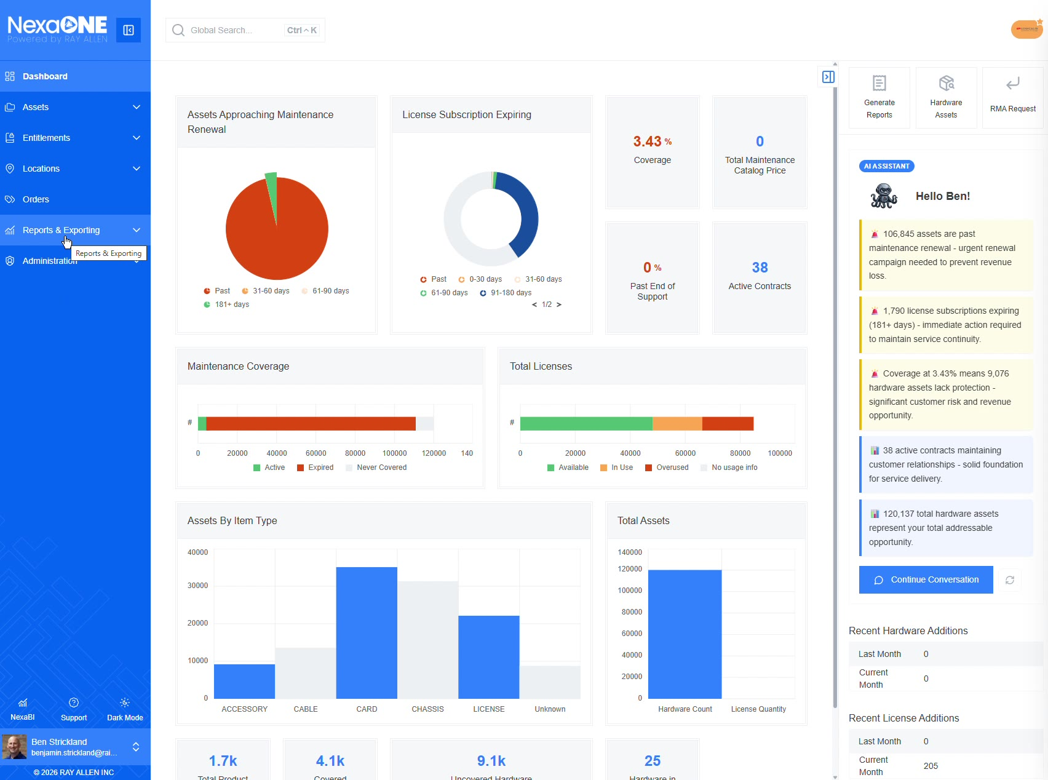

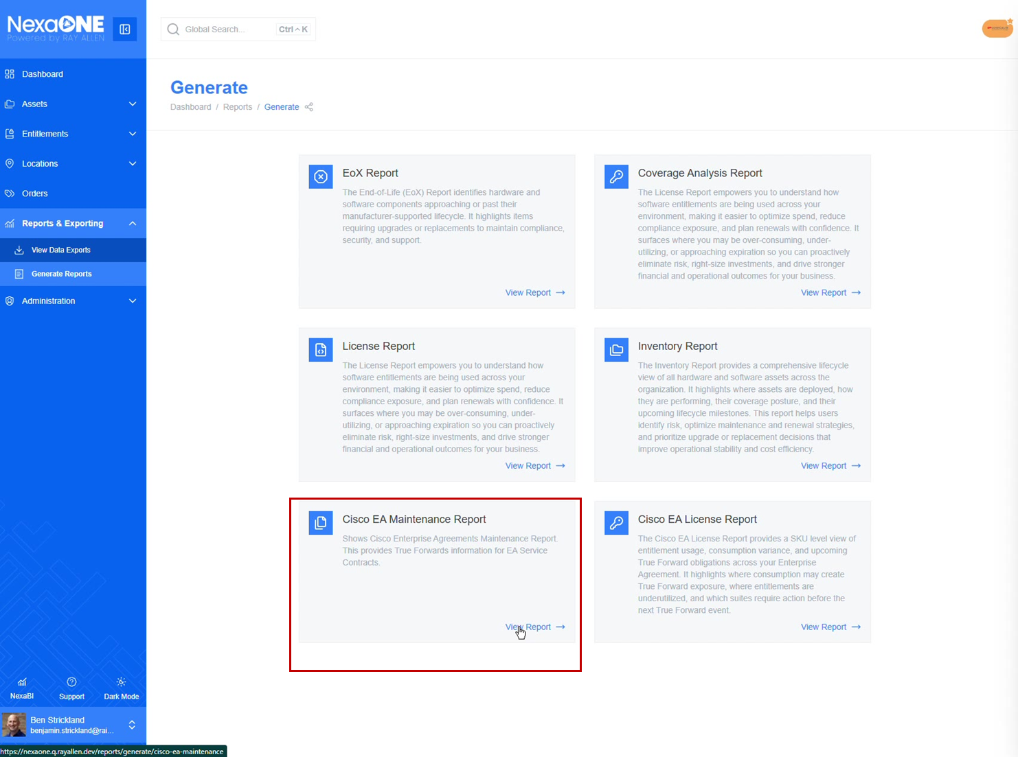
Selecting Cisco EA Maintenance Report
The EA Maintenance Report provides information on the current status of an existing enterprise agreement that covers hardware maintenance.
These may also be called CXEAS, which can be found in this report.
The report gives the overall health of the EA, including coverage status, asset changes, and agreement timelines.
- How many assets are covered
- How many assets were purchased as part of the coverage
- Whether a true forward is due
- How many devices were added since the last true forward
- How many devices were removed since the last true forward
- When the next true forward occurs
- General time frames such as:
- How much time is left on the EA
- The end date
- The overall term
- The number of years remaining
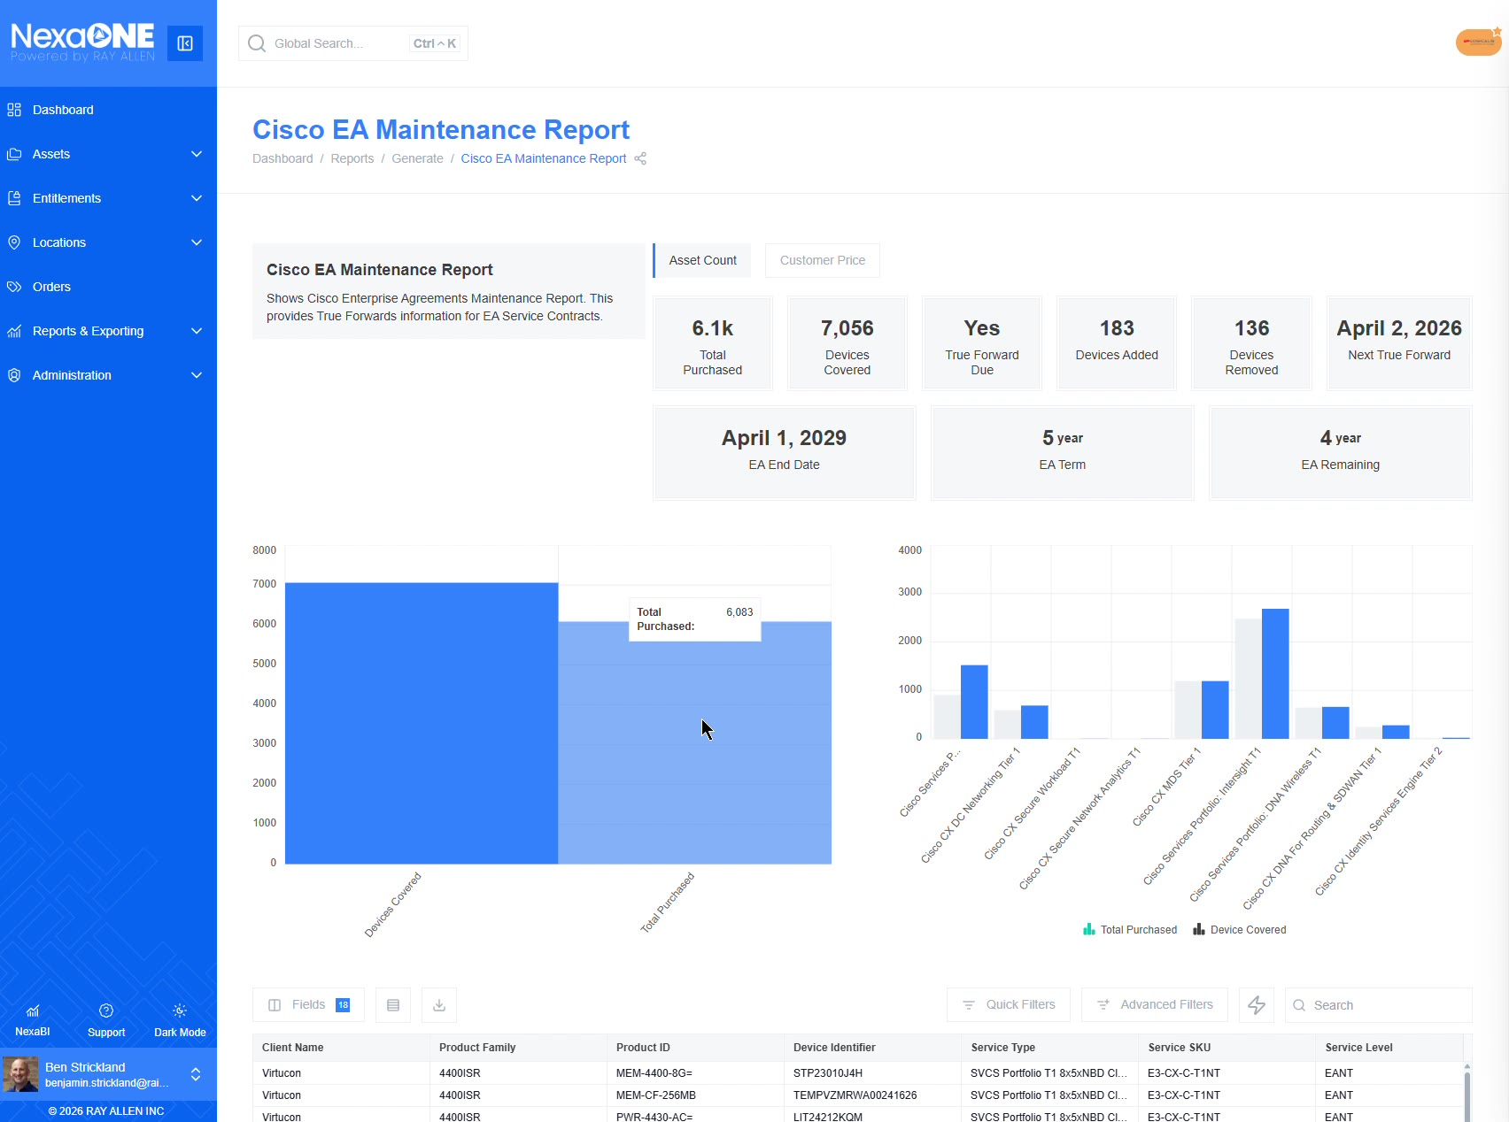
Cisco EA Maintenance Report overview

Customize Report Fields
As with other fields, user may customize the information that is presented, along with the order and the fields you would like, by using the fields page.
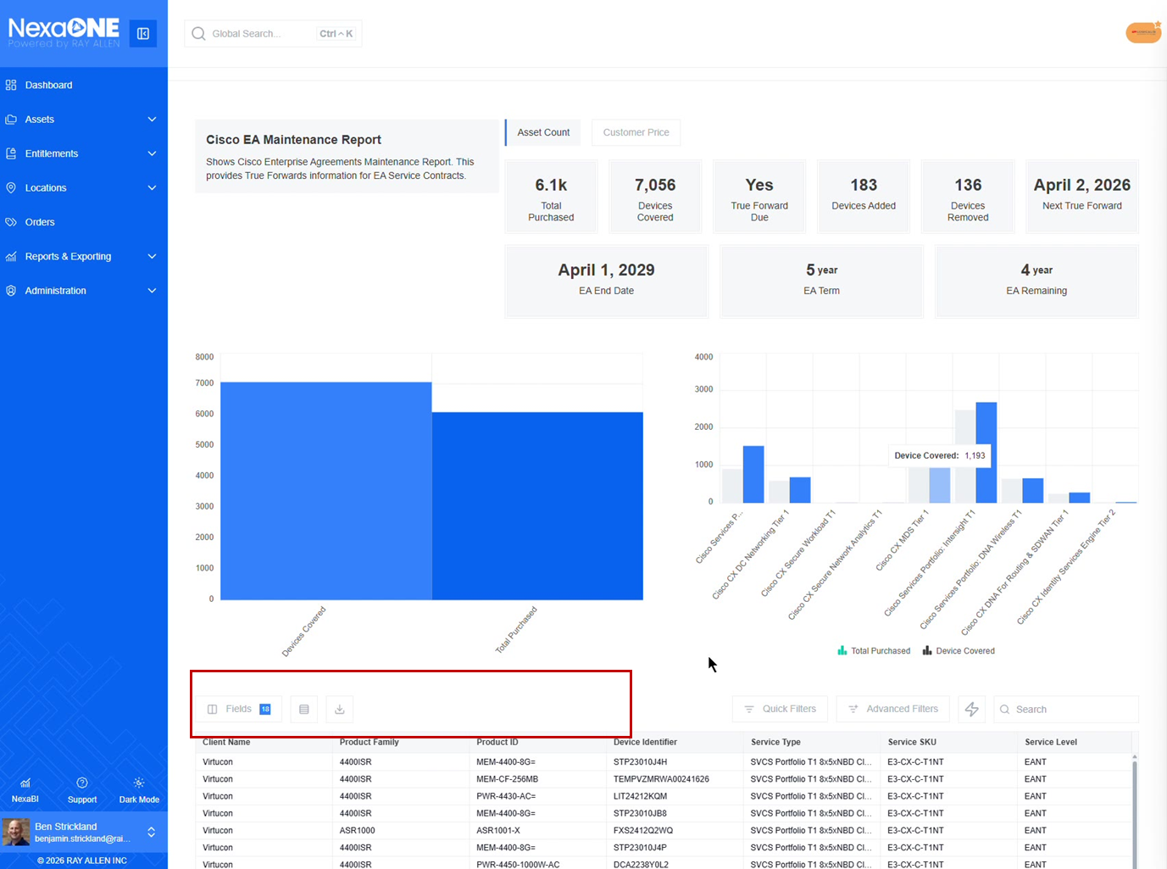

Use Visualizations and the Data Table
From a visualization perspective, the report is segmented by individual subscriptions. For example, user can see the amount purchased versus the overall count in each subsection.
The data can be explored more thoroughly using the data table at the bottom. The table provides information on which assets are currently covered or are no longer covered by the enterprise agreement.
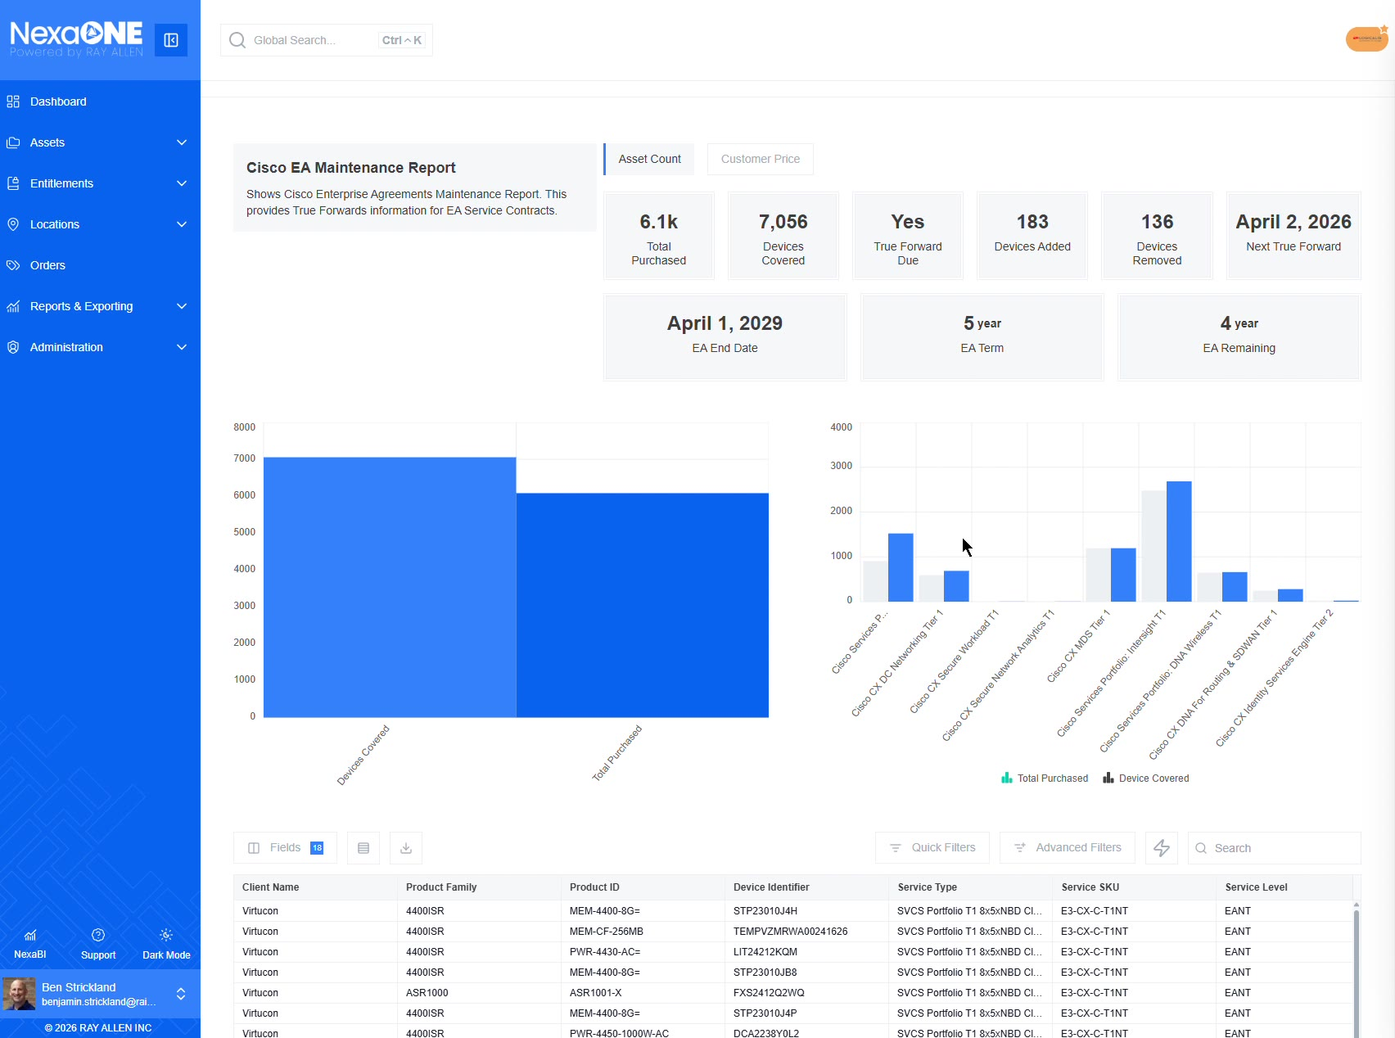
Visualizations broken down by individual subscriptions

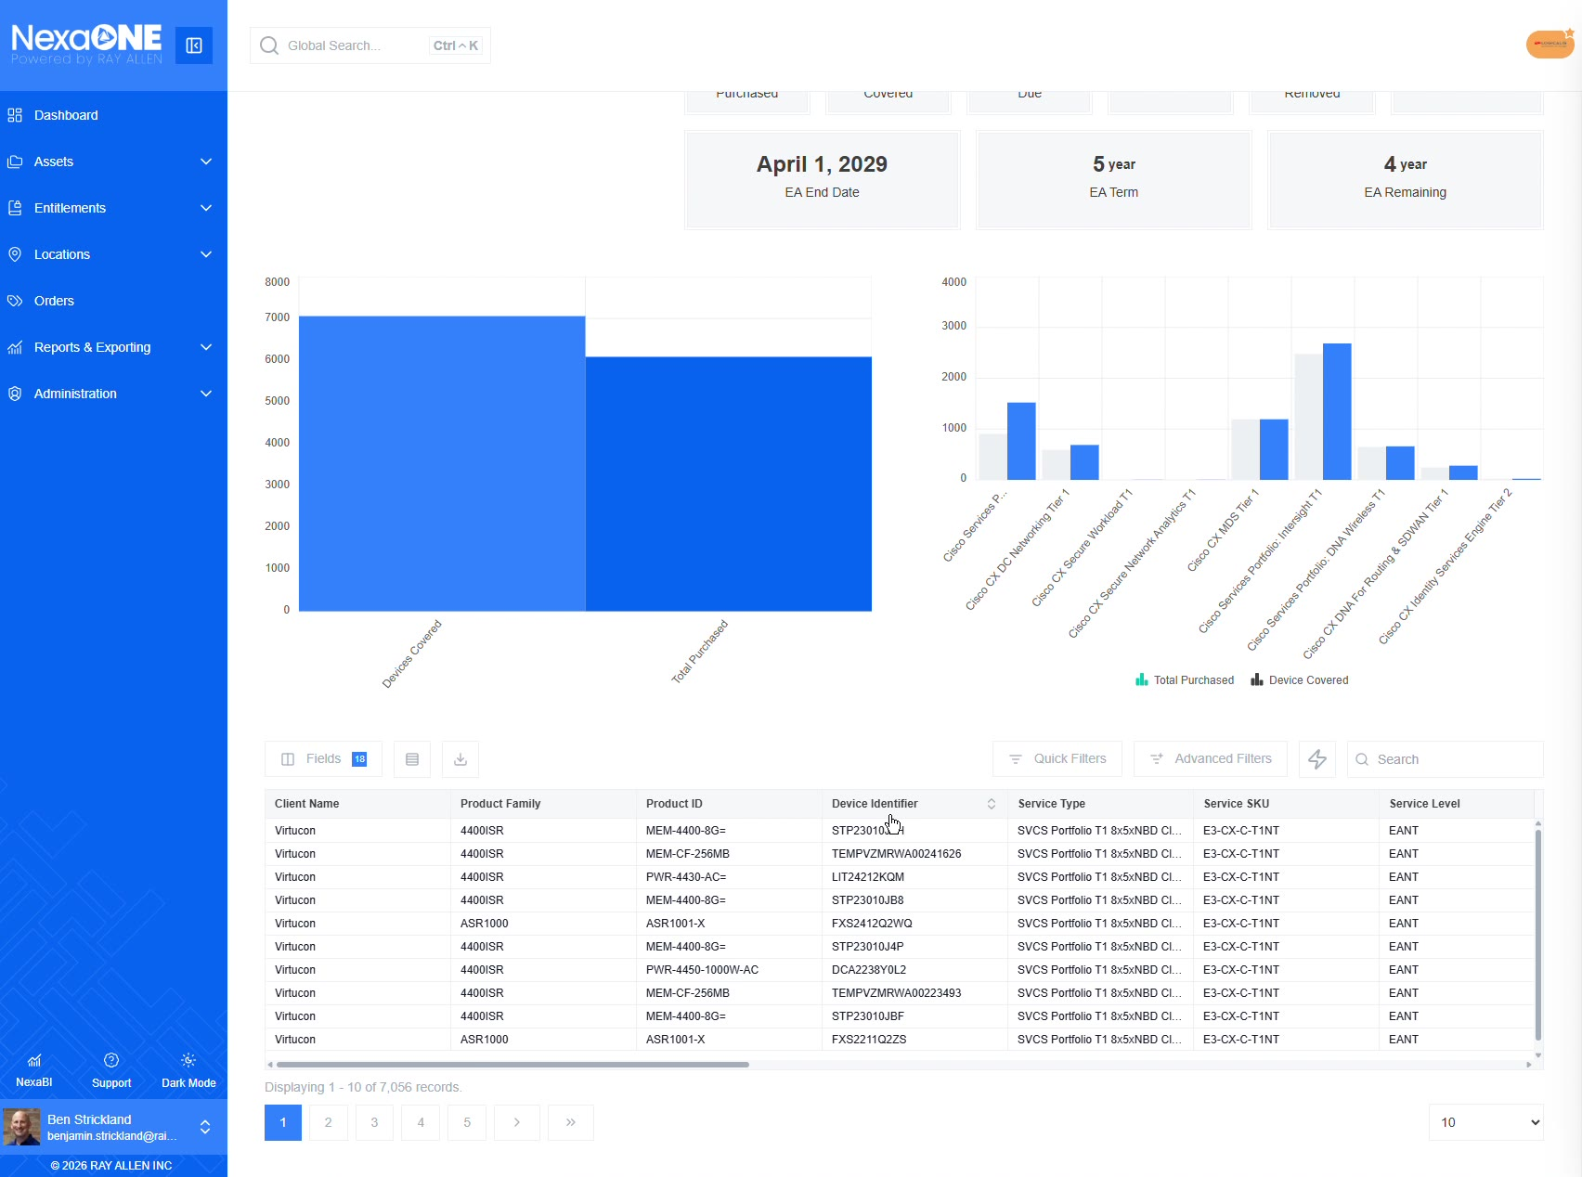
Data table showing assets covered or no longer covered

Filter by Transaction Type
The report includes both advanced filters and quick filters.
Using transaction type is described as especially useful for understanding what changes were made on a maintenance subscription.
Example,
- Select the transaction type remove to view devices that were taken off coverage.
- Change the transaction type to add to view devices that were added to coverage.
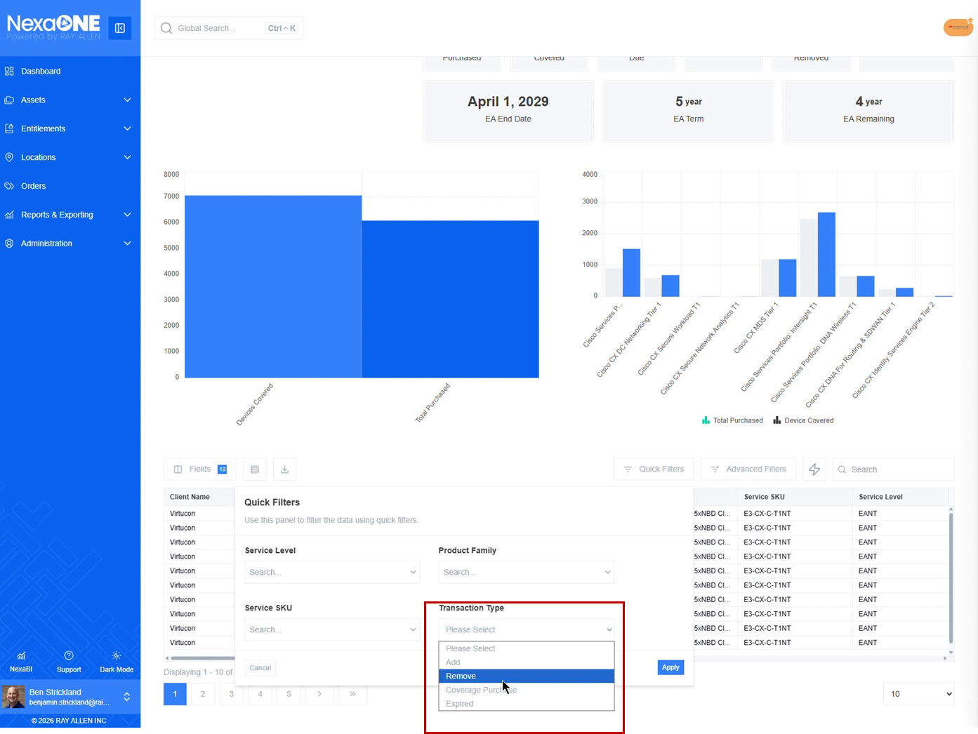
Transaction type set to remove showing devices taken off coverage

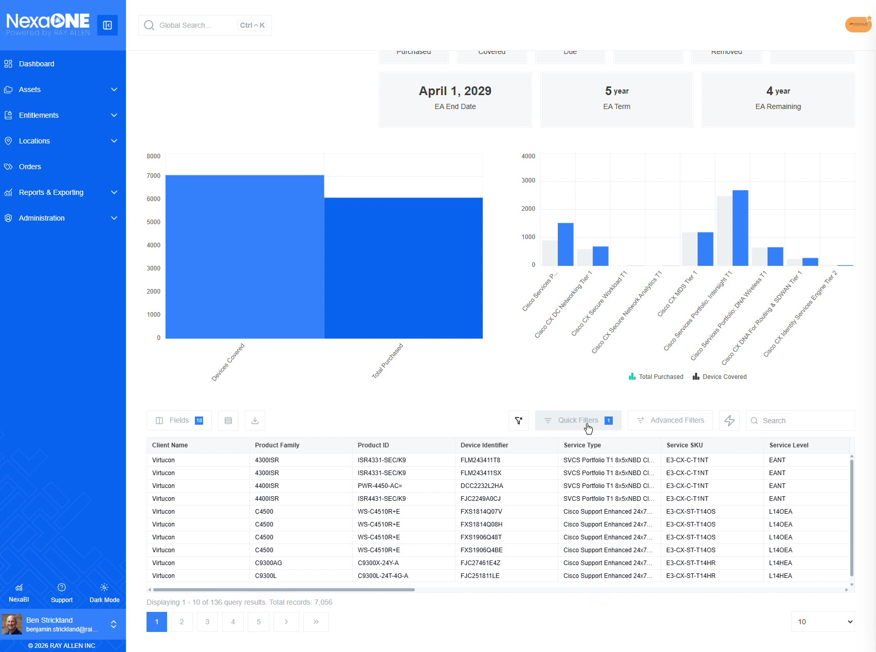
Transaction type set to add showing devices added to coverage

