Reports: Cisco EA License Report
This guide explains how to access the Cisco EA License Report from Reports and Exporting section.

Access Cisco EA License Report
Go to Reports and Exporting and then click Generate reports.
Two new reports are available there: Cisco EA Maintenance Report and Cisco EA License Report. To open a report, pick the appropriate report, Cisco EA License Report.

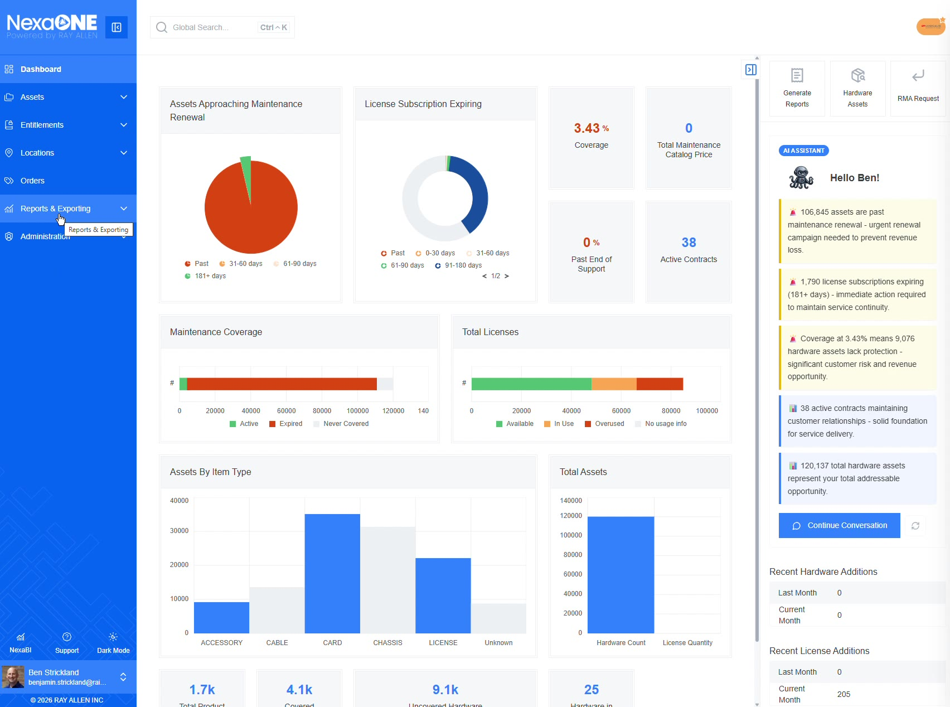
Cisco EA License Report
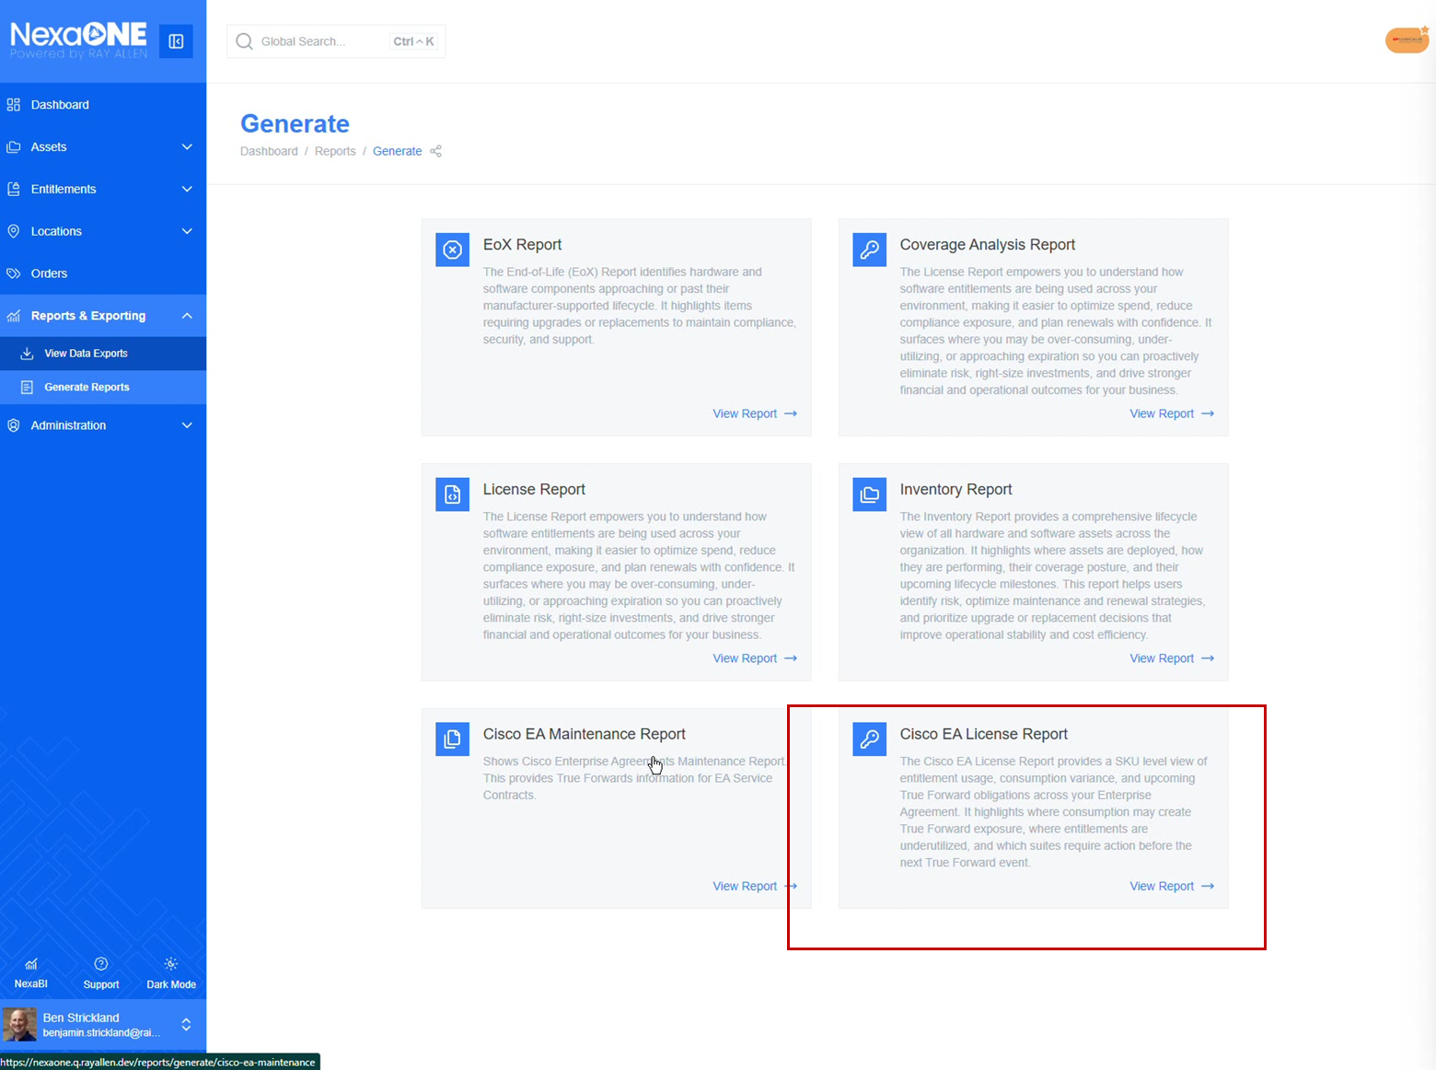
Selecting Cisco EA License Report

The EA License Report focuses on licenses rather than maintenance agreements and helps explain the current true forward position of active license EAs.
It provides information to help user understand the overall true forward stance of current license EAs.
The report breaks information out into individual suites and lets user see:
- Overall consumption
- What has been used
- The balance

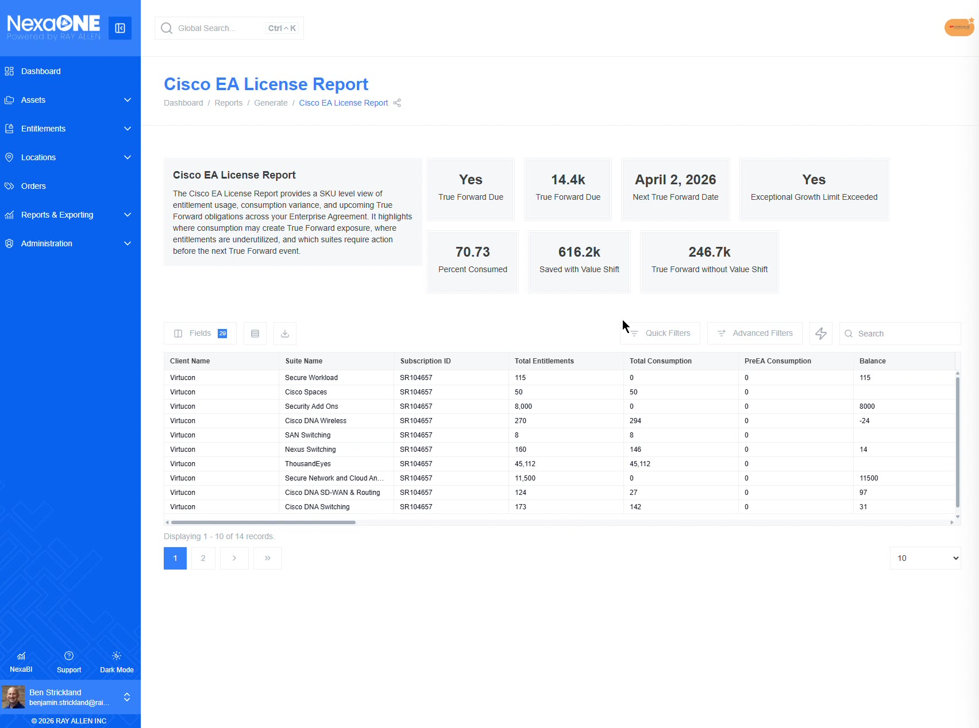
Cisco EA License Report overview

True Forward and Value Shift Details
The report can help calculate items such as:
- Whether a true forward is going to be necessary
- What value shift looks like
- How much money has been reclaimed as part of the value shift in the agreement
- What the true forward would have looked like if value shift did not exist
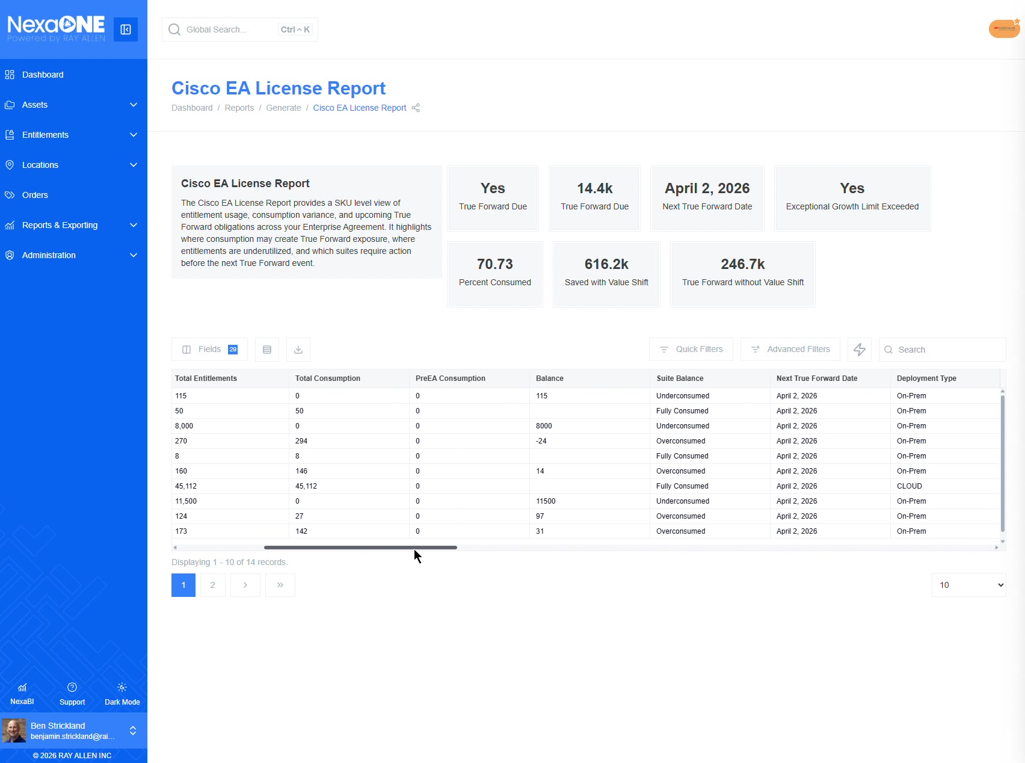

Compare with Enterprise Agreements Module
For more detail on the individual items in these EA subscription reports, compare the information against the Enterprise Agreements module under Entitlements.
This can be used to see suite-level information and individual license-level information at the same time.
