Location Management > View Locations
Accessing Locations Management
- Navigate to the menu.
- Select "Locations".
- Select "View Locations". This action will take you to the Locations Management interface, where you can view and manage your locations.
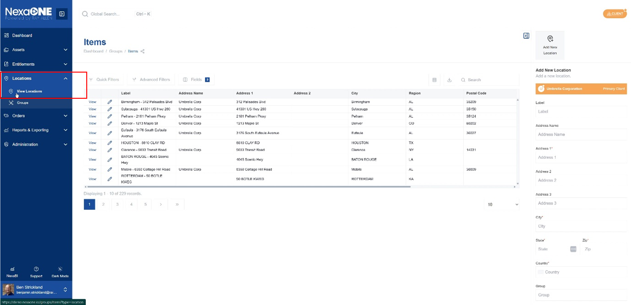
Understanding the Locations Table
Upon accessing Locations Management, a table displaying location information is presented. This table provides an overview of all your configured locations and their key details. This table functions similarly to other modules within NexaOne, ensuring a consistent user experience.
Modifying Table Items (view)
- Use the "Fields" panel to customize the table view. The "Fields" panel allows you to choose which columns are displayed in the table, tailoring the view to your specific needs.
- Add or remove visible/hidden fields. This feature lets you include or exclude specific data points related to each location.
- Rearrange fields to optimize your preferred view. Drag and drop the column headers to reorder them for efficient data analysis.
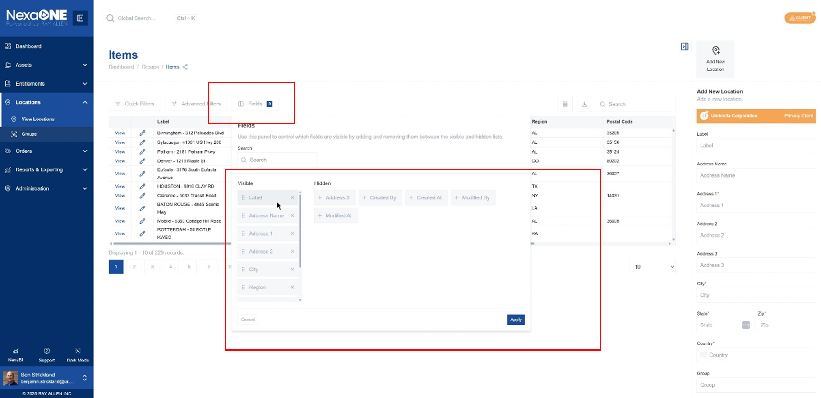
Filtering and Searching
- Utilize quick filters for common searches. Quick filters provide pre-defined criteria to quickly narrow down the list of locations based on common attributes.
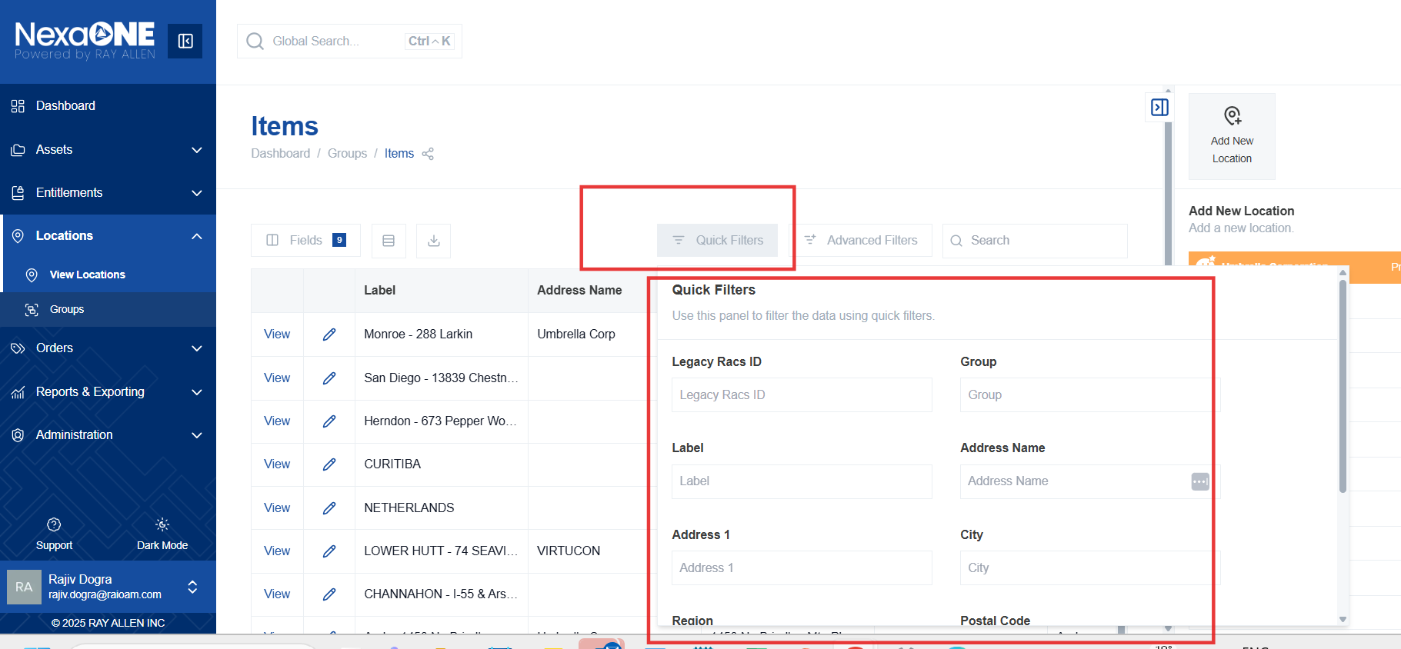
- Employ advanced filters for more specific queries. Advanced filters allow you to create custom filtering rules using multiple criteria and operators, enabling highly targeted searches.
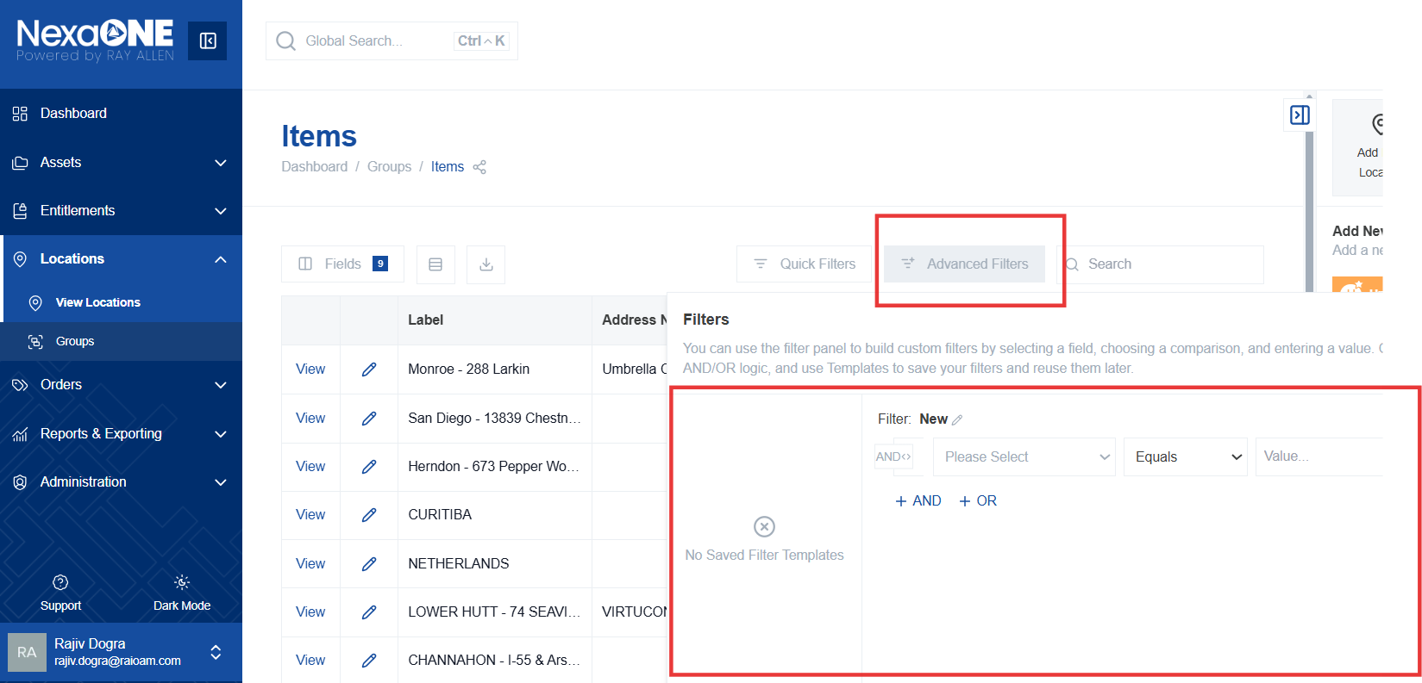
- Use the search bar in the top right corner to find a particular location. Simply enter a location name or keyword in the search bar to instantly locate matching entries.
