Location Management > View Locations > Details
Viewing Location Details
- In the Menu, select "Locations" and then click "View Locations".
This action will take you to the Locations Management interface, where you have the list of locations.
- Click the "View" button to access detailed information about a location. This opens the location's detailed view, providing a comprehensive overview.
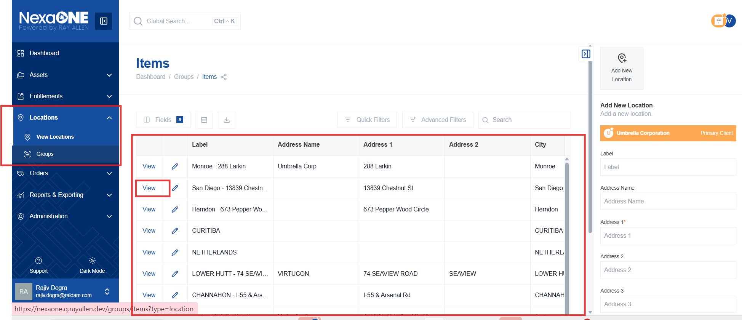
- A zoomable map is displayed, pinpointing the address (if validated). The map allows you to visually confirm the location and its surroundings. The address needs to be valid for the pinpointing functionality to work correctly.
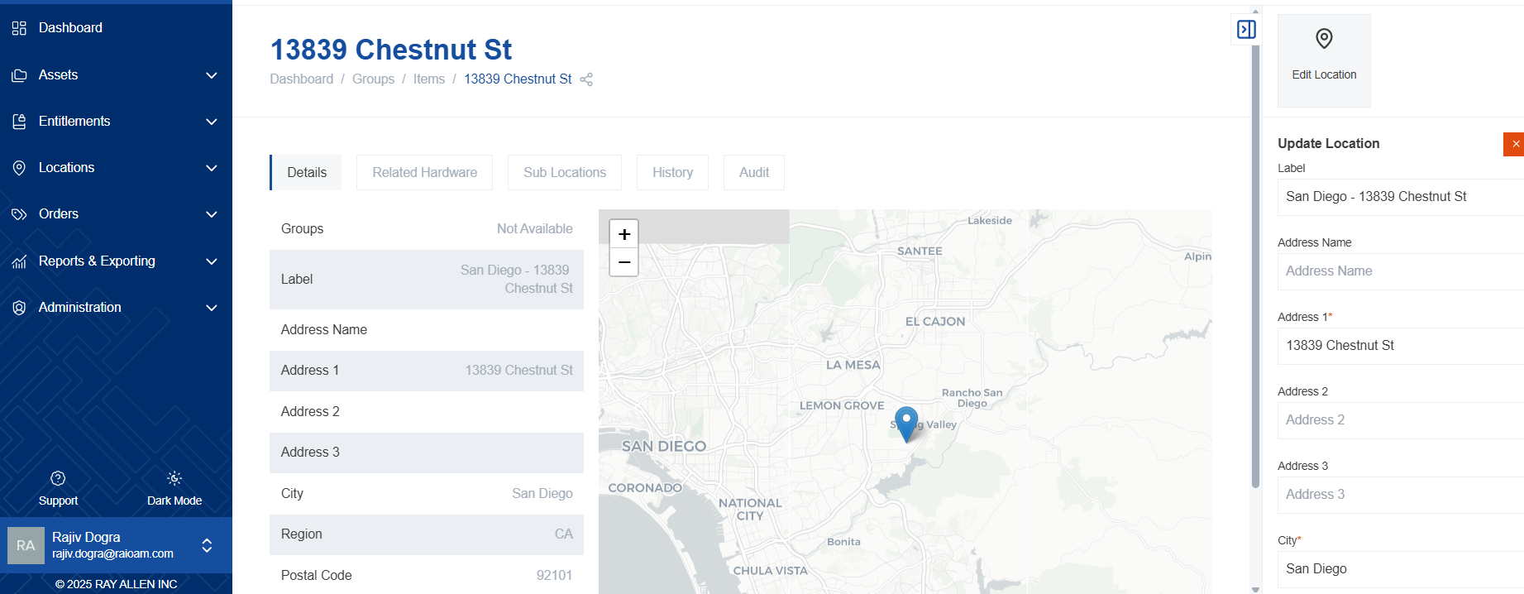
- Location information is shown on the left-hand side. This panel displays all the relevant details of the location, such as address, group, and other attributes.

