Location Management > View Locations > Details > Sub Locations
View Sublocations
- In the location's detailed view, providing a comprehensive overview click on the "Sublocations" tab to define new places within a location. Sublocations are useful for specifying more precise locations within a larger facility, such as specific rooms or areas.
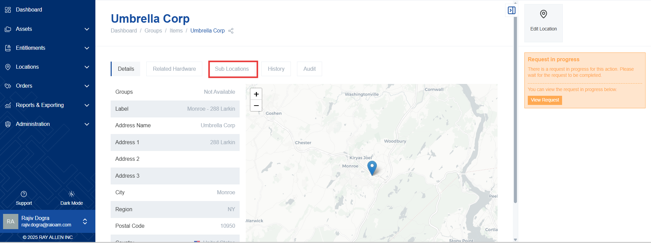
- A list of existing sublocations for the selected location is displayed. This provides an overview of the currently defined sublocations.
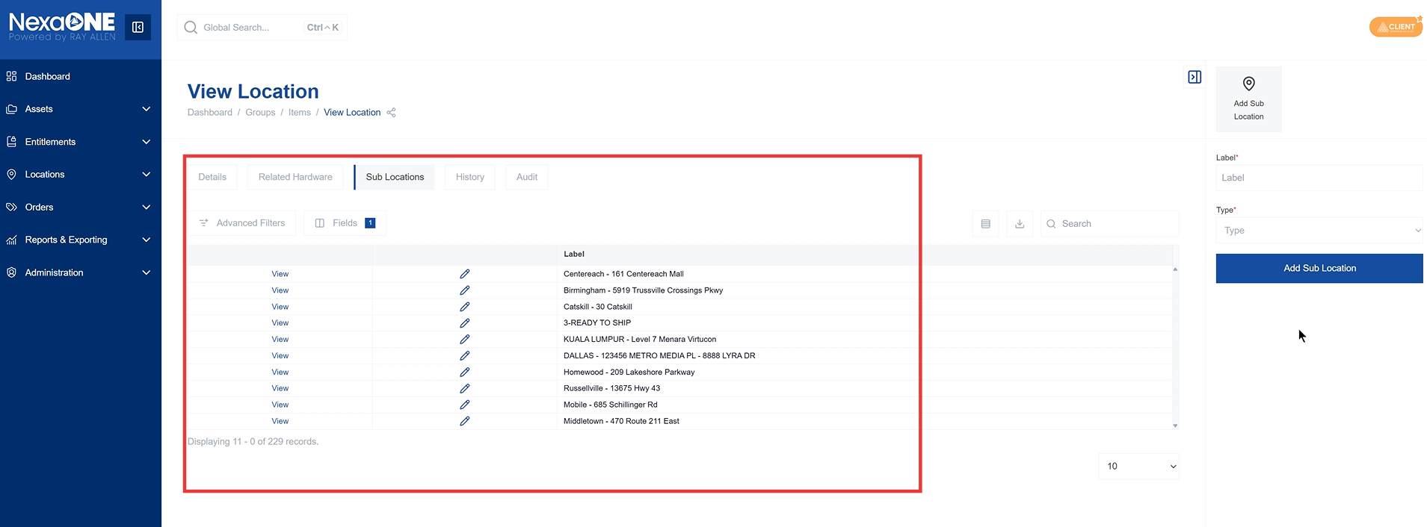

Add Sublocations
- Click the "Add Sublocation" button in the contextual panel to create a new sublocation. This initiates the process of adding a new sublocation to the selected location.
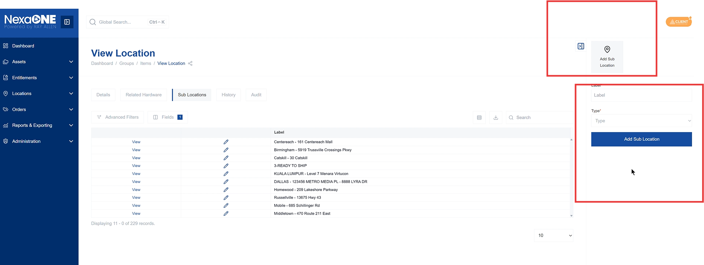
- Enter the new sublocation details and select the type of place. You will need to provide a name for the sublocation and specify its type, such as "Server Room" or "Reception Area".
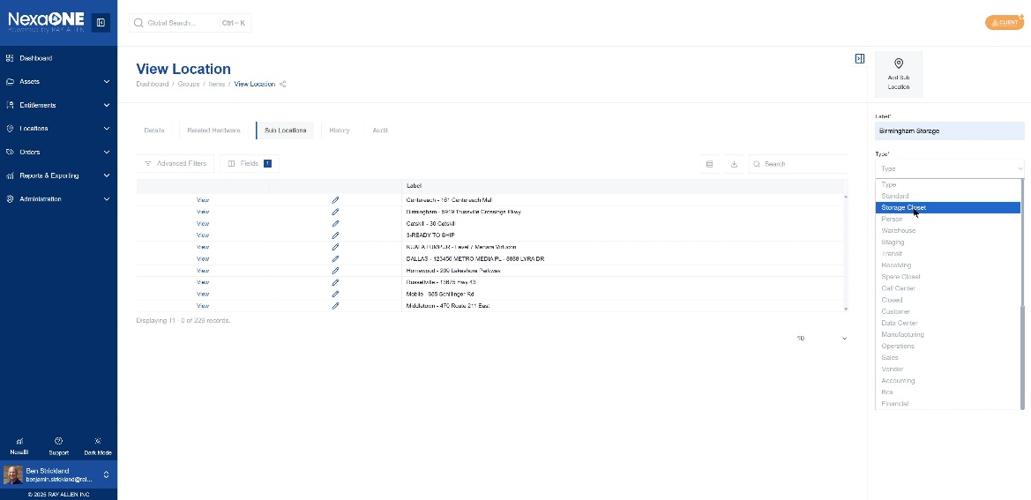
- Click the "Add Sublocation" button to create the sublocation. This saves the new sublocation and adds it to the list.

