Location Management > View Locations > Details > Related Hardware
Related Hardware
- In the location's detailed view, providing a comprehensive overview, click on “Related Hardware”
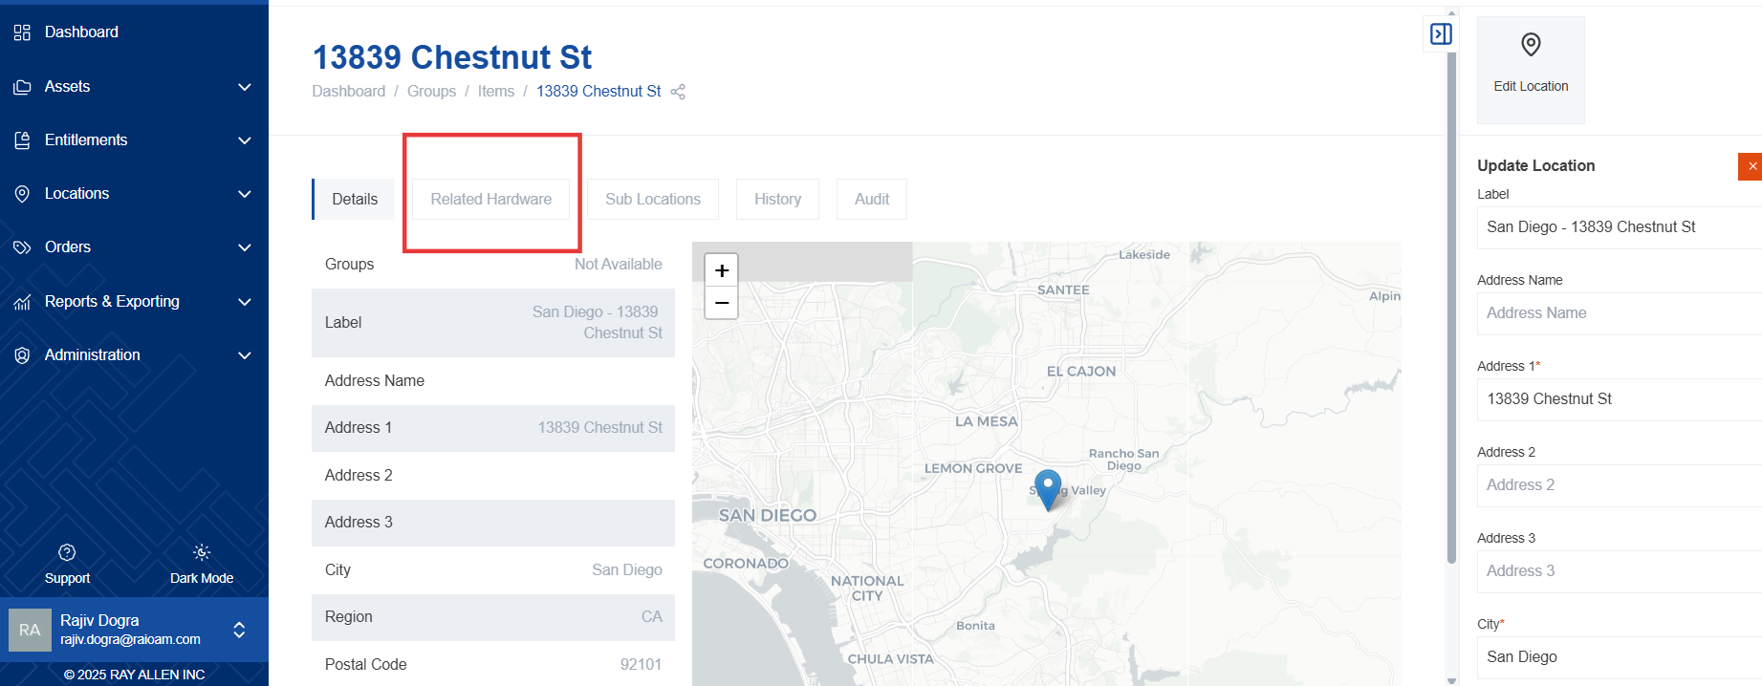
- This tab displays a list of all hardware assets associated with the selected location.
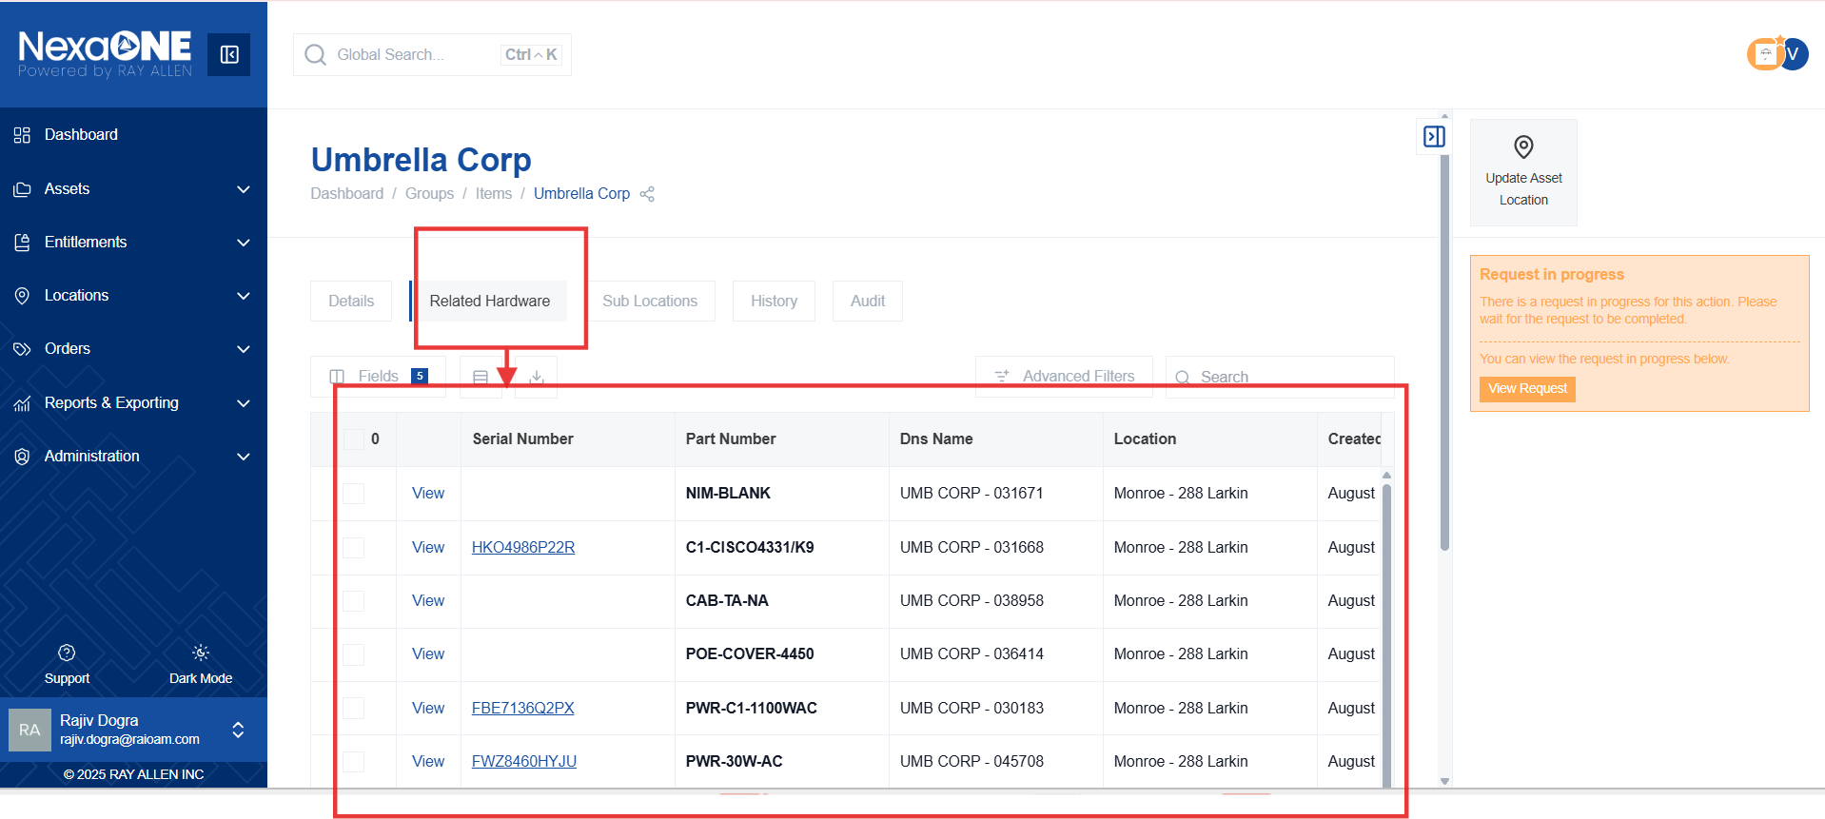
- This displays all hardware associated with the selected location. This allows you to easily track which hardware is deployed at each location.
- Click the "View" button to see details of specific hardware. This will take you to the hardware's details page, where you can view its configuration, status, and other relevant information.
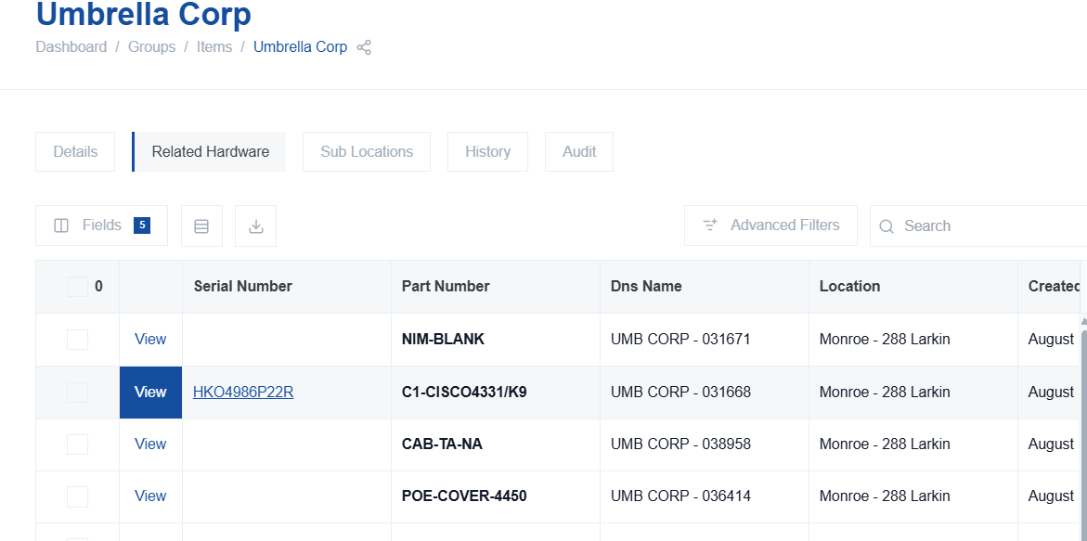
- You can update the related hardware's location by selecting multiple items and updating asset location from contextual bar.
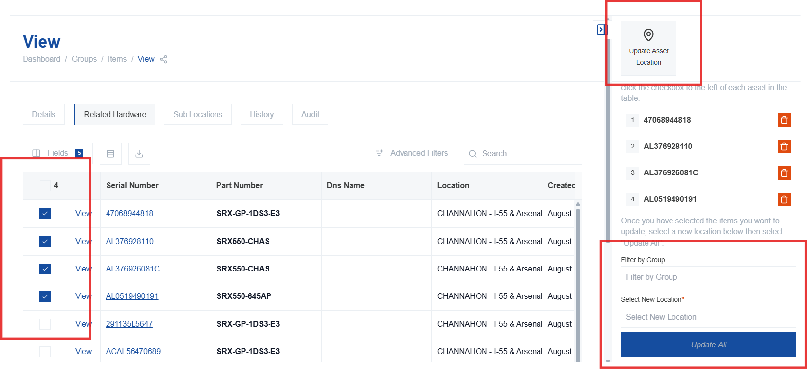

Maintaining accurate location data for hardware is crucial for inventory management and asset tracking.

