Location Management > View Locations > Details > History

History and Audit
- In the location's detailed view, providing a comprehensive overview click the "History" tab to view changes made to the location over time. This tab provides an audit trail of all modifications to the location record.
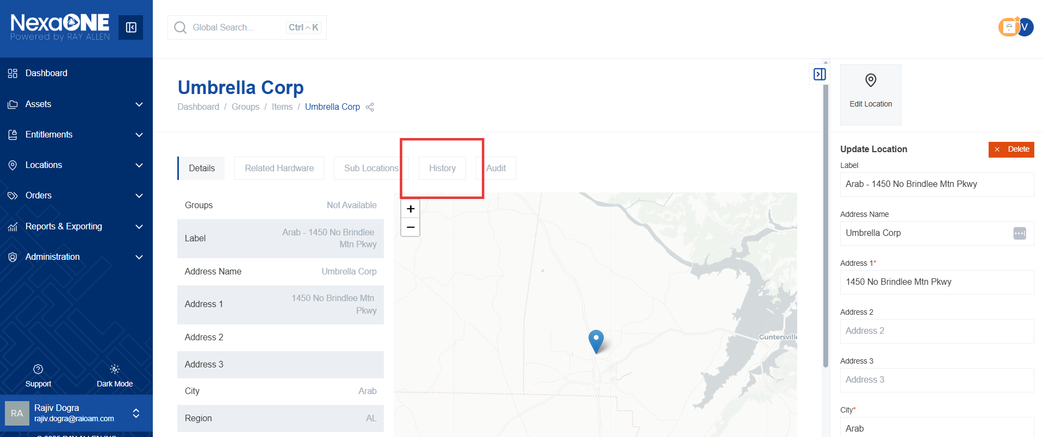
- Track prior requests, sublocation additions, and other modifications. This feature is useful for troubleshooting issues and understanding the evolution of the location's configuration.
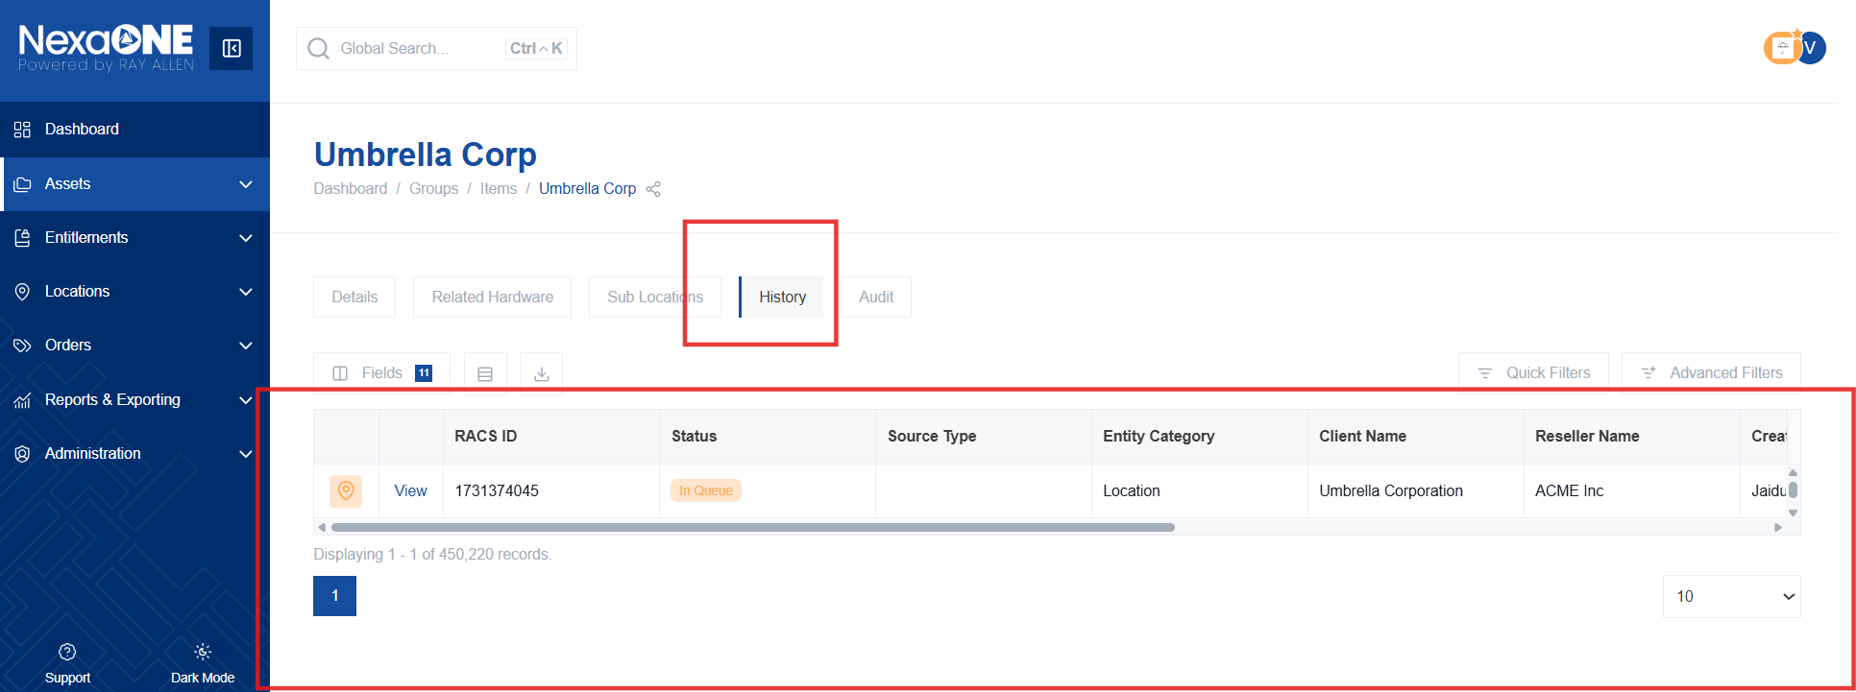
- Click the "Audit" tab to access audit capabilities for the location. This tab provides detailed audit logs related to the location, including user actions and system events.
