Location Management > View Locations > Actions > Update Location
You can edit a location using two methods: directly from the table or from the location's detailed view.
Method 1: Edit Button in Table
- Click the "Edit" button next to the location label in the table. This button provides direct access to the editable fields for that specific location.
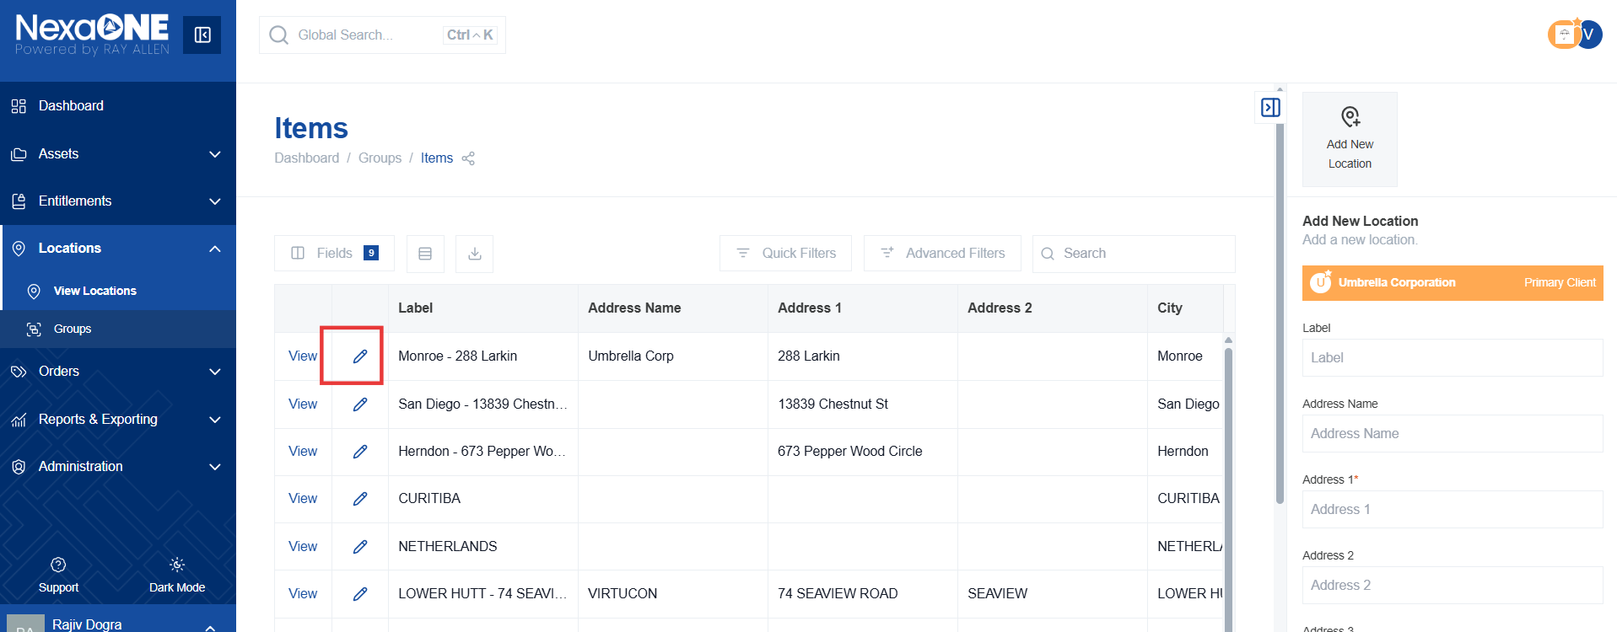
- This will show location information in contextual side bar, click “Update Location”
- This will display editable fields, adjust the location information as needed. Modify any of the fields, such as address, group, or label, to reflect the current details of the location.
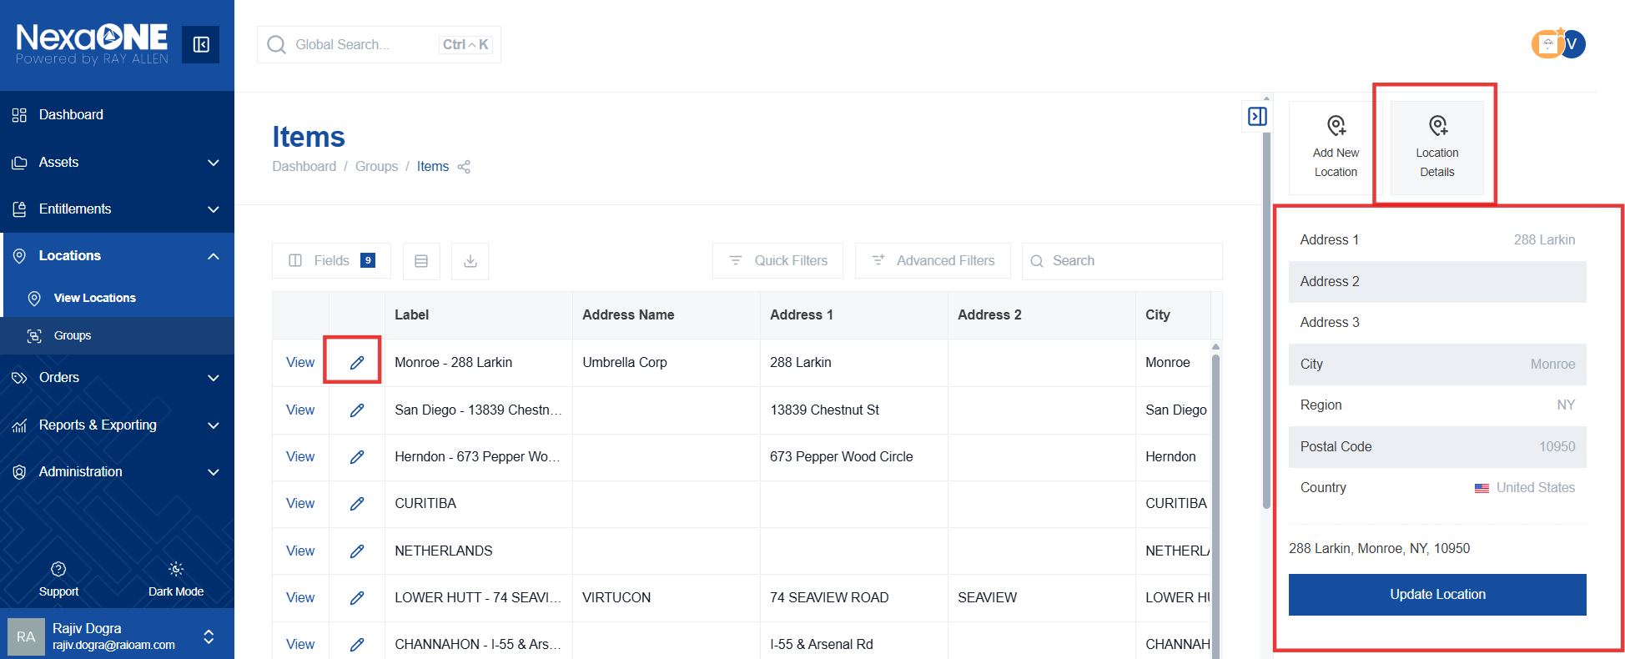
- Click the "Update Location" button to submit the changes. This saves the modified information and updates the location record.
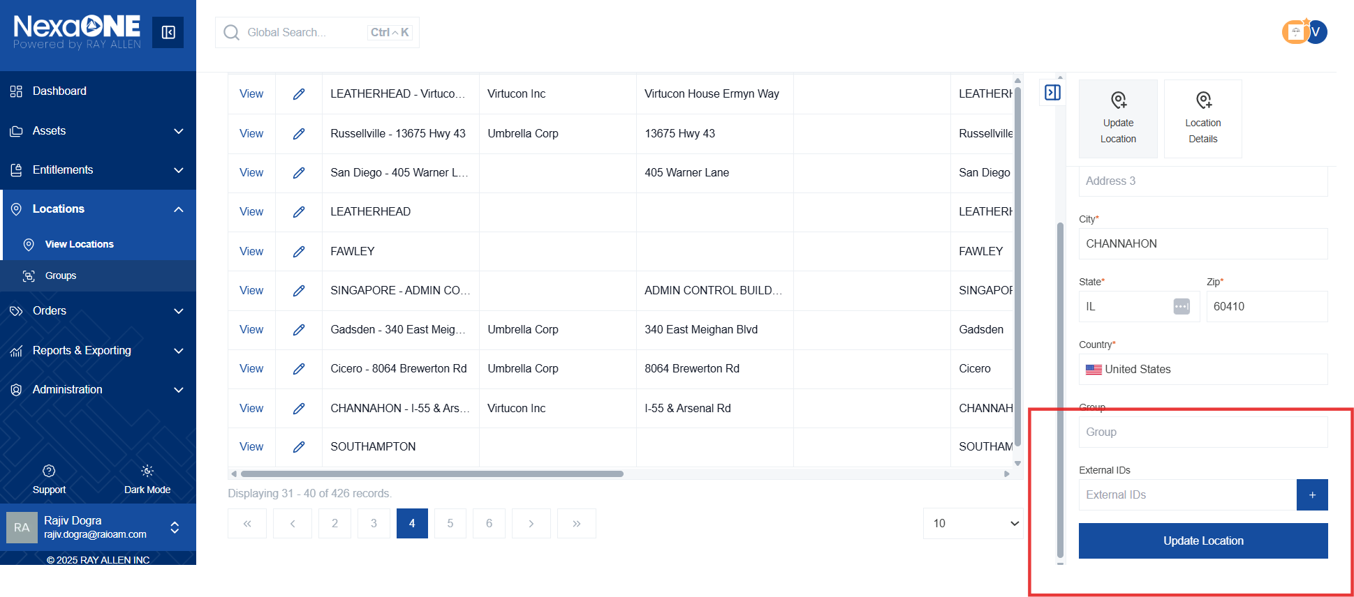

Method 2: Edit Location from View
- Click the "View" button to zoom in on a specific location. This button displays detailed information about the location, including a map and related data.
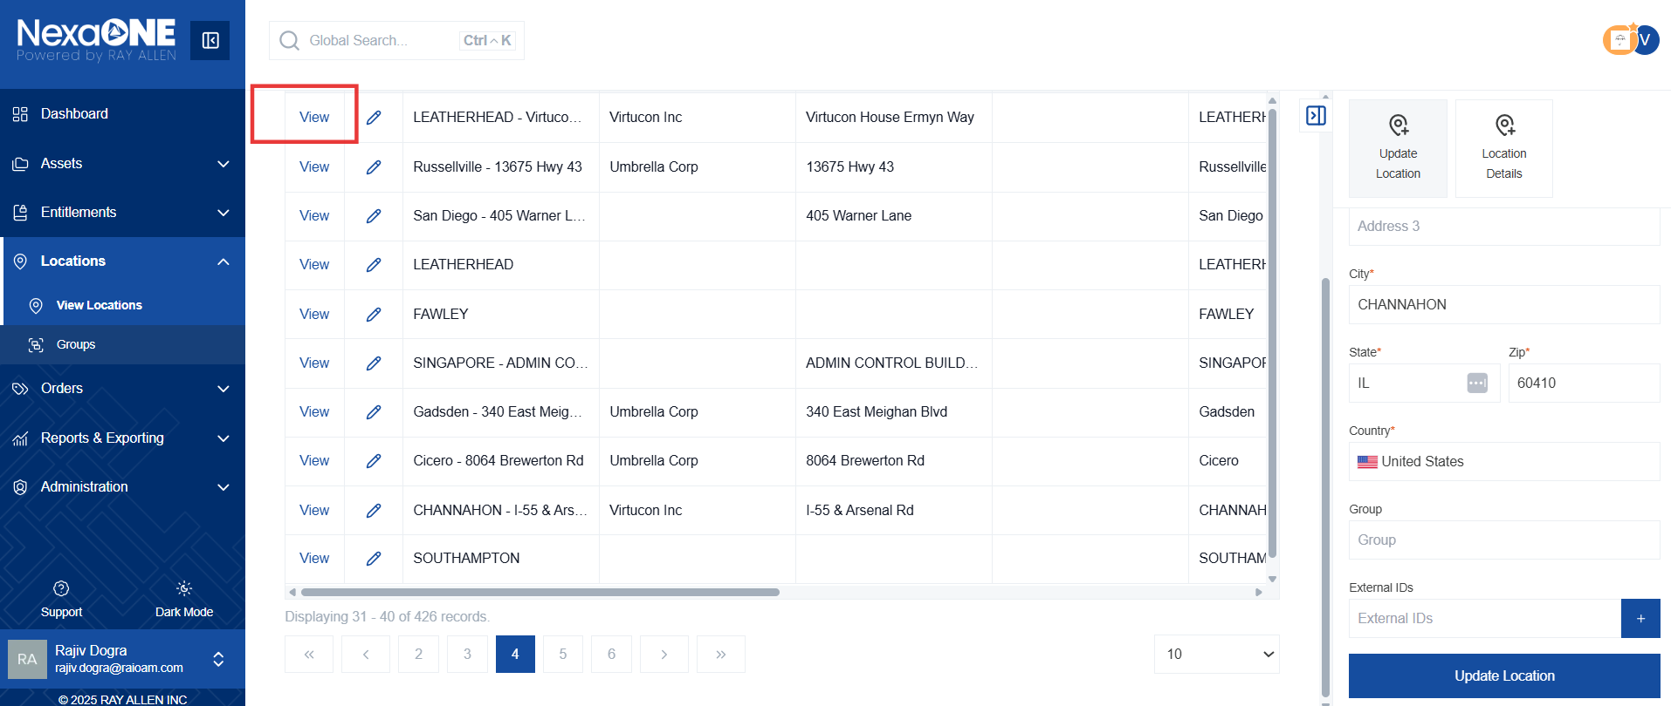

- Click the "Edit Location" button in the contextual panel. This button, located within the detailed view, allows you to modify the location's information.
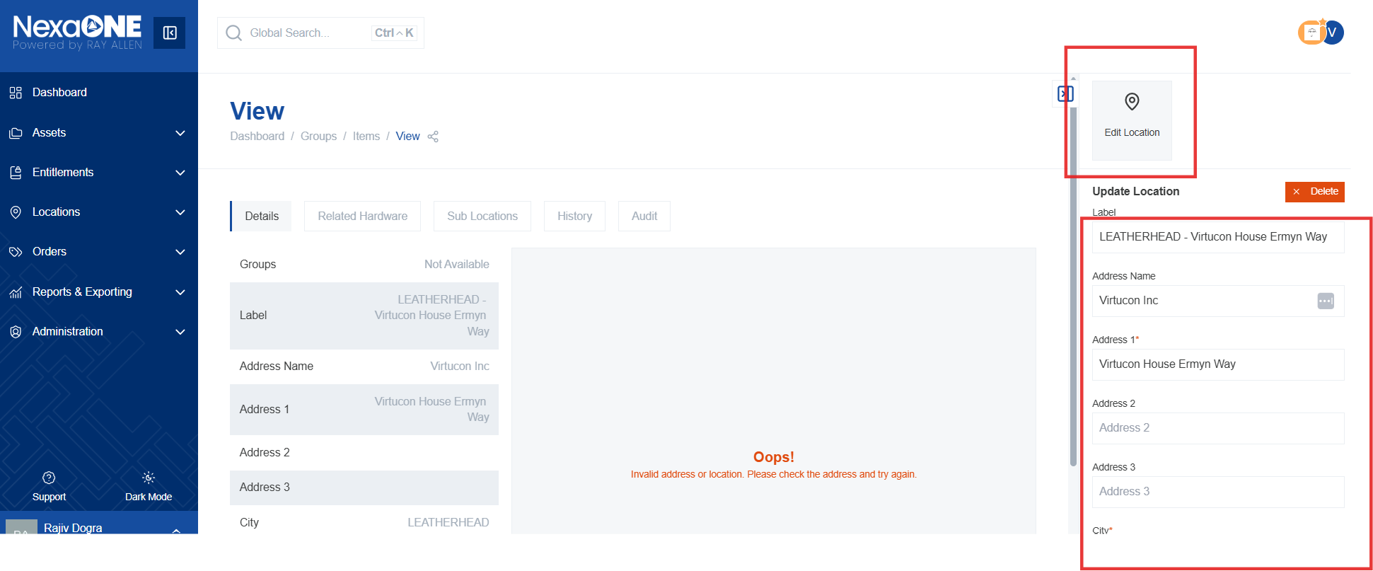

- Add or modify location information. Make any necessary changes to the location details in the editable fields and click update information.

