Location Management > View Locations > Actions > Add New Location
Adding a New Location
- Click the "Add New Location" button in the contextual bar. This button initiates the process of creating a new location record in the system.
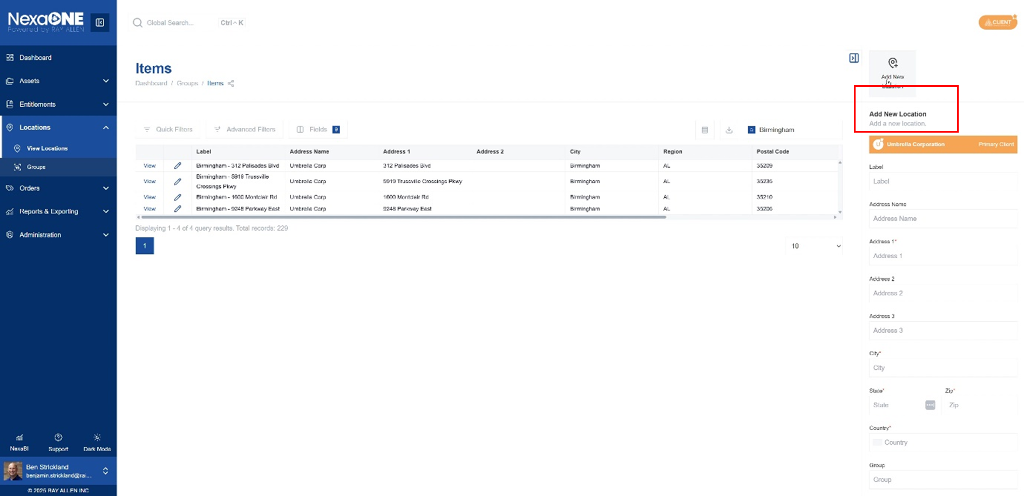
- Enter a label for the new location. The label is a short, descriptive name that will be used to identify the location throughout NexaOne.
- Input the address details: address name, address 1, address 2, city, state, zip code, and country. Provide complete and accurate address information to ensure proper location identification and mapping. Address 1 and Address 2 fields allow for detailed street-level information.
- Specify the group to which the new location belongs. Assign the location to a relevant group for organizational and reporting purposes. This helps in categorizing locations based on region, function, or any other relevant criteria.
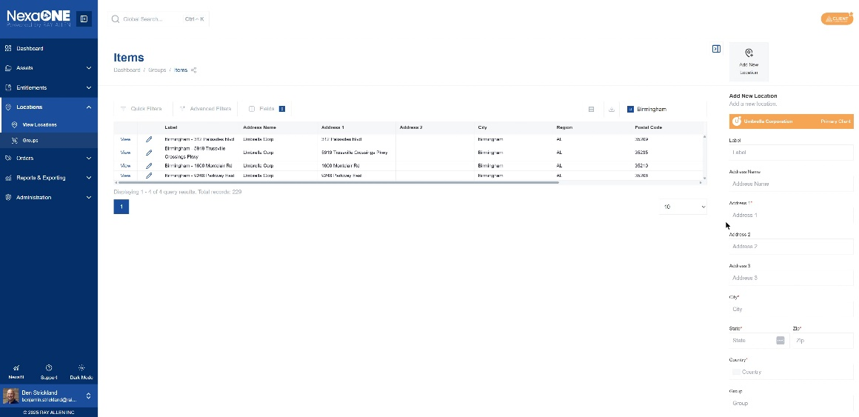
- Click "Add Location" to create the new location request. This action submits the new location details and initiates the creation process.
