Location Management > Groups > Details
Viewing Locations in a Group
- Find the specific location group you want to examine.
- Click the "View" button, usually represented by an eye icon, next to the desired location group. This will display the locations associated with that group.
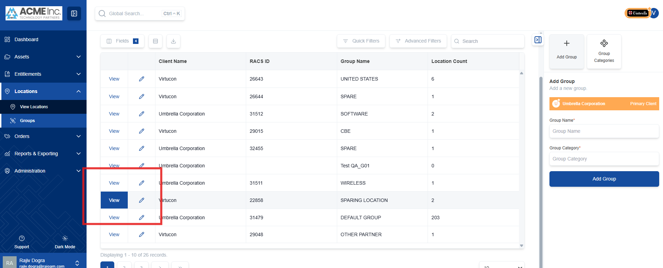

A list of location labels and location names currently associated with the location group will appear. This allows you to see exactly which locations are part of the selected group.
