Location Management > Groups > Details > Assets
Viewing Assets Within a Location
- From the list of locations, drill into the specific location you want to inspect. "Drilling in" usually means clicking on the location name or a dedicated "Details" button.
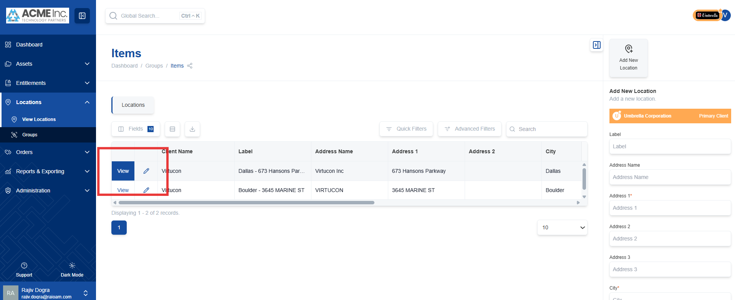
- Once you are viewing the details of a specific location, select the "Related Hardware" option. This may be a tab or a button within the location's details page.
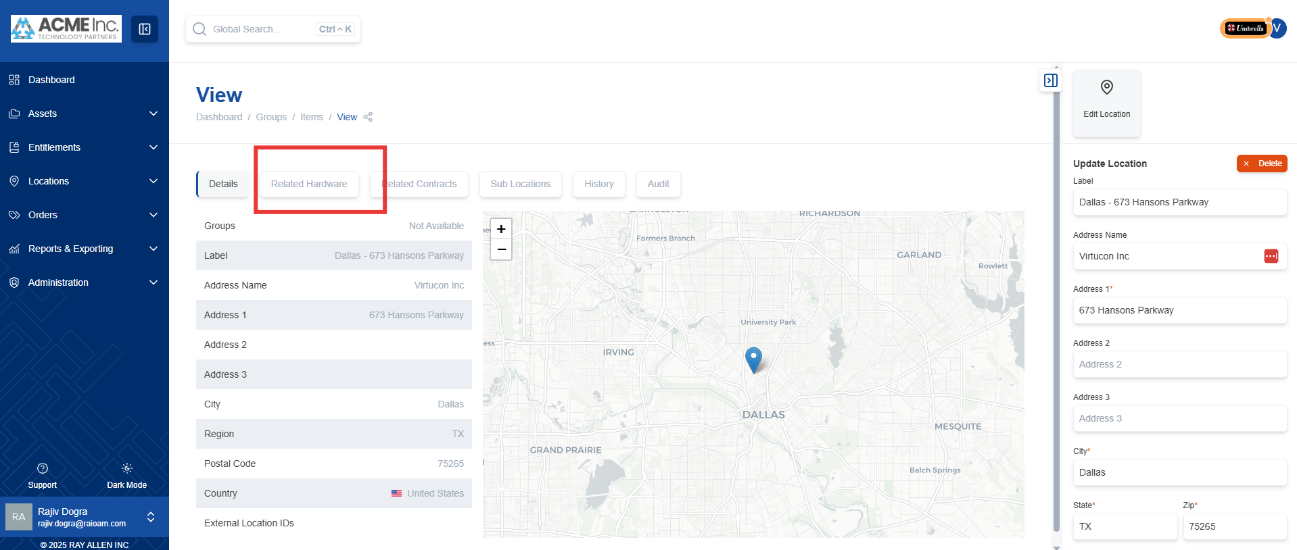
- A comprehensive list of all hardware associated with the specific site ID and location label will be displayed. This provides a clear overview of the assets present at that location.
