Location Management > Groups > Actions > Add Group
Adding a New Location Group
- Locate the "Add New Group" section on the right-hand side of the page. This is where you can create a new location group.
- In the provided field, enter a descriptive name for the new location group. Choose a name that clearly identifies the purpose or category of the group (e.g., "West Coast Stores," "Data Centers," etc.).
- Select a relevant category for the location group from the available options. This helps further classify and organize your location groups.
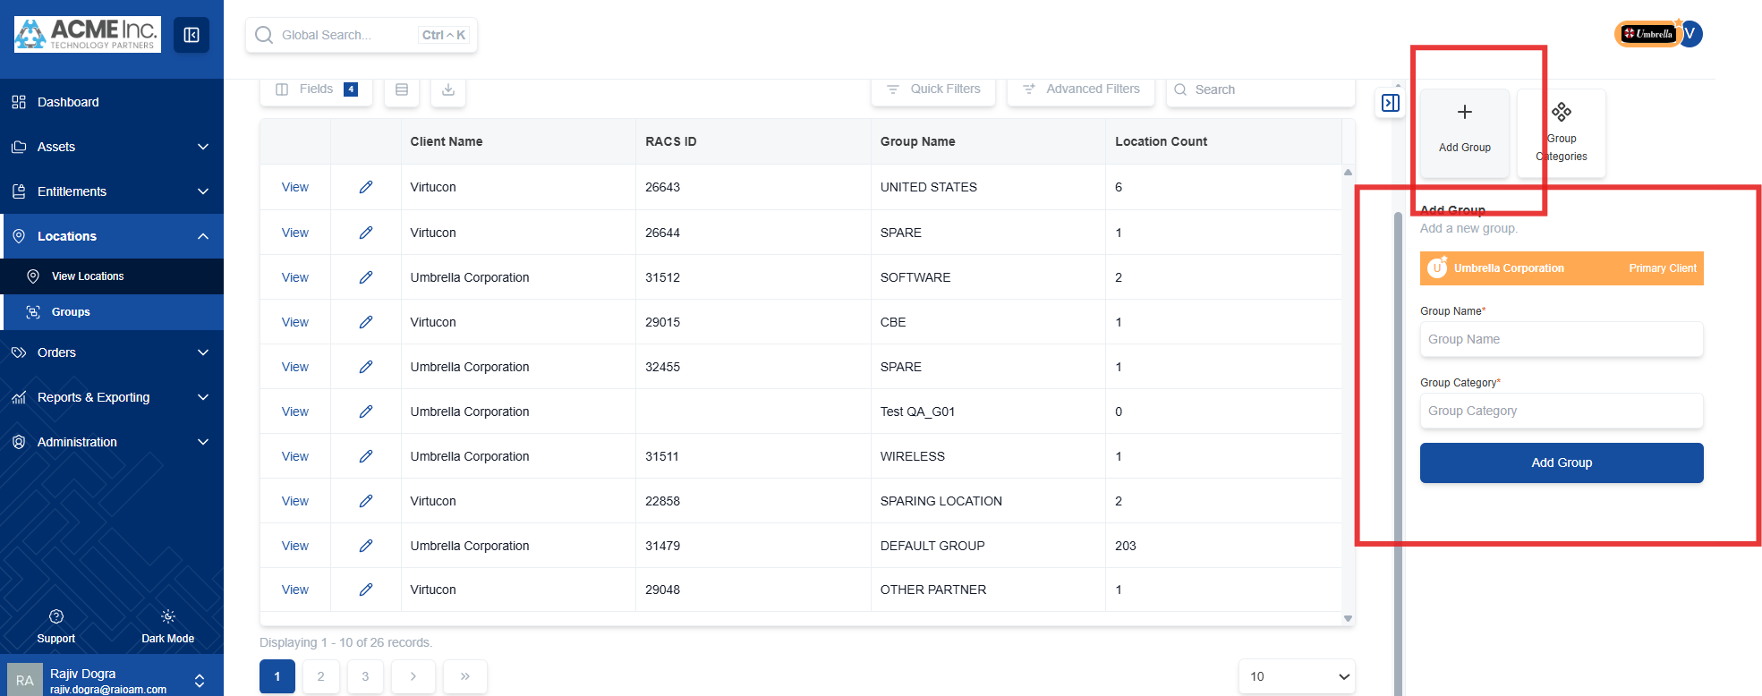
- After entering the name and selecting a category, click the "Add Group" button. This action will create the new location group.
- The new location group is now created and available for use. You can start adding locations to this group to organize your assets effectively.

