General > Top Level Searching
This section details how to use the global search feature to find specific information within NexaONE.
Accessing Global Search
The global search bar is accessible from every page within NexaONE.
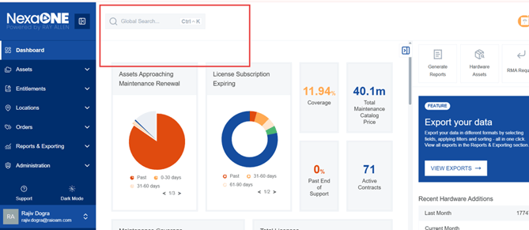
Performing a Search
- Click the Search Button: Click on the search button (magnifying glass icon) to open the search dialog.
- Choose Search Categories: You can specify which categories to search within, such as "Assets," "Orders," "Locations," "Contracts," "Licenses," and "Credit Bank". Hovering over each category will show the fields search for that category.
- Enter Search Term: Type in the search term you are looking for. This could be a serial number, product type, order number, contract number, or license number. As you type, results will begin to appear below the search bar.
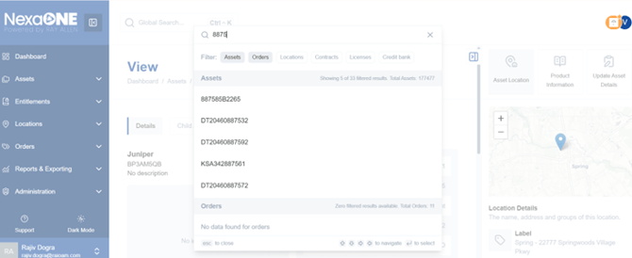
Understanding Search Results
- Review Results: Each search result will display the item found and the category it belongs to (e.g., "part number," "serial number").
- Navigate to Result: Click on any result to be taken directly to the corresponding page in NexaONE. For example, clicking on a hardware serial number will take you to the "View Hardware" page with the appropriate filters applied.
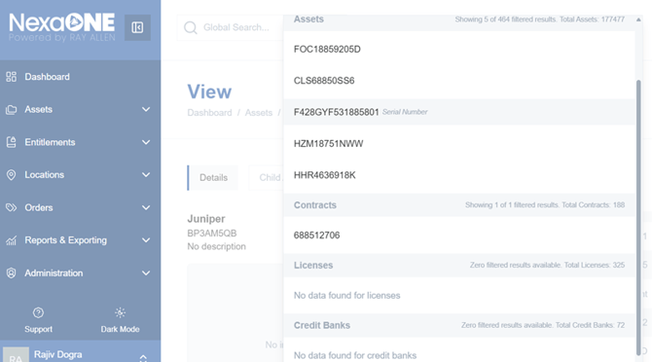
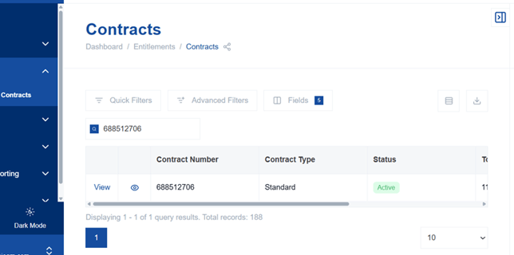
Filtering Search Scope
- Choose Search Categories: You can specify which categories to search within, such as "Assets," "Orders," "Locations," "Contracts," "Licenses," and "Credit Bank."
- Select Categories: Check the boxes next to the categories you want to include in your search. Selecting specific categories can help narrow down your search and improve results.
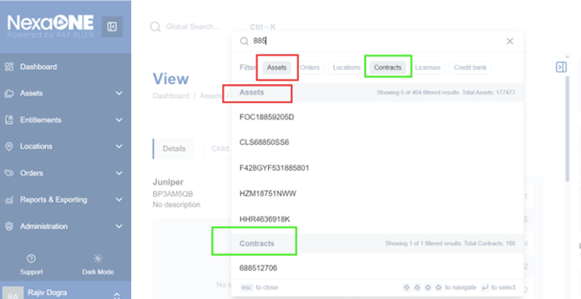
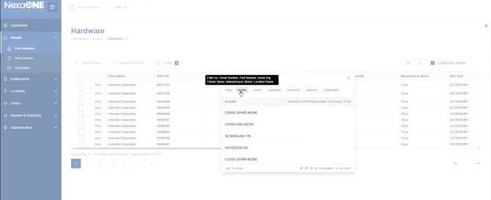

Example: Searching for a License
- Select "Licenses" Category: Check the box next to "Licenses" in the search categories.
- Enter Search Term: Type in a relevant search term, such as a license identifier or product name.
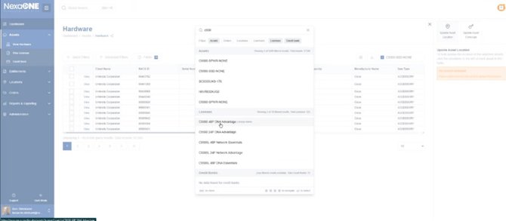
- The search results will now only display licenses that match your search term.
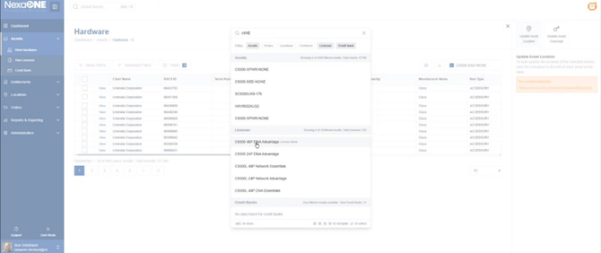
- Navigate to License: Click on a license from the search results to view its details in the "Licenses" view.
