General > List Pages > Column Customization
Column customization allows users to configure which columns are visible on the list pages.
Customizing visible fields affects the data exported when choosing the "Only Visible Fields" option.
Steps:
- Click the "Fields" icon (the number indicates the number of currently displayed fields).
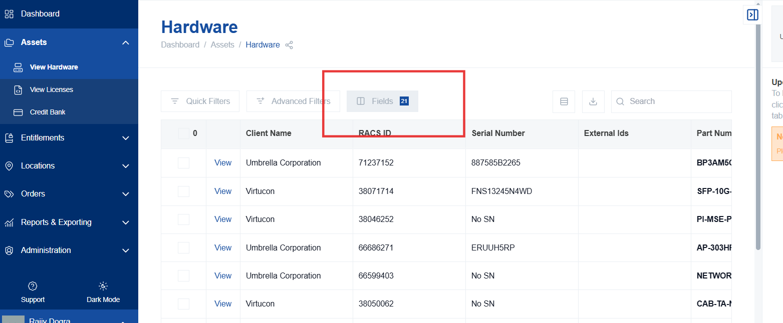
- In the "Customize Fields" window, you'll see "Visible Fields" and "Hidden Fields."
- To remove a field, click the "X" next to the field name. It will move to the "Hidden Fields" list.
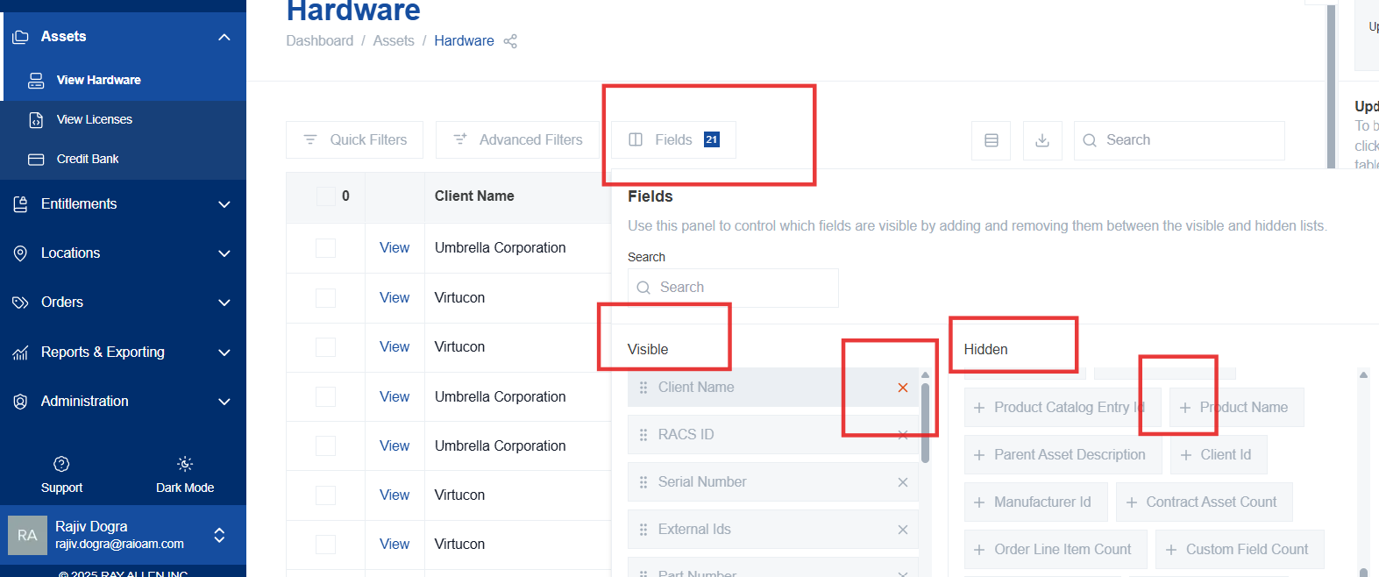

- To add a field, locate it in the "Hidden Fields" list and click the "+" sign. It will appear at the bottom of the "Visible Fields" list.
- Fields will automatically show in the order seen in the visible fields list. To reorder fields, click and drag the six dots next to the field name to the desired position.
- To find a specific field, type its name in the search bar.
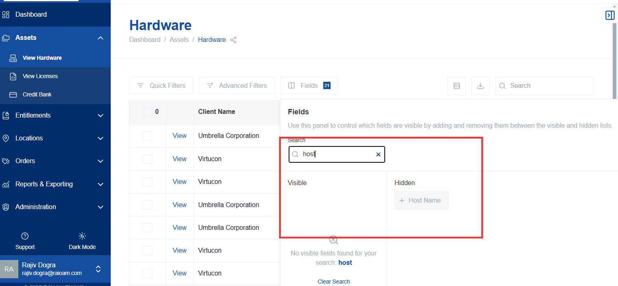
- Click "Apply" to save the changes, "Cancel" to discard them, or “Reset to Default” to reset all fields to the default view.
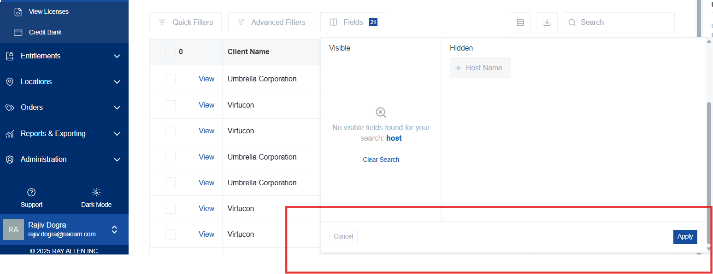
Relevance: Customizing fields allows users to tailor the displayed and exported data to their specific needs.
Note: Field customizations are saved per user ID and will remain until reset by the user by clicking “Result to Default” in the Customize Fields window. To reset to the original settings, click "Reset to Default".

