General > List Page Searches
Basic Search
The basic search bar allows you to search for any field that is currently displayed in the table.
Steps:
- Locate the search bar on the right-hand side of the list table
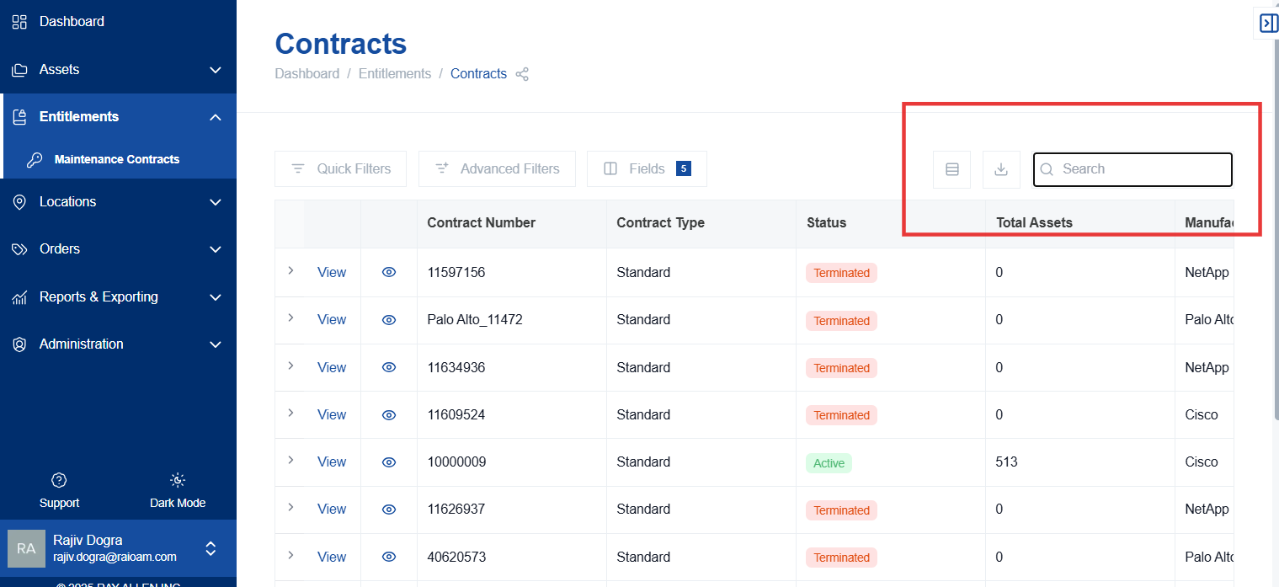
- Enter your search term (e.g., description, part number, serial number).
- Press "Enter" to initiate the search. The search filters the table results in real time, matching records that contain your search term in the fields currently included in the table.
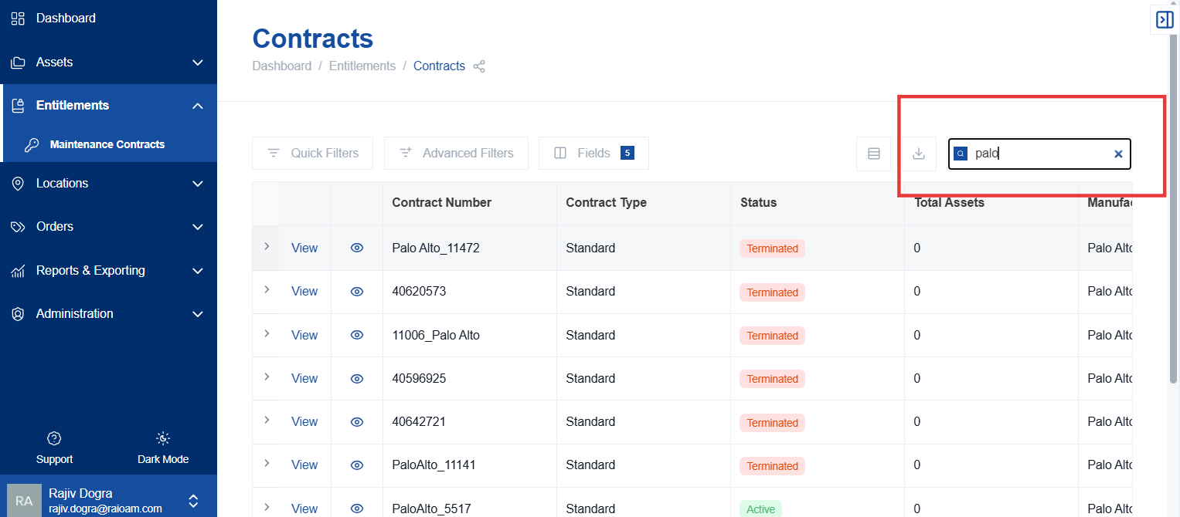
Relevance: This allows users to quickly find specific assets or items based on displayed information.
Note: Some added or previously hidden fields may not be fully searchable at this time. To clear the search and return all results, click the “X” in the search bar.

