Entitlements > Enterprise Agreements
This guide explains how to access and use the Enterprise Agreements section under the Entitlements menu. It covers navigation, viewing license-based and maintenance-based agreements, using page controls and filters, and reviewing agreement-level details and transactions.

Access Enterprise Agreements Section
The Enterprise Agreements section is located under the Entitlements menu.
At initial launch, this section is specifically for Cisco-only enterprise agreements. Additional OEMs will be added later.
To open the Enterprise Agreements page:
- Navigate to Entitlements.
- Click Enterprise Agreements.
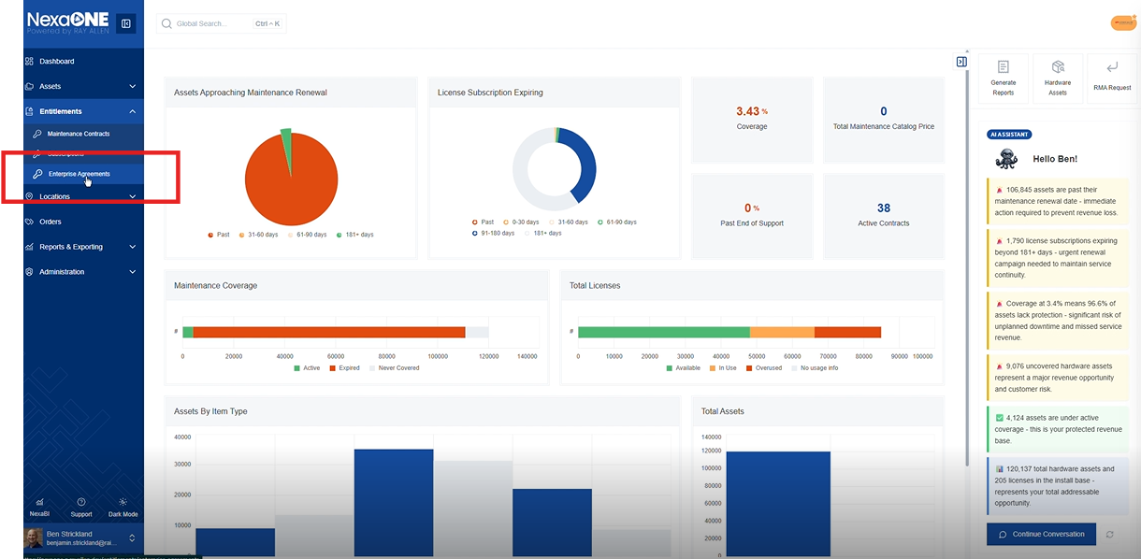

- A list of all Enterprise Agreements currently available to you is displayed.
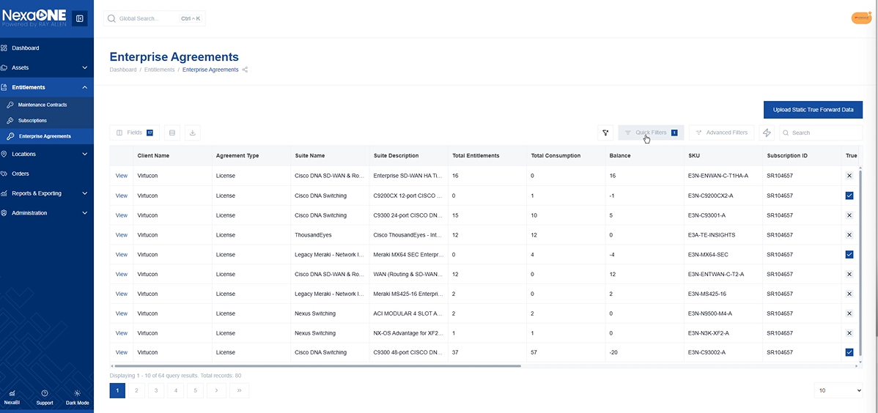
Enterprise Agreements table

Switching Between License-Based and Maintenance-Based Agreements
Enterprise Agreements can be viewed in two categories:
- License-based enterprise agreements
- Maintenance-based enterprise agreements
Use the Quick Filters at the top of the page to toggle between license and maintenance views. Not all data fields are available for all EA types.
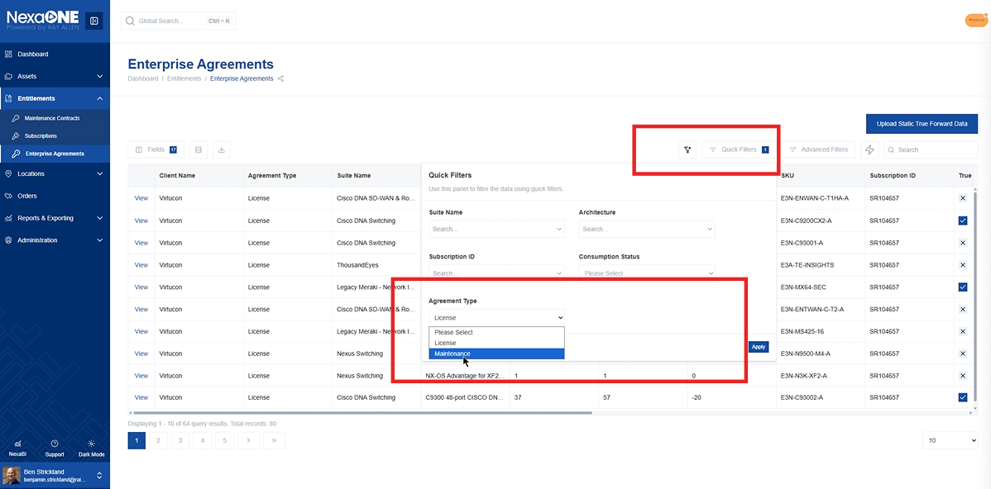
Quick filters used to switch between license and maintenance

Enterprise Agreement View
After you select Agreement Type as Licence, it will open a page with the list of Enterprise Agreements. The page offers standard NexaONE capabilities, such as the ability to change and organize fields.
Available capabilities include:
- Changing displayed fields
- Organizing field order
- Switching to compact view
- Switching to full screen view
- Exporting filtered data to CSV or Excel
- Applying advanced filters
- Applying quick filters
Filters allow users to:
- Search directly, or
- Select from a dropdown list to filter to a specific item
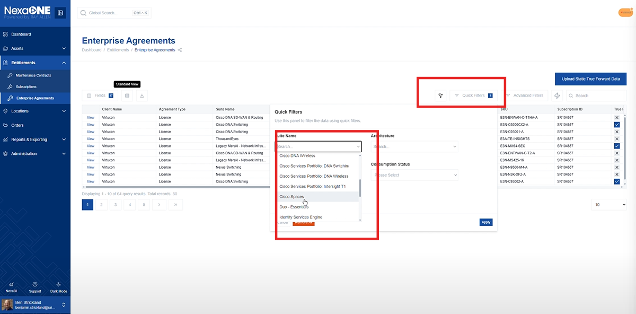
Also, advanced filters, quick filters and the contextual search bar can be used together.

Enterprise Agreement - Detailed Information
You can drill into any enterprise agreement item to see a more detailed view.
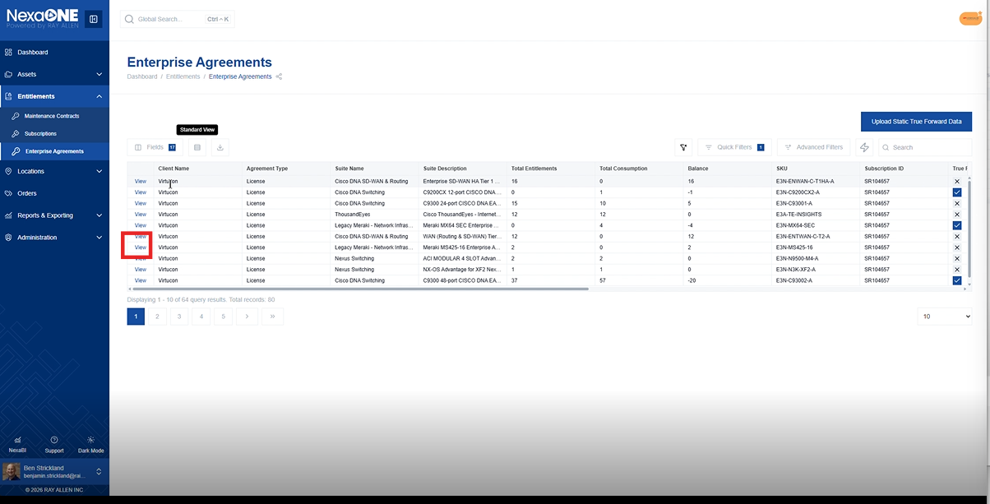
On the details page, you can see:
- A list of KPIs or key features for that item within the EA suite
- The suite name shown in the example: DNA switching suite
- The commerce SKU used for purchase
- Total consumption
- How many entitlements were originally purchased
- Any balance
- Whether a true forward is deriving from them
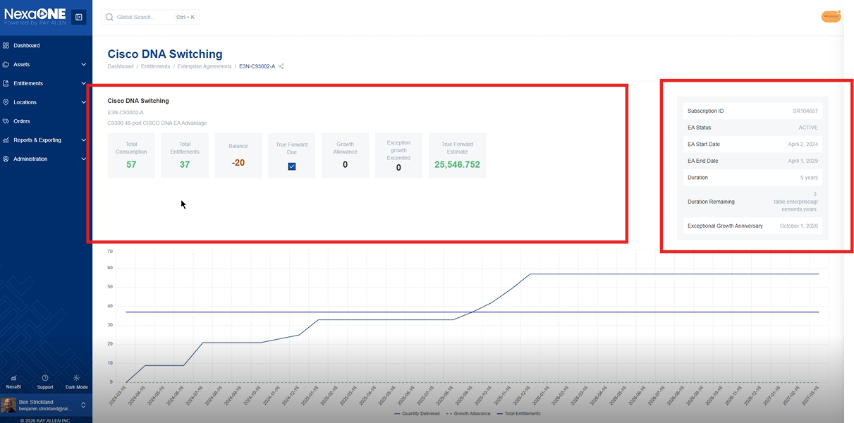
Enterprise agreement detail page with KPIs and suite info
The page also includes a graph below that provides a visual representation of how utilization changed over time.
In the example described:
- Utilization started at zero on the far left side of the graph
- The blue line (horizontal) represents the amount purchased
- The graph also shows the approximate point at which the entitlement number crossed the ownership or contract number
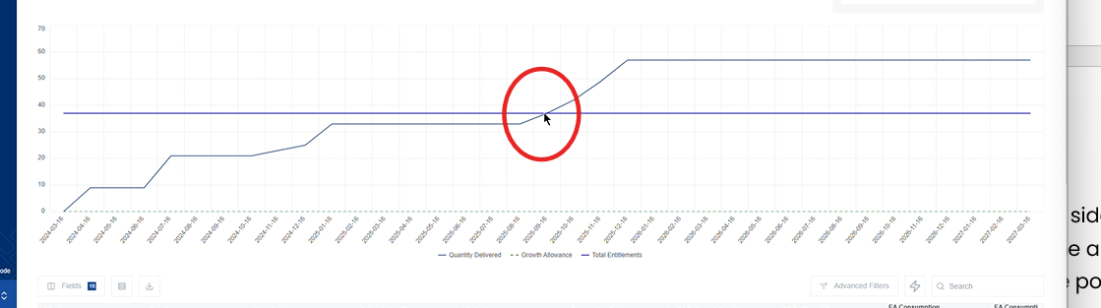
Utilization graph with blue purchased line over time

Review transactions behind utilization changes
If you scroll further down on the enterprise agreement detail page, you can see all transactions that generated the increase in license utilization.
The transaction list shows:
- When the transactions happened
- Who generated them
It also covers,
- Transaction requester
- Transaction type
These provide a description of how licenses were added to the enterprise agreement and the date on which those changes happened.
This information can be used for troubleshooting a particular sequence of events.
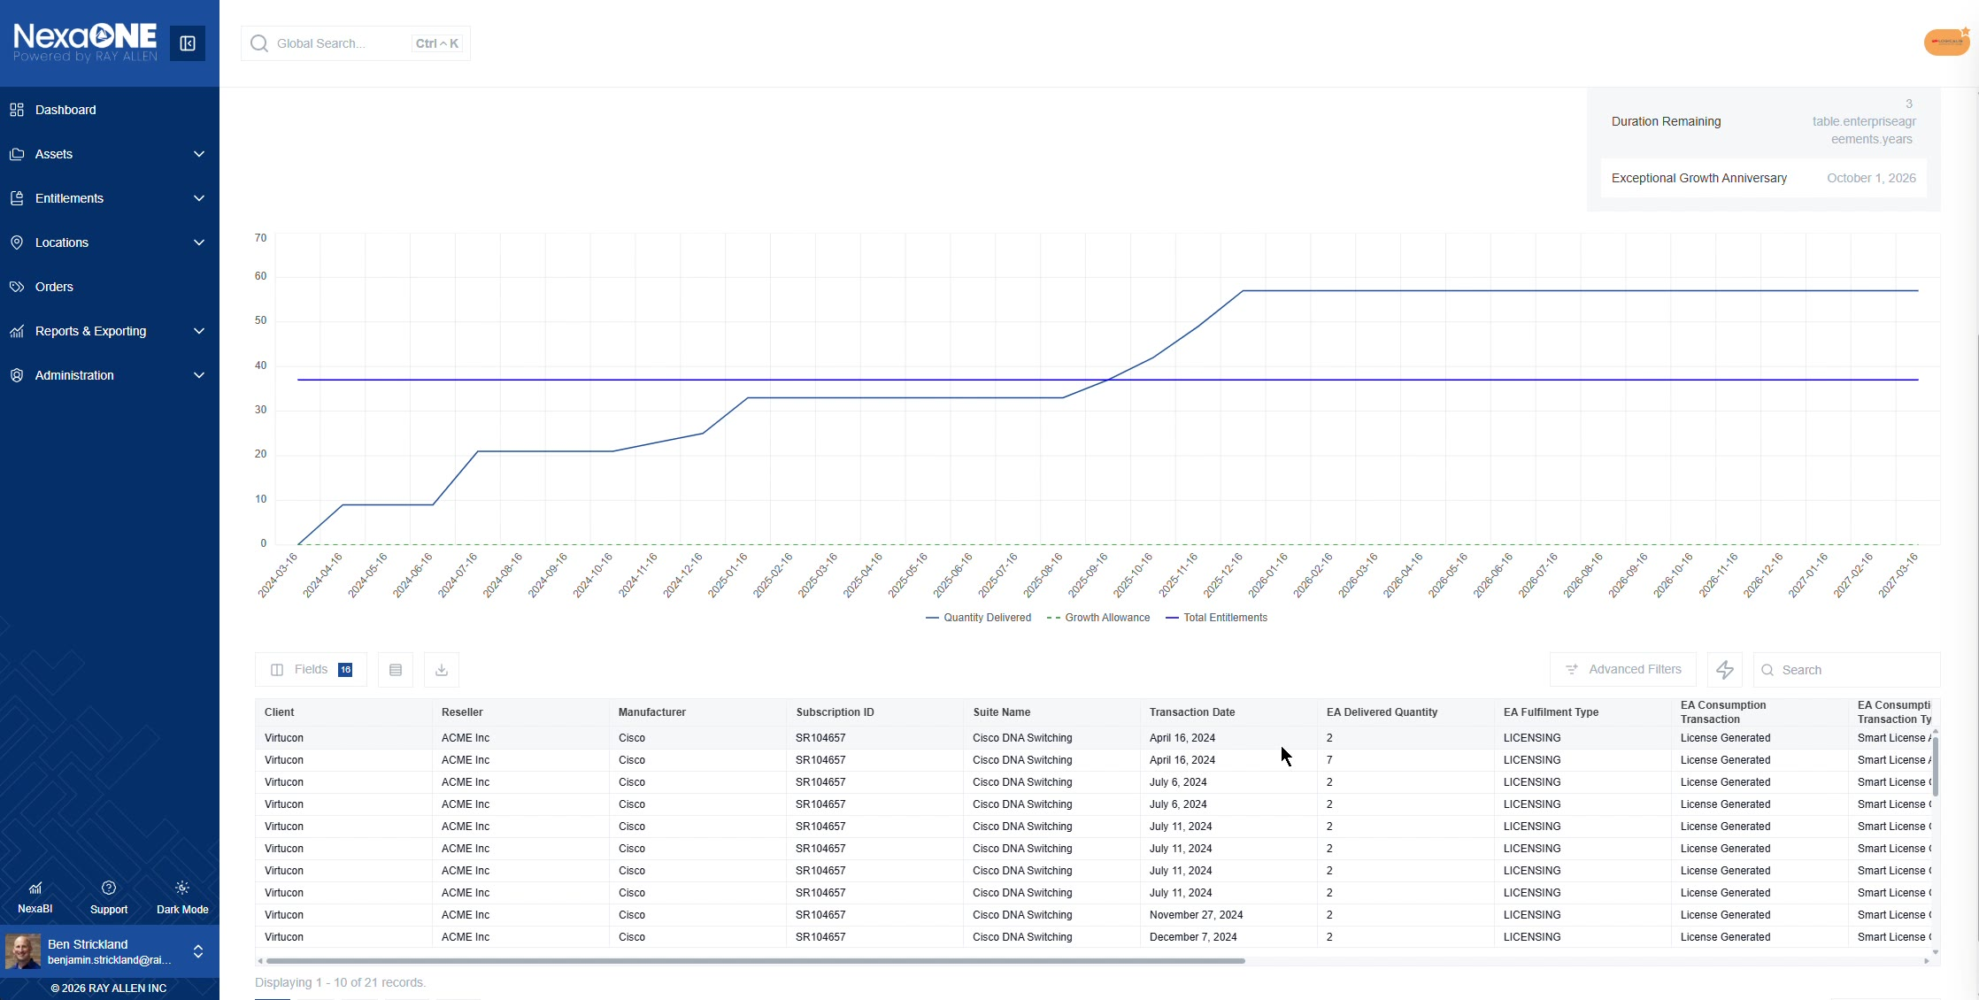
Transaction list showing when transactions happened

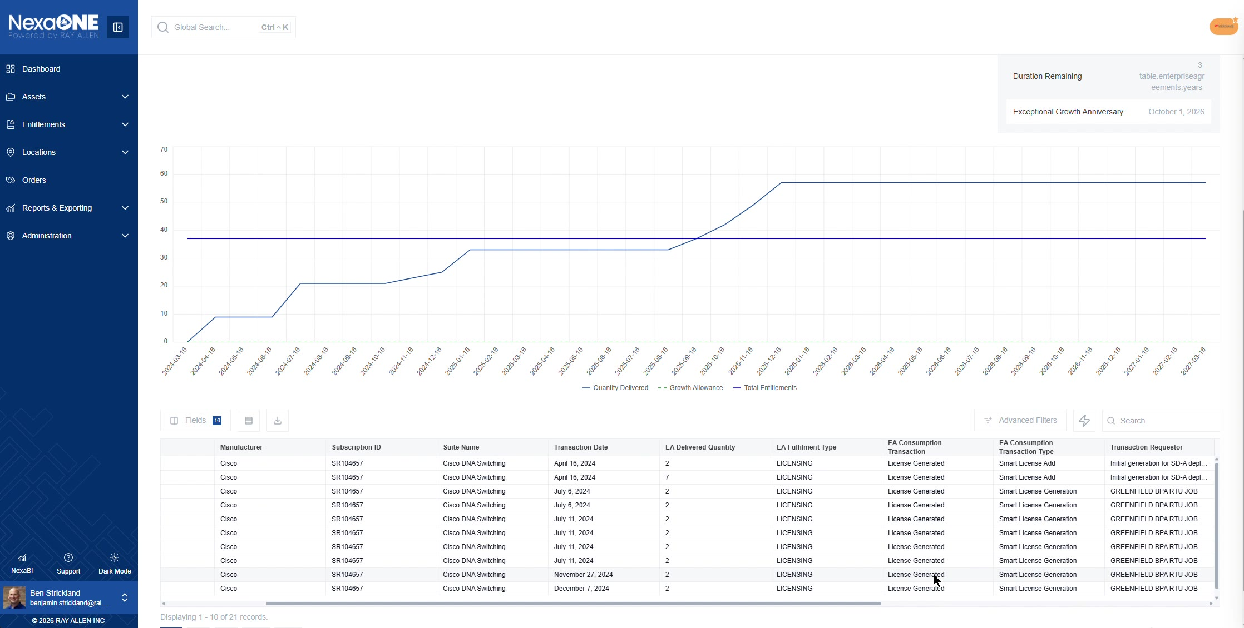
Transaction requester and transaction type columns

View Maintenance Agreement Details
From the Enterprise Agreements area, you can also switch to maintenance items from Quick Filter.
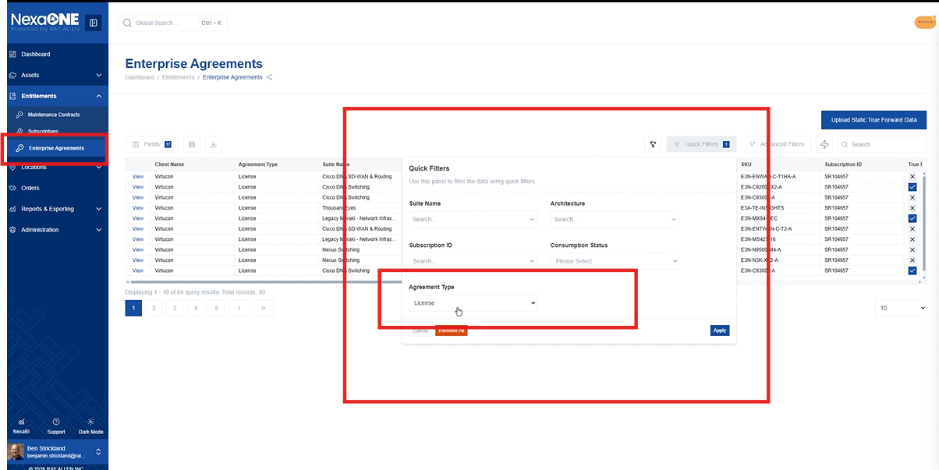
Switch to maintenance items

Everything generally works the same, including the fields, and that you can drill into maintenance agreements as well.
For maintenance agreements, similar visualizations are shown, including:
- How many are covered
- How many were purchased
- How many were added
- How many were removed
The graph below also provides a quick sense of how the numbers changed over time by following the timeline.

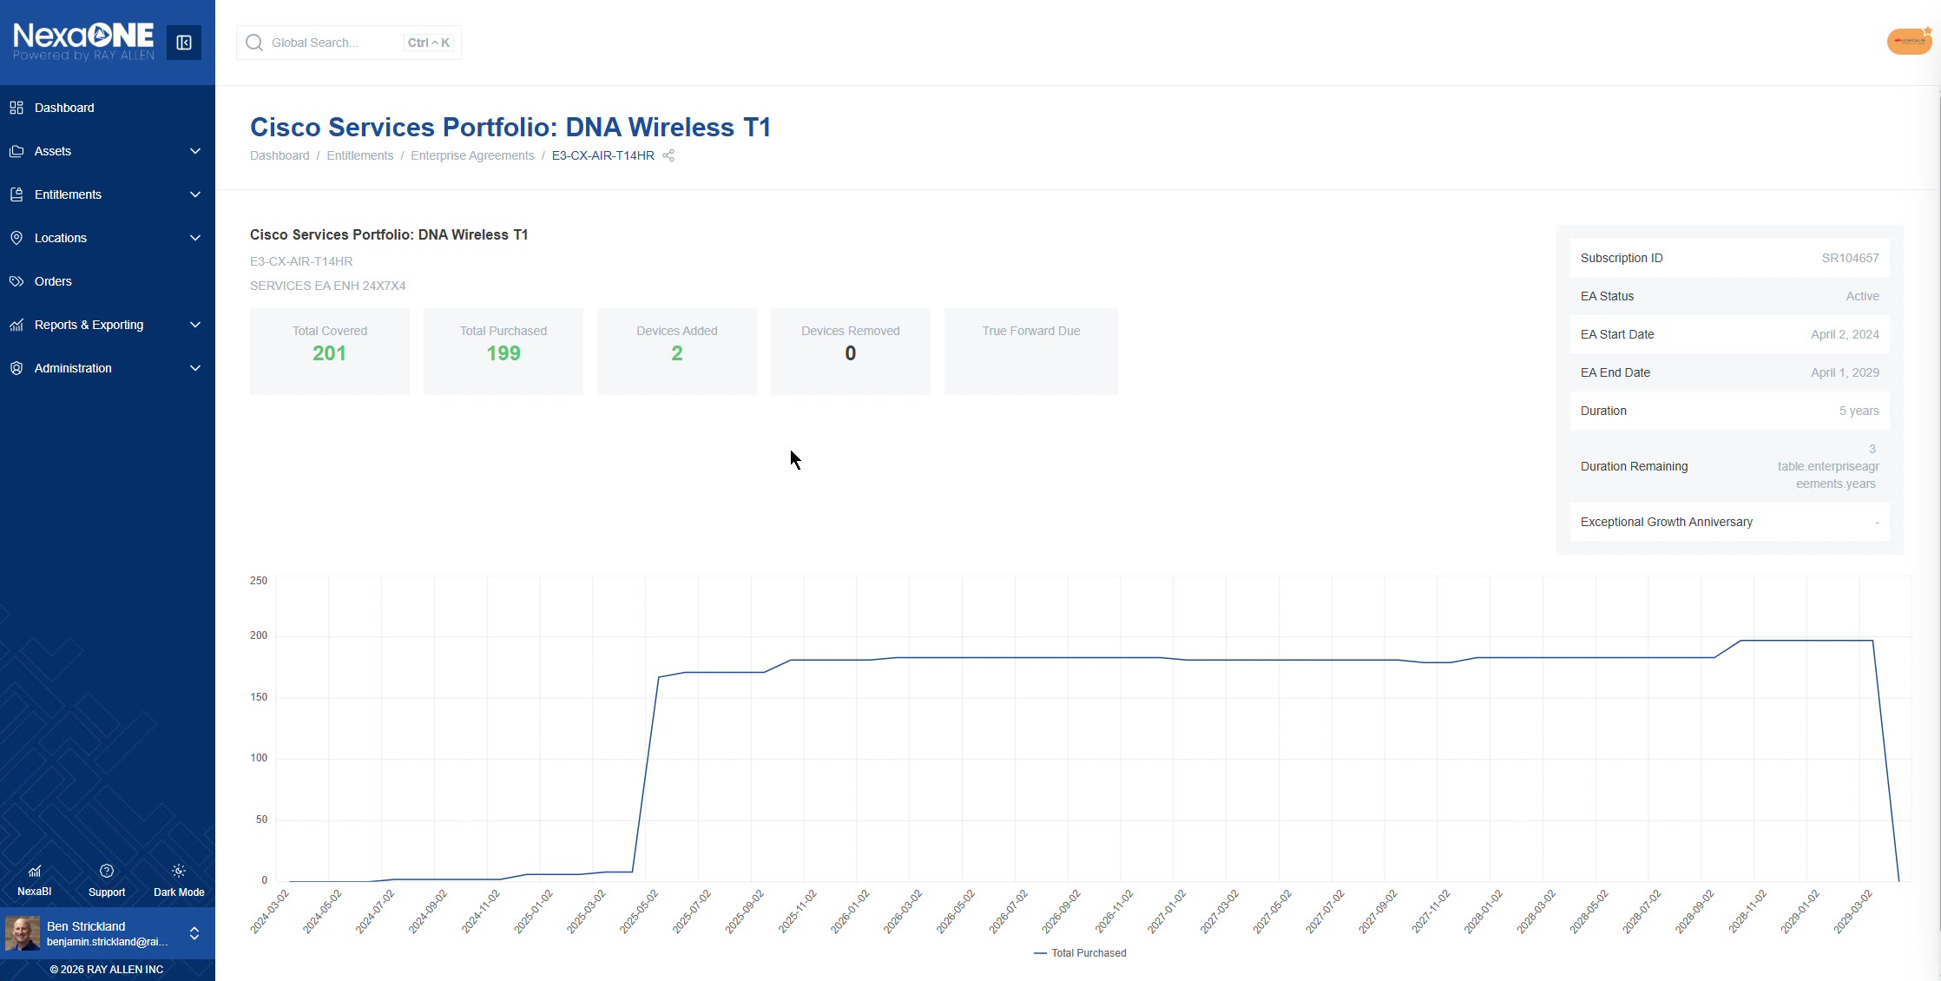
Maintenance agreement details with covered and purchased counts

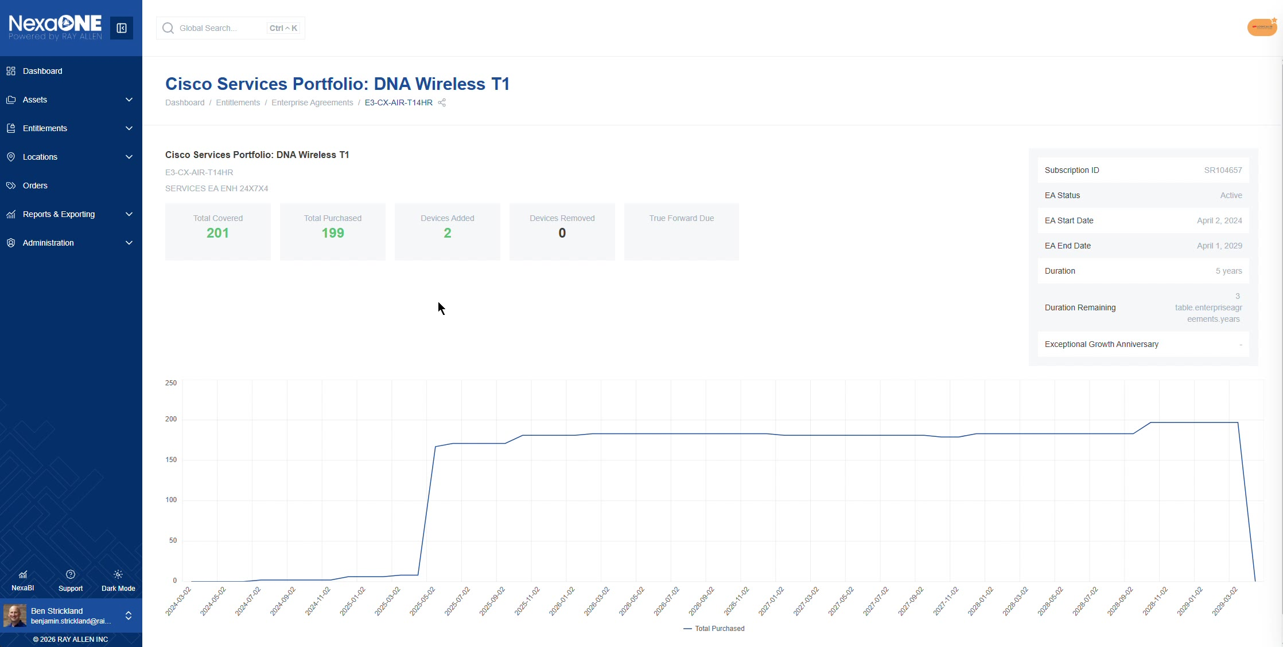
Timeline graph showing changes over time

