Entitlements > Subscriptions
This guide explains how to access and use the Subscriptions interface in NexaONE. It covers how to view available subscriptions, customize the subscriptions table, apply filters, export subscription lists, and open a subscription to review additional details.
Access the Subscriptions Interface
Navigate to Entitlements menu, then select Subscriptions to open the Subscriptions interface in NexaONE.
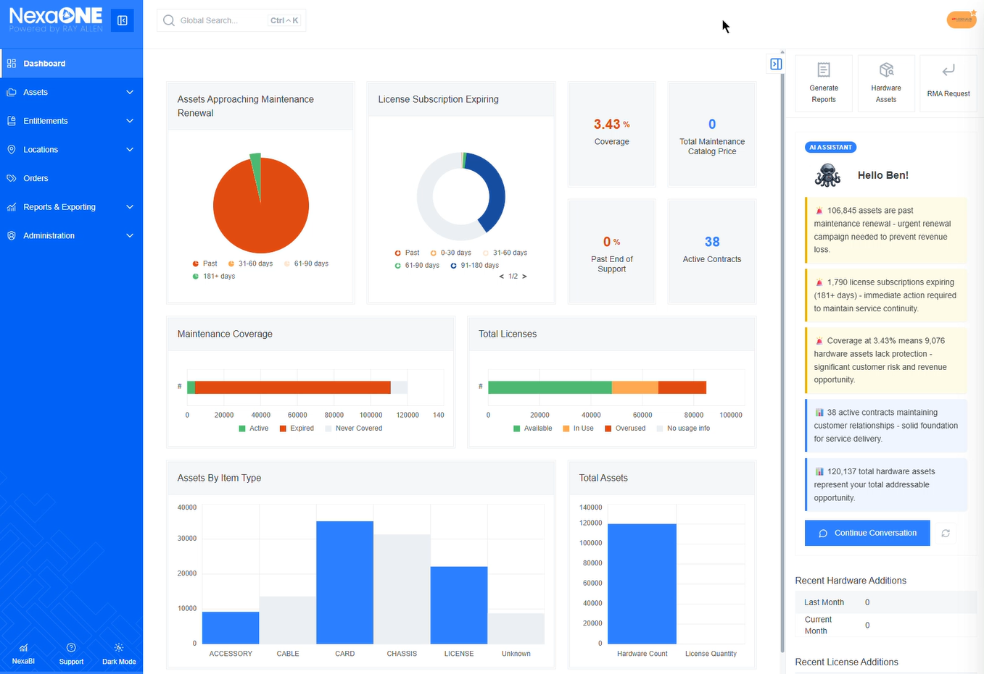
Once the Subscriptions interface opens, begin by selecting your primary subscription.
At this point, the table displays all subscriptions that are available at that point of time.
Work with the Subscriptions Table
The subscriptions table can be customized in the same way as other tables in NexaONE:
- Change which fields are shown
- Add additional columns
- Reorganize the table layout to surface the data you are looking for
You can also export a subscription list when you need to reuse or share the data.
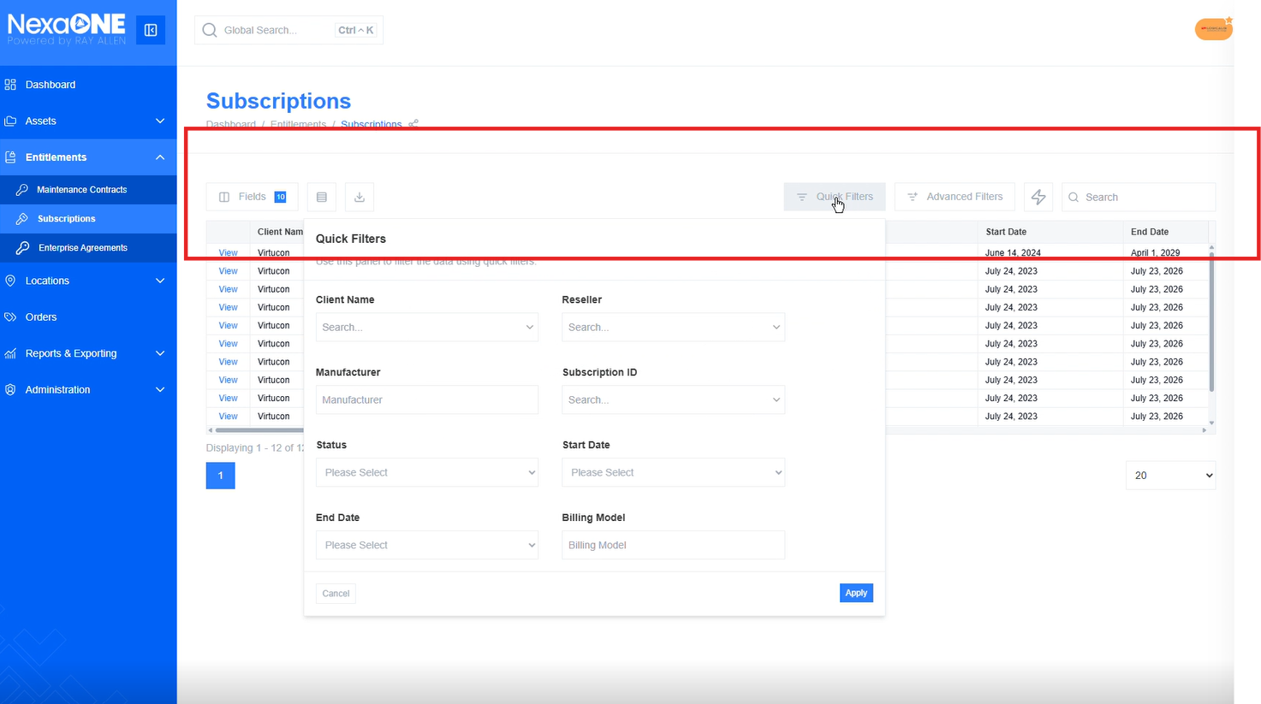
Filter subscriptions
Both Quick Filters and Advanced Filters are available and can be used to locate specific subscriptions.
- Use Quick Filters to quickly look up and sort individual subscriptions.
- Use Advanced Filters to search using the standard advanced filter criteria to find items that match a specific subscription.
- Use the Search option to narrow the results and display only the subscriptions that match your criteria.

Subscription Details
To review a subscription in more detail, select the View button for that subscription.
This opens the subscription detail view, where you can see information such as:
- Subscription status
- Renewal timing
- Whether the subscription includes multiple products
- A list of the individual products
- Individual start and end dates that may be associated with those products
