Entitlement Management > View Maintenance Contracts
Accessing the Maintenance Contract Section
- Navigate to the "Entitlements" section. This is where you'll find all options related to your entitlements and contracts within NexaONE.
- Select "Maintenance Contracts". This will take you to the main maintenance contract management page.
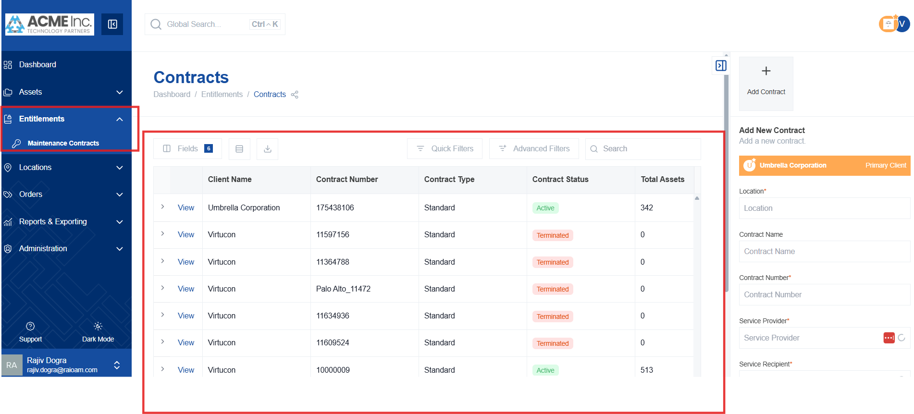
Overview of the Maintenance Contract Page
Upon accessing the Maintenance Contracts page, you'll be presented with a table displaying a comprehensive list of your contracts. This table is designed to be user-friendly and shares similar functionalities and a familiar interface with other modules within NexaONE, ensuring a consistent experience.
Modifying Visible Fields
- Click the "Fields" button located within the table interface. This allows you to customize the columns displayed in the table, showing only the information most relevant to you.
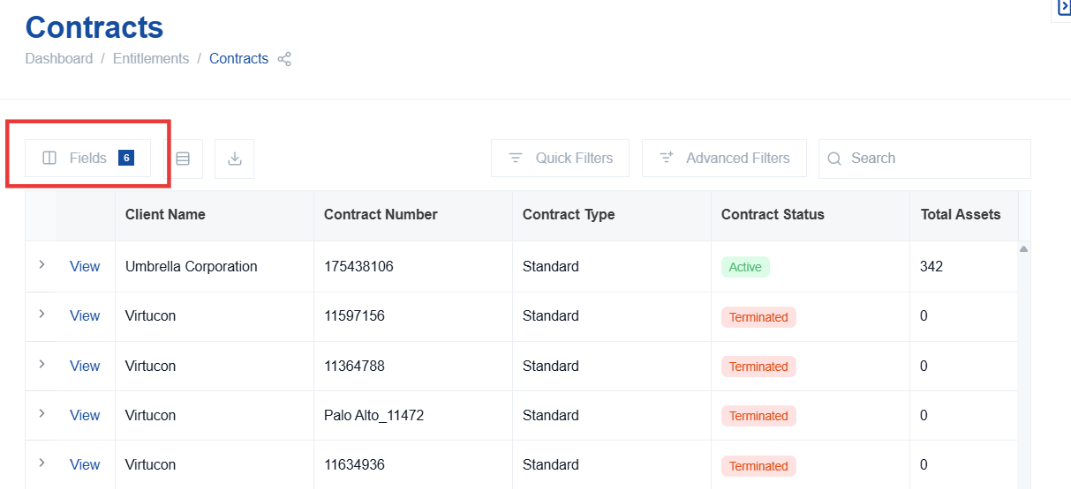

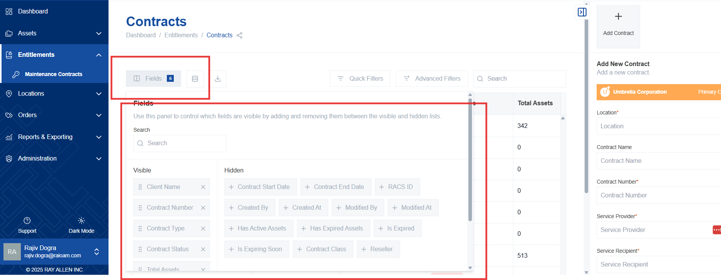
- Refer to the documentation section on modifying fields for detailed instructions on how to add, remove, and rearrange columns to suit your specific needs.
Filtering Data
- Use quick filters or advanced filters to refine the displayed data and quickly locate specific contracts based on various criteria. Quick filters provide pre-defined options, while advanced filters allow for more complex and customized searches.
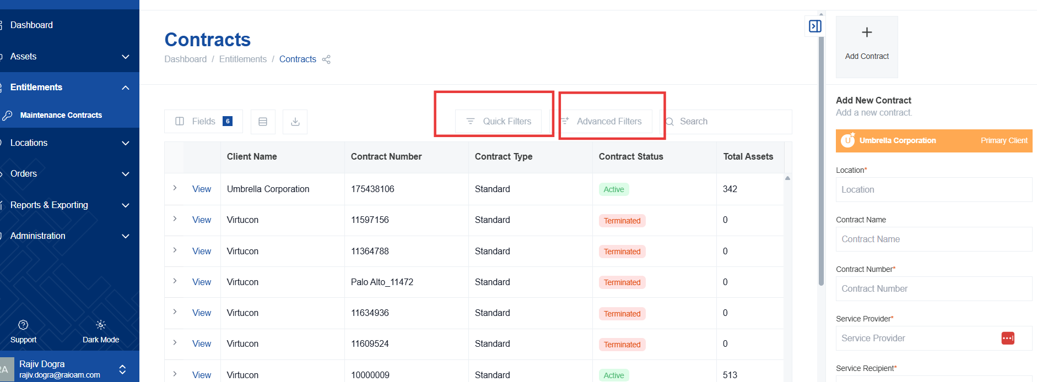

Text-Based Filtering
- Type directly into the search bar to quickly find specific contracts. For example, you can enter a contract number, a company name, or any other relevant keyword.
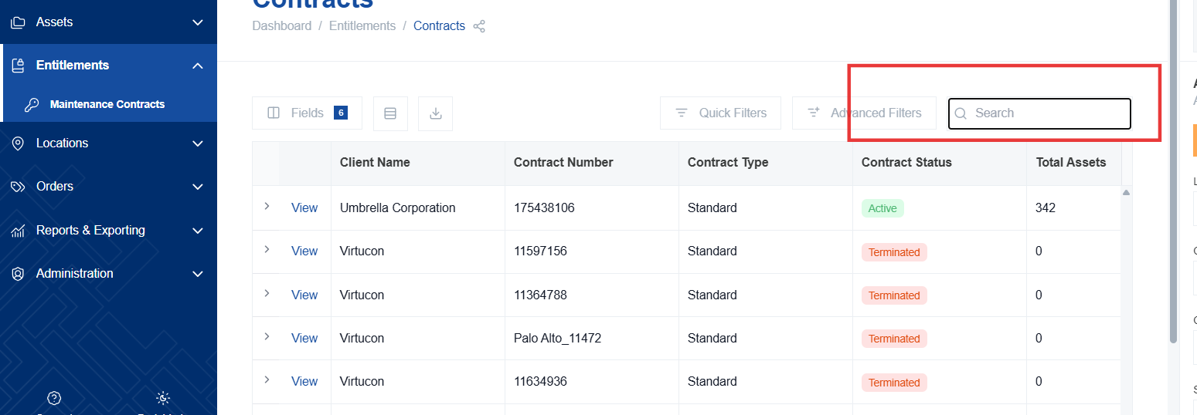
- The table will dynamically filter as you type, showing only the contracts that match your search criteria. This allows you to quickly narrow down the list and find the information you need.
Exporting Data
- Click the "Export" button to download the current table view as a file (e.g., CSV or Excel format). This allows you to further analyze the data or share it with others.
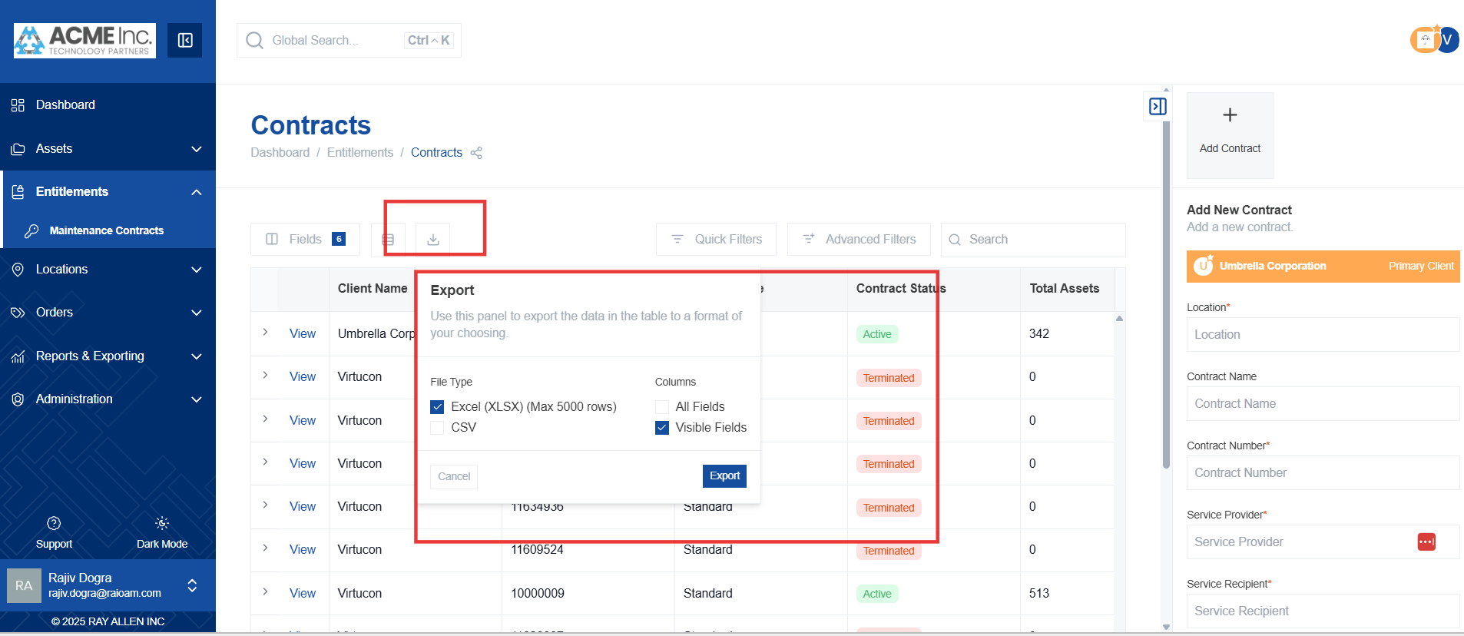
- The exported file will contain the results of any applied filters, ensuring that you only export the data that you're interested in.

