Entitlement Management > View Maintenance Contracts > Details
Service Name Drop-Down
- Locate the drop-down button (usually represented by an arrow or similar icon) associated with each contract in the table.
- Click the drop-down to view a detailed list of service names, service levels, and counts associated with that specific contract. This provides a quick overview of the services included in the contract.
Note: The availability and specific content of this feature are OEM dependent, meaning they may vary depending on the Original Equipment Manufacturer.
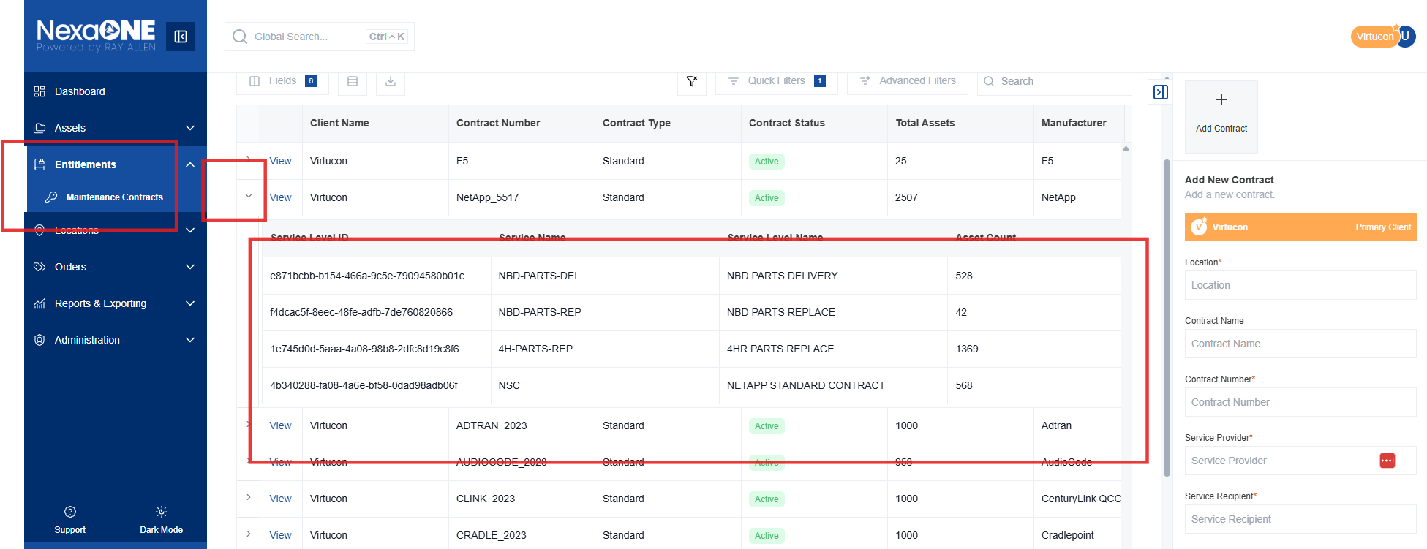

Viewing Contract Details
- Click the "eye" icon (often representing a view or details option) next to a contract to view a list of assets currently associated with that contract in the contextual bar.
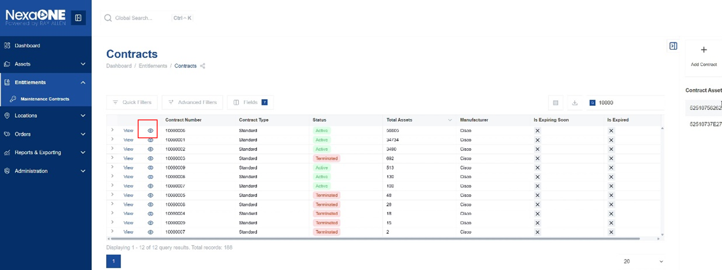
- Click the "View" button to access a comprehensive view of the contract's details, including key information and settings.
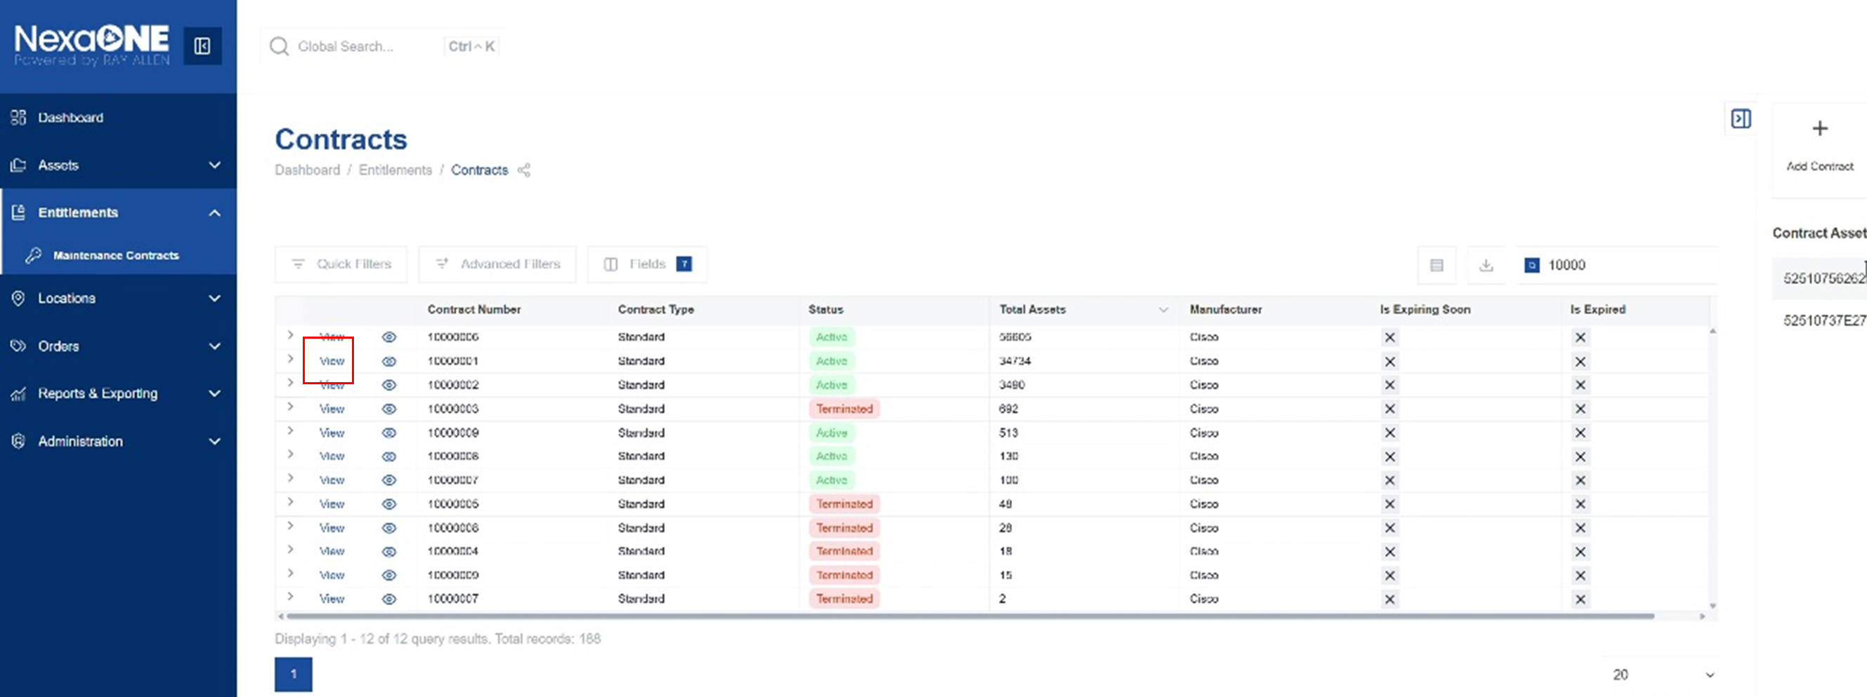
- The contract details include important information such as the start and stop dates of the contract, specific contract details, the OEM (Original Equipment Manufacturer), and other relevant information.
