Entitlement Management > View Maintenance Contracts > Details > Related Assets
Related Assets Table
- From contracts table, click on the “view” link for the specific contract.
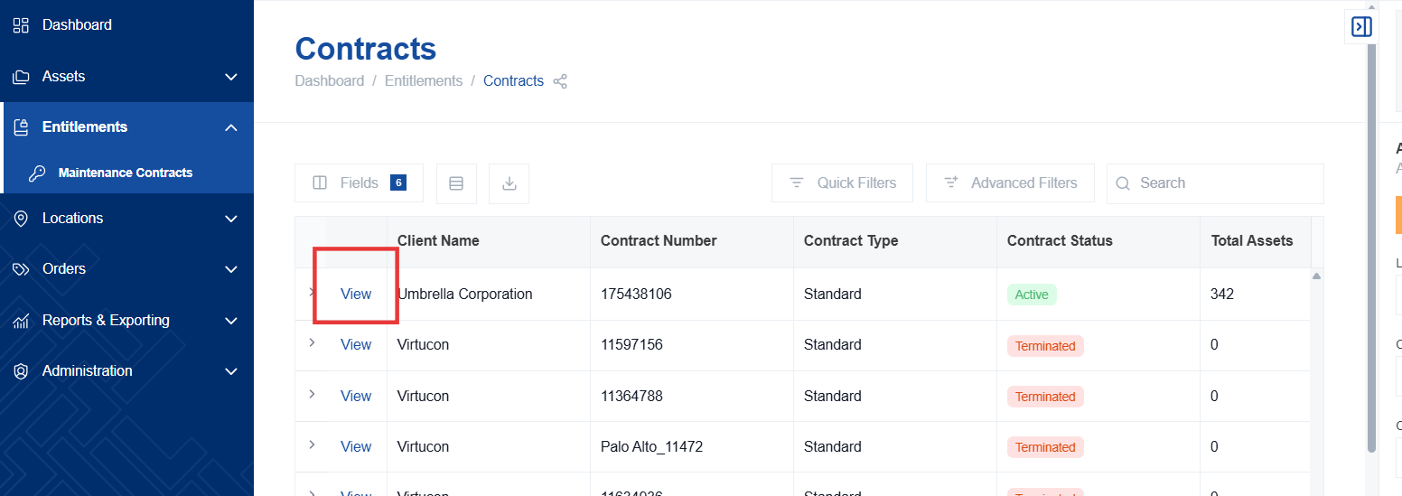
- Within the contract details view, click on "Related Assets". This will navigate you to a dedicated section for managing and viewing the assets associated with the contract.
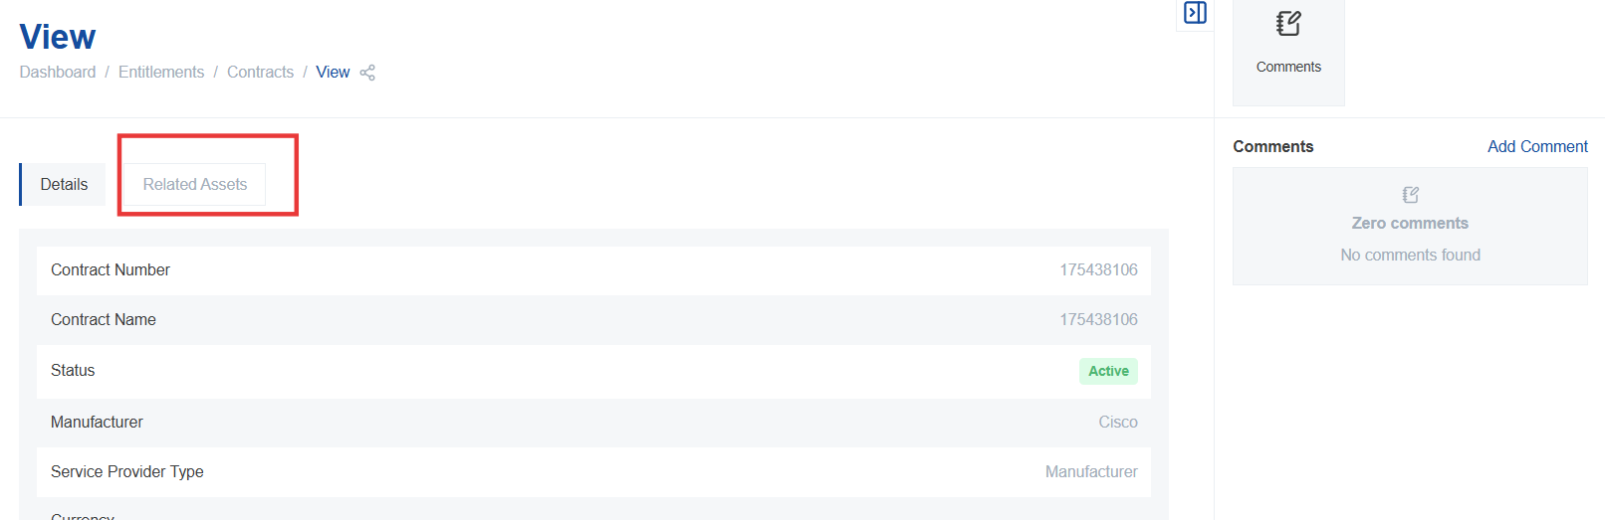
- A new table will appear, listing all assets that are currently associated with the selected maintenance contract.
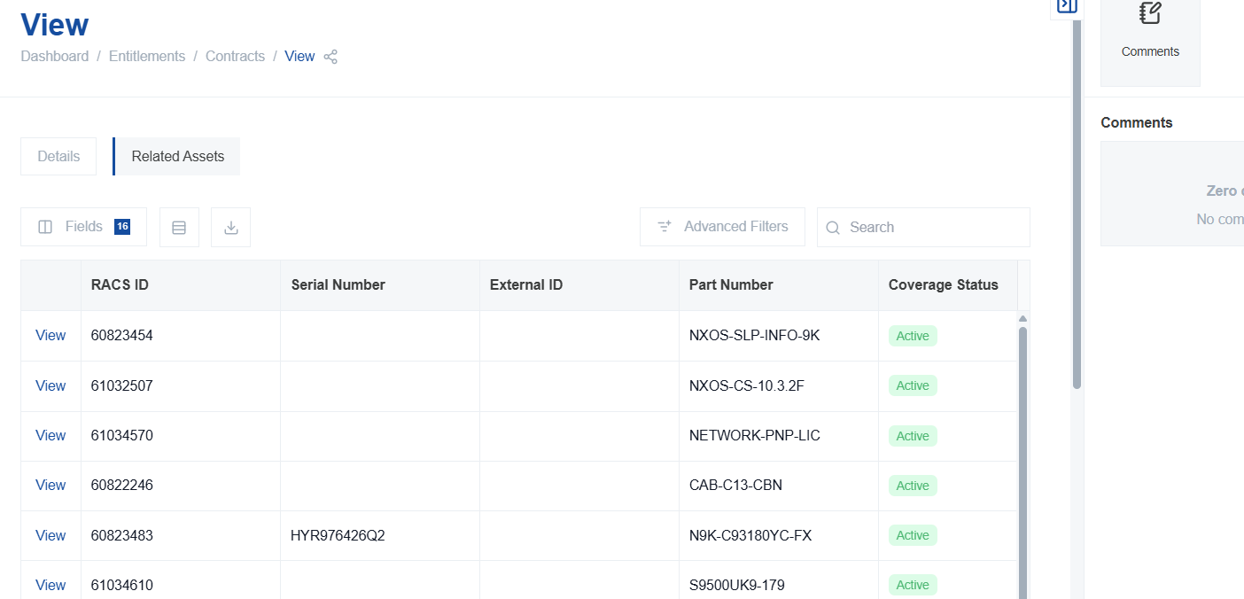
- The table displays the start and stop dates for each individual asset within the contract, along with its current status, indicating whether the asset is still actively covered under the contract.

Navigating to Hardware Asset Details
- In the "Related Assets" table, click the "View" button located next to a specific asset that you want to investigate further.
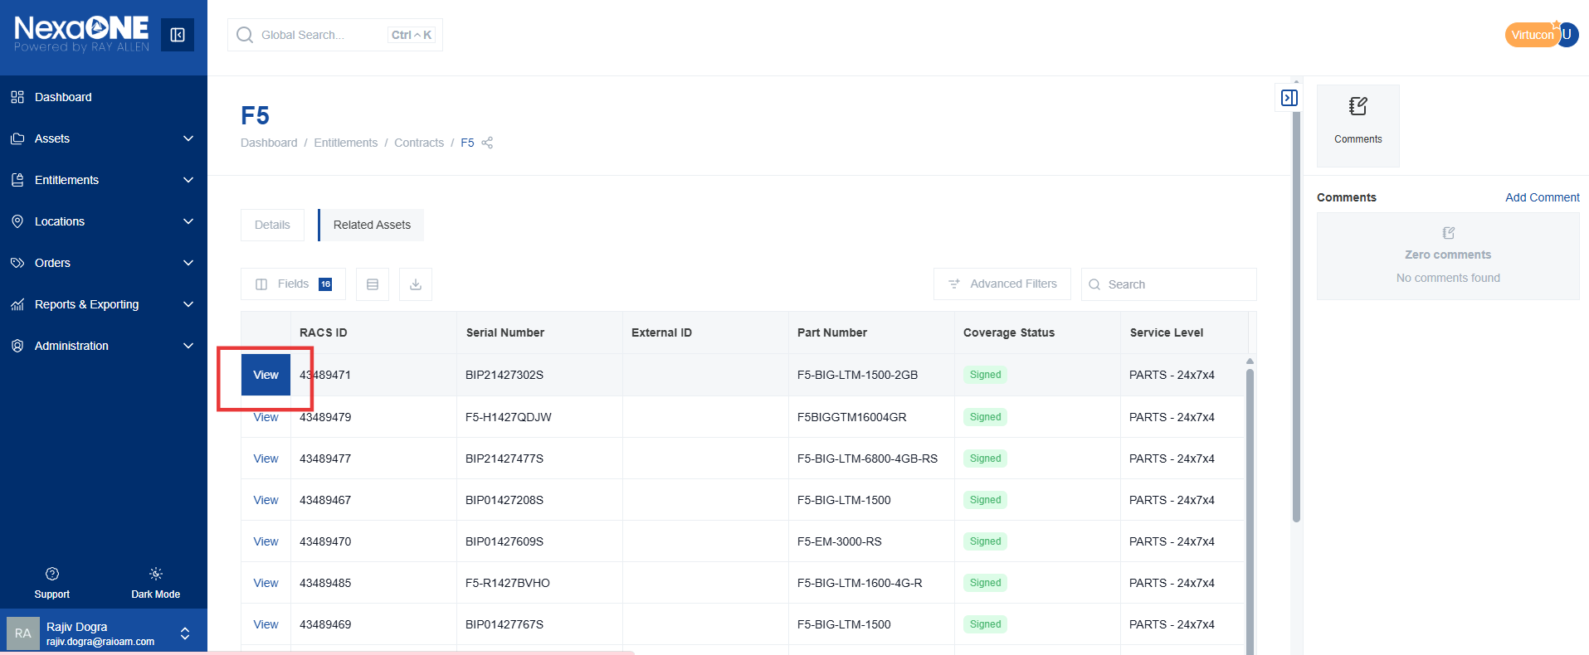
- This action will redirect you directly to the hardware asset table for that particular item, providing you with detailed information about the asset's configuration, history, and other relevant data.

