Dashboard > Widgets
The dashboard primarily contains widgets. Widgets are selectable and configurable elements that display visualizations of your data.
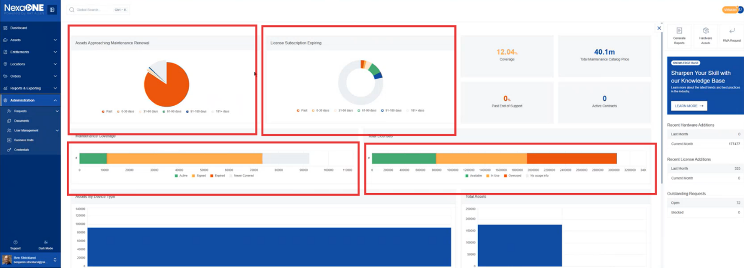
The widgets may display charts, graphs, tables, or other visual representations of data. These widgets provide a summarized view of key performance indicators (KPIs), data trends, and other important metrics.
Clicking on a widget will take you directly to the relevant data table by opening a new view or side panel displaying the detailed data related to the widget's summary.
The data table presents the raw data that the widget visualizes, allowing for in-depth analysis.

