Dashboard > Dashboard Overview
Upon successfully logging in, the first page you'll see is the dashboard. The dashboard serves as the central hub for accessing key information and functionalities within NexaONE.
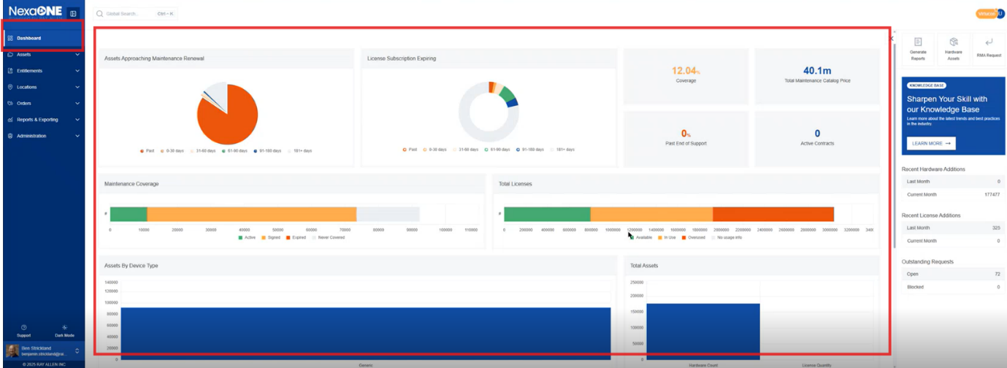
The dashboard typically contains various widgets and panels displaying summaries of data, performance metrics, and quick access links. Common elements include charts, graphs, tables, and quick action buttons for frequently used tasks.
There are three main sections: Menu System, Primary Work Pane, and Contextual Panel. Understanding these sections is crucial for navigating and utilizing the NexaONE platform effectively.
The dashboard is comprised of three main sections:
- Menu System: This menu allows navigation between different modules such as dashboard, assets, entitlements, locations, orders, reports, exporting, and administrative actions. The menu typically appears as a vertical or horizontal bar with icons and labels representing the different modules. The specific icons and labels will depend on the NexaONE configuration and your user role.
- Primary Work Pane: This central section displays the main content related to the currently selected view within NexaONE. This section will dynamically change based on the module or function you are currently using. For instance, if you're viewing the "Assets" module, the Primary Work Pane will display a list of assets, their details, and related actions.
- Contextual Panel: Located on the right-hand side, this panel shows additional information and options relevant to the current page. The contextual panel often includes filters, settings, and related data elements. For example, if you are viewing a report, the contextual panel might show filtering options, report settings, or related data points.
