Asset Management > View Licenses
Within Assets, the View Licenses tab gives you a clear view of your customer’s software and subscription licenses. From one place, you can confirm what’s active, see what’s nearing renewal, and trace each license back to the related asset or contract. This helps you stay ahead of renewals, catch coverage gaps early, and keep your customer environments properly licensed without digging through multiple systems.
Accessing the View Licenses Tab
- Navigate to the main menu.
- Select "View Licenses" from the menu options.
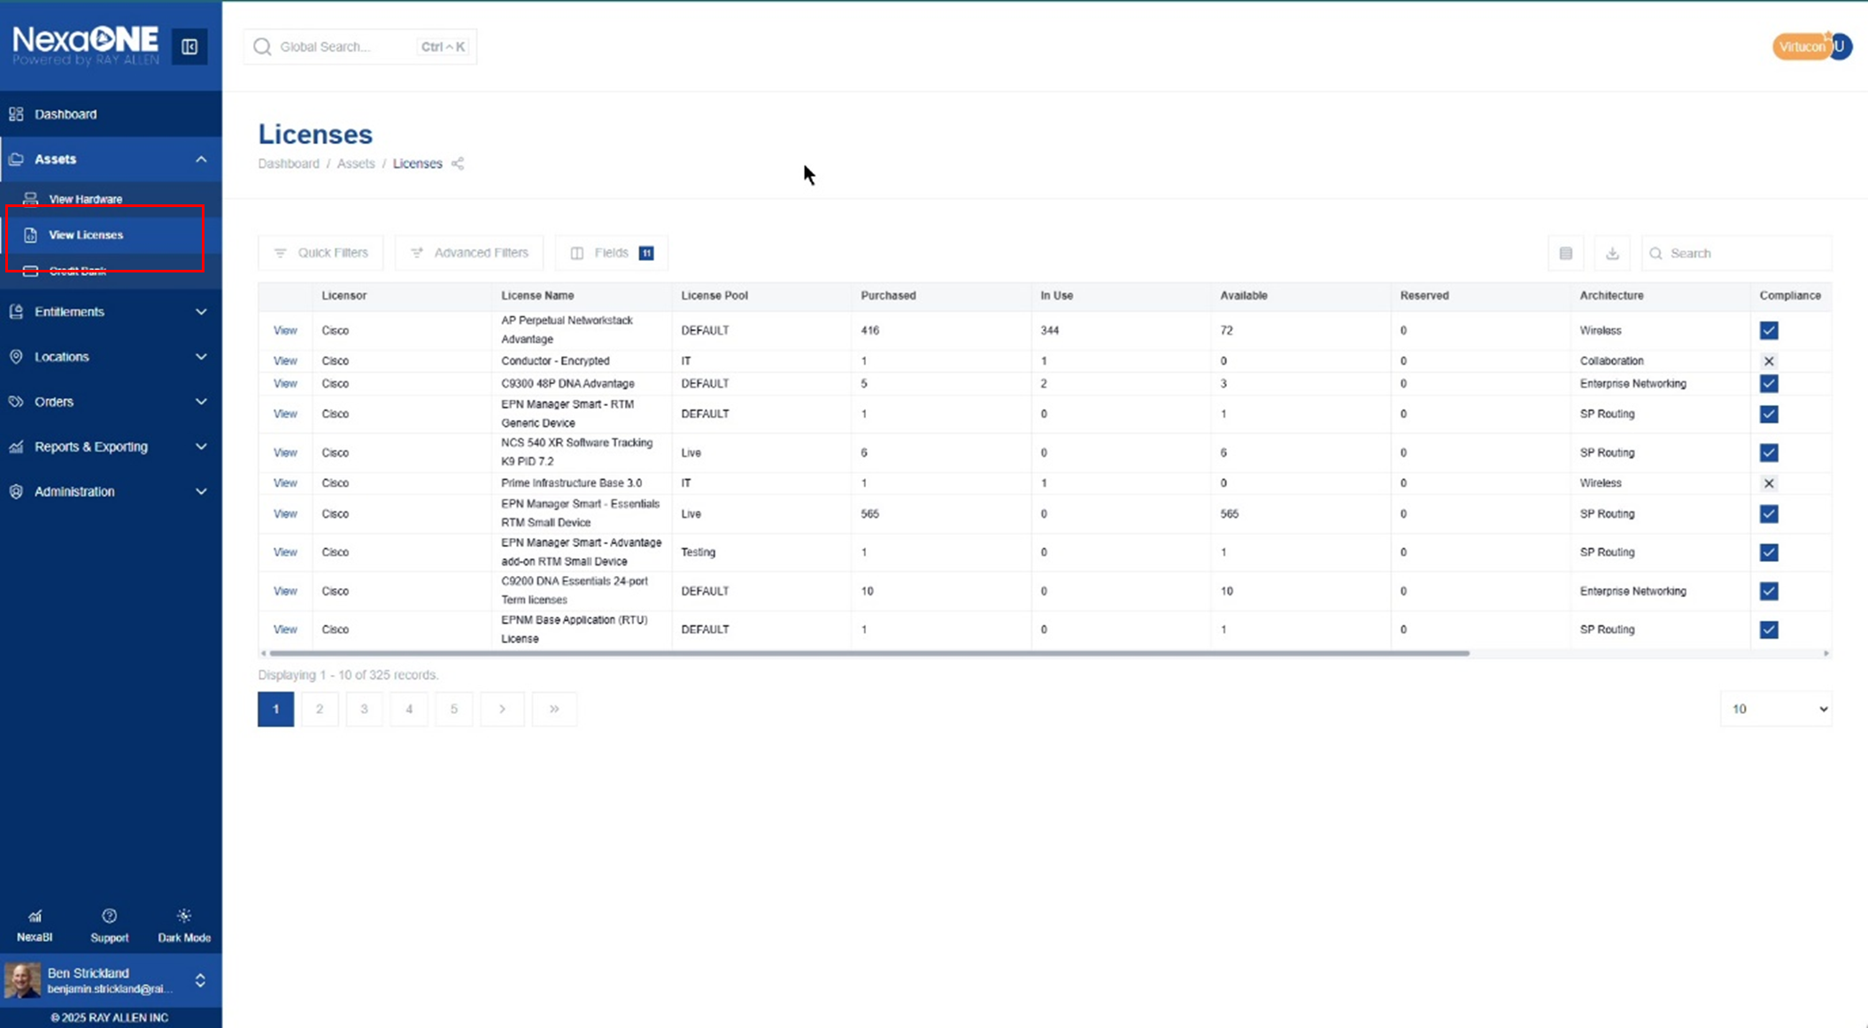

Understanding the Primary License Table
Upon accessing "View Licenses," you'll land on the primary table. This table provides a comprehensive list of all your licenses.
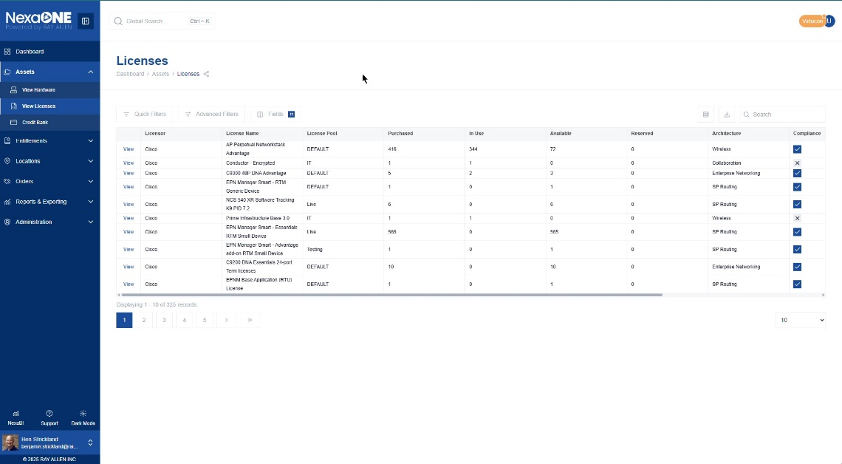
Adjusting the Number of Licenses Displayed: You can control how many licenses are displayed per page by selecting the desired number of entries from the dropdown menu at the bottom of the table. This allows you to view more or fewer licenses on a single page.
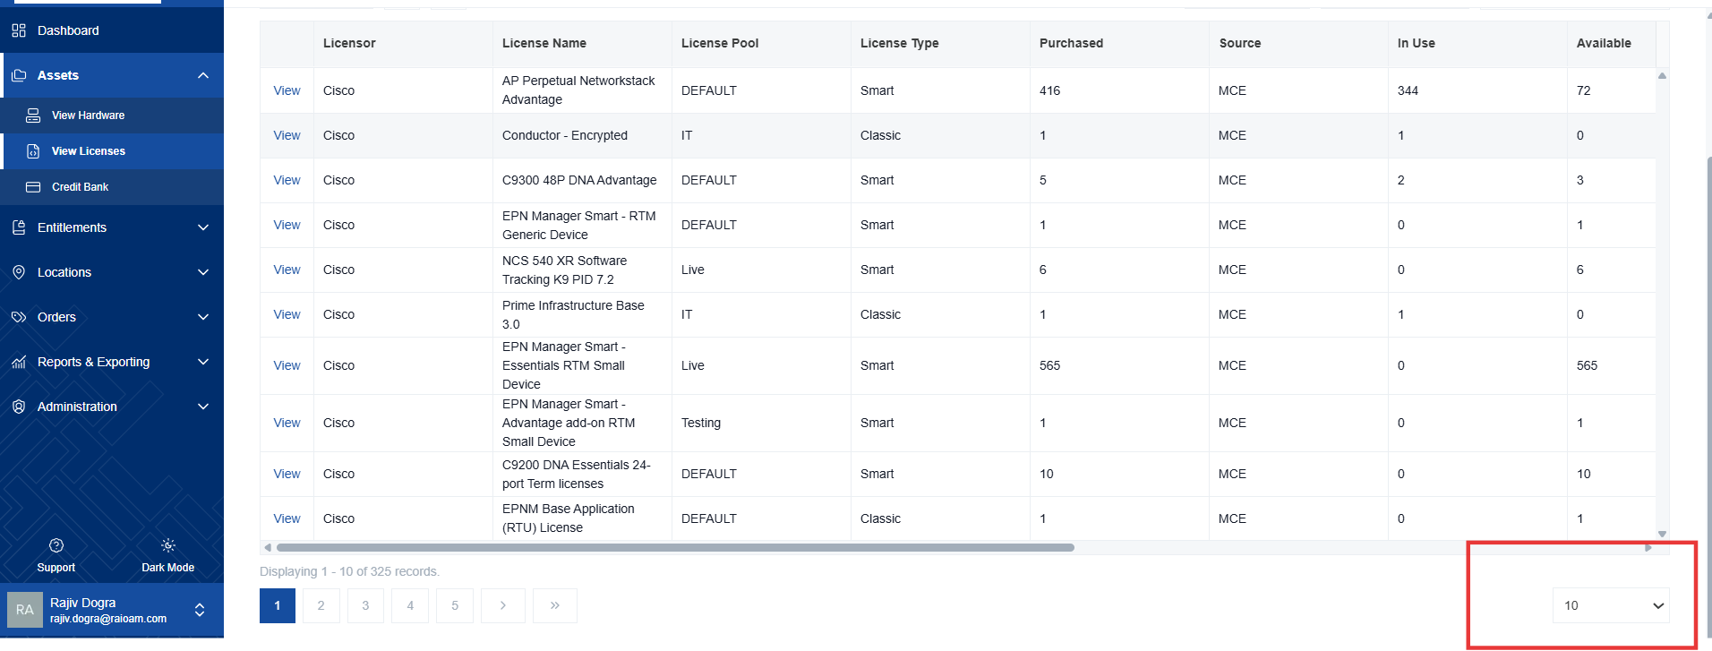

Filtering and Searching for Licenses
In NexaONE, you can use both search and filters to narrow down the list of licenses you see. The Search box above the table looks for any text that matches what you type, such as a product name, license key, or serial number. The Filter options (to the left of the Search box) let you focus on specific details, like Tenant, License Type, or Renewal Date. When you use them together, the search finds the right records, and the filters help you focus on just the ones that meet your exact criteria.

- Quick Filters: Use quick filters, located above the table, for rapid searches based on common criteria like license type or status.
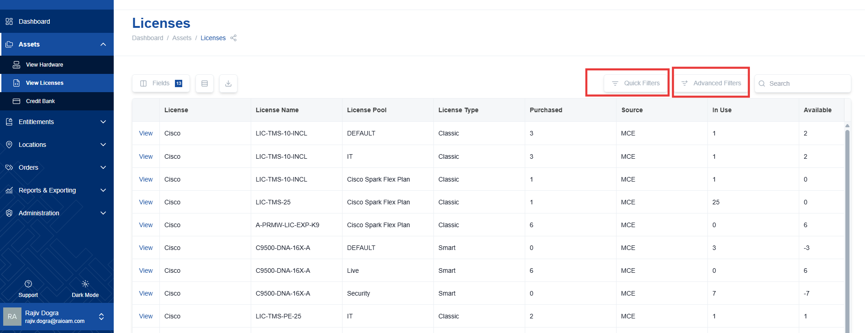
- Advanced Filters: For more complex and specific searches, utilize advanced filters.
  - Advanced filters employ Boolean logic (AND, OR, NOT) to create specific queries.
  - This allows you to combine multiple criteria to find exactly the licenses you need.
  - For example, you could search for "all Smart licenses that are expiring within the next 30 days."
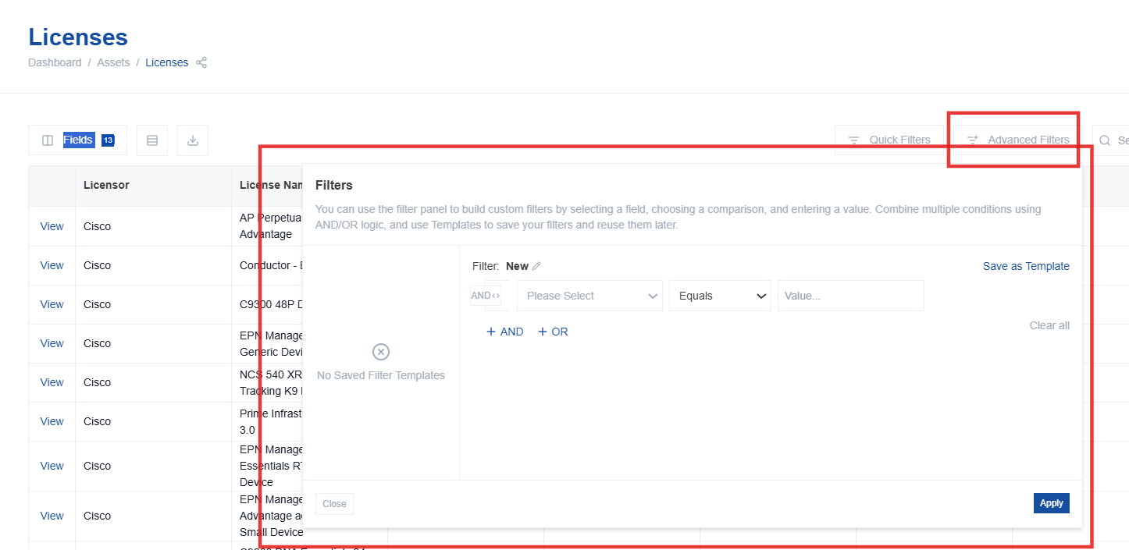

Customizing the License Table View
The Fields option lets you choose which columns appear in the License table so you can focus on the details that matter most to your work. For example, you might want to see Renewal Date and License Type when reviewing expirations or hide technical fields that aren’t relevant to you. By customizing the visible fields and their order, you can create a view that fits your role and makes it easier to spot the information you need at-a-glance.

- The Fields Button: Click the "Fields" button (located near the table controls) to modify the columns displayed in the table. This allows you to choose which data fields are visible and in what order.
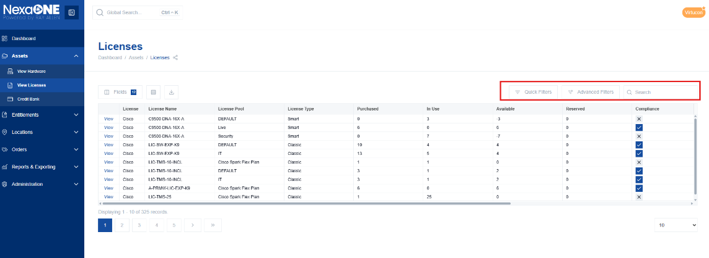
- Reorganizing Fields:
  - In the licenses page, upon clicking “Fields”, A pop-up window will appear, showing a list of available fields.
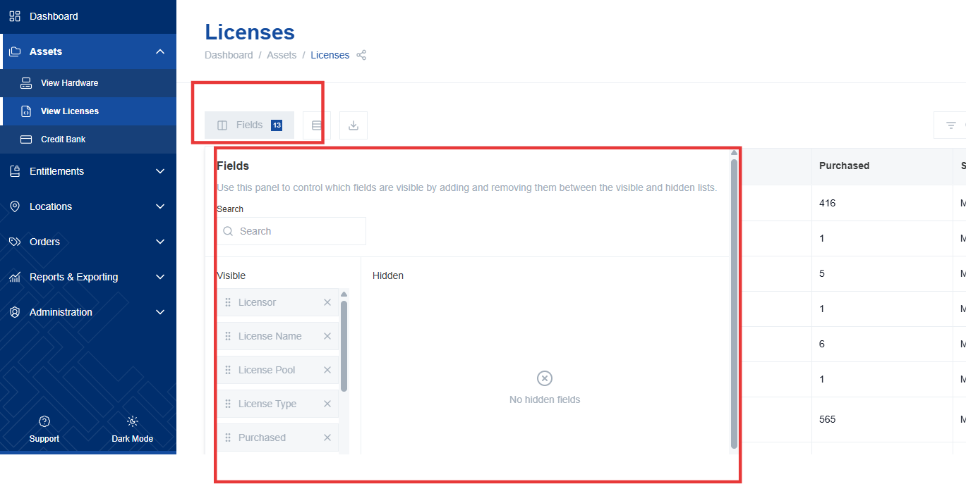

  - Drag and drop fields to rearrange their order in the table. The order in the pop-up window determines the column order in the table.
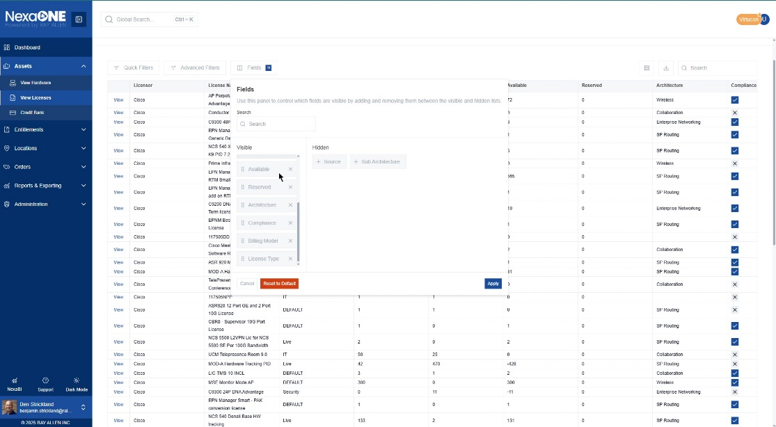

- Reset to Default: Revert to the default table configuration by clicking "Reset to Default" in the Fields customization window. This will restore the original column arrangement.
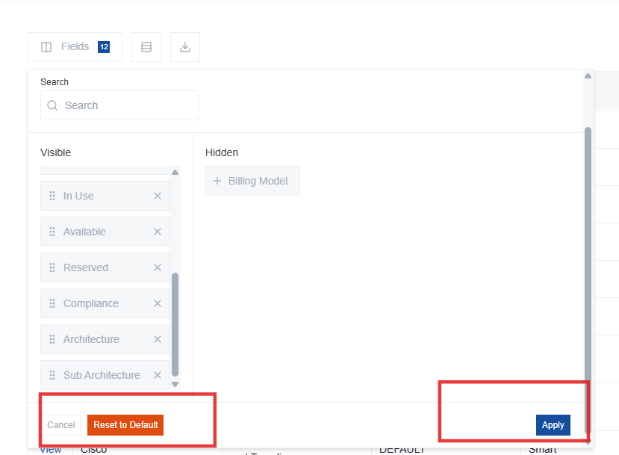
- Apply Changes: Save your changes and update the table view by clicking "Apply" in the Fields customization window.

