Asset Management > View Licenses > Details
The License Details page gives you a clear, practical view of how a specific license or group of licenses is being used. From here, you can quickly see totals, usage, and where coverage may be running low. Each section helps you understand whether your customer’s environment is licensed correctly and what actions you may need to take before renewal.
The top of the License Details page shows a summary of how the license is being used.
- Total Licenses – The total number of licenses you own for this product or license type.
- Licenses in Use – How many licenses are currently assigned to active devices.
- Licenses Substituted – Licenses covered by other, higher-level licenses. This can help identify when customers are using bundled coverage instead of direct licenses.
- Remaining Balance – The number of unused licenses still available for assignment.
Use of these totals allow you to spot compliance issues early. For example, if your customer is running low on available licenses or relying on substitutions, it may be time to plan renewals or purchase additional licenses.
Diving Deeper into Individual License Groupings
To get a complete picture of a license’s status, select the license you want to explore and open its Details page. This lets you drill into how it’s used, what’s available, and where you may need to act before renewals or coverage gaps occur. 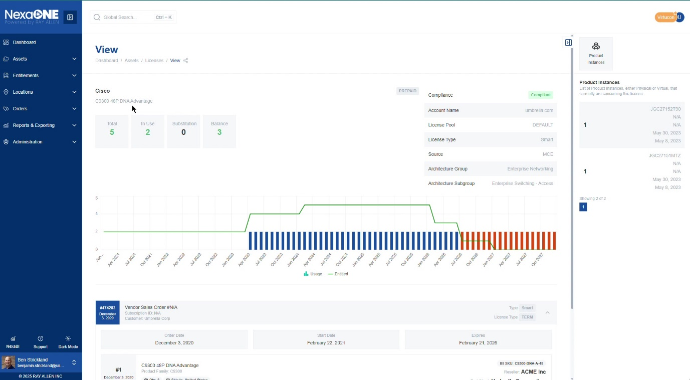

Understanding License Details
You open License Details when you need to confirm what your customer owns versus what’s in use. This view helps you spot shortages, substitutions, or unused licenses so you can plan renewals, true-ups, or reassignments, or to identify upsell potential.

- Quantity Overview: The top section of the license details page displays key quantity metrics, providing an overview of license usage:
  - Total Licenses: The total number of licenses you own for this specific license type.
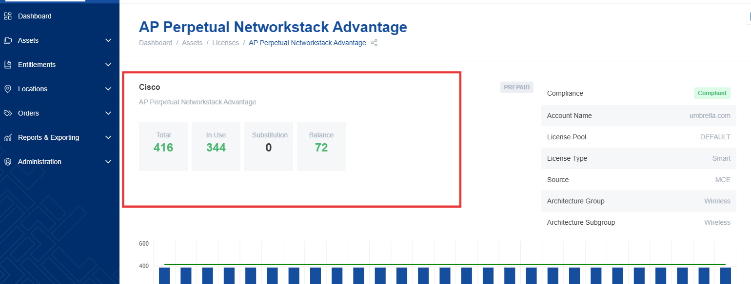
  - Licenses in Use: The number of licenses currently being used by devices in your network.
  - Licenses Substituted: The number of licenses that are being covered by other licenses (e.g., a higher-level license covering a lower-level one).
  - Remaining Balance: The number of licenses that are still available and not currently in use or substituted.
- License Information: This section displays key attributes of the license:
  - Account Name: The name of the account associated with the license.
  - License Pool: The license pool to which the license belongs (if applicable).
  - License Type: The type of license, such as "Smart" or "Classic."
    - Smart Licenses: These licenses are managed through a central licensing server.
    - Classic Licenses: These licenses are typically tied to specific devices.
  - Data Source: The source from which the license data is being retrieved.
- Architecture and Sub-Architecture: These fields provide additional information about the types of devices the licenses are compatible with, allowing you to understand the intended use of the license. For example, the architecture might be "Network Switches," and the sub-architecture might be "C9300 Series."

