Asset Management > View Licenses > Details > Product Instances
The Product Instances view gives you deeper insight into how a specific license is being used. From Asset Management > View Licenses > Details > Product Instances, you can move from a high-level list of licenses down to the exact devices consuming them—turning basic license data into actionable usage insight.

Examining Product Instances
The Product Instances tab helps you see exactly which customer devices are using a license and how many copies each device is consuming. This view gives you proof of usage at the device level so you can confirm entitlements, catch overuse before it becomes a compliance issue, and make sure every license you’ve sold is tied to an active asset. It’s the quickest way to understand where each license is deployed and how it’s being used in real time.

- Product Instances Tab: Locate the "Product Instances" tab on the right-hand side of the license details page to see a list of devices currently using the selected license. This tab provides a device-level view of license consumption.
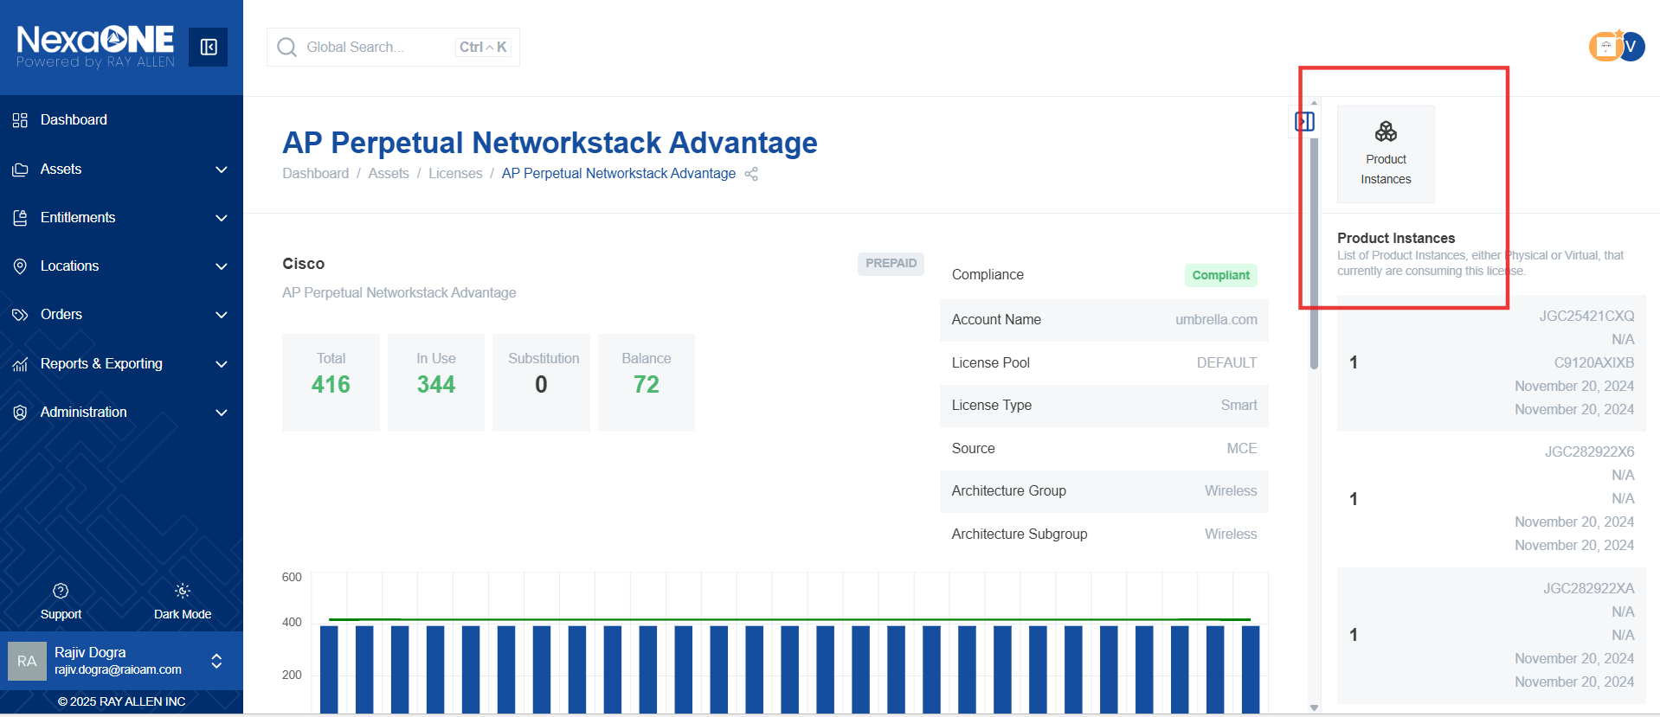
- Device Details: The list shows each device and the number of licenses it is consuming. This helps you identify which devices are using specific licenses and how many they are using.
- Navigating to Device Details: Click on the serial number of a device in the "Product Instances" tab to access that device's information in the asset table. This allows you to view more details about the device itself.
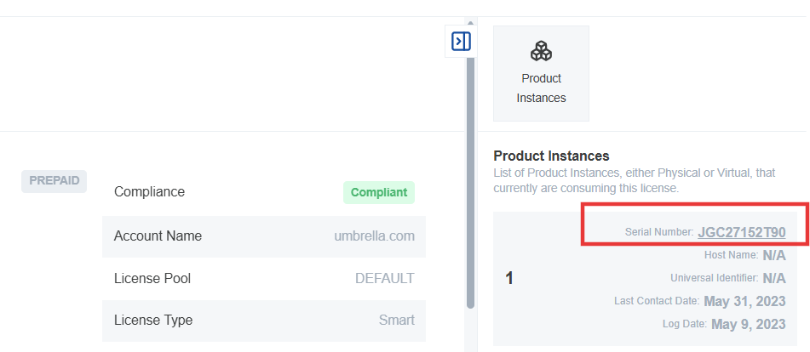
- Additional Identifiers: Other identifiers, such as the hostname of the device, may also be displayed in the "Product Instances" tab to help you identify the devices using the license.
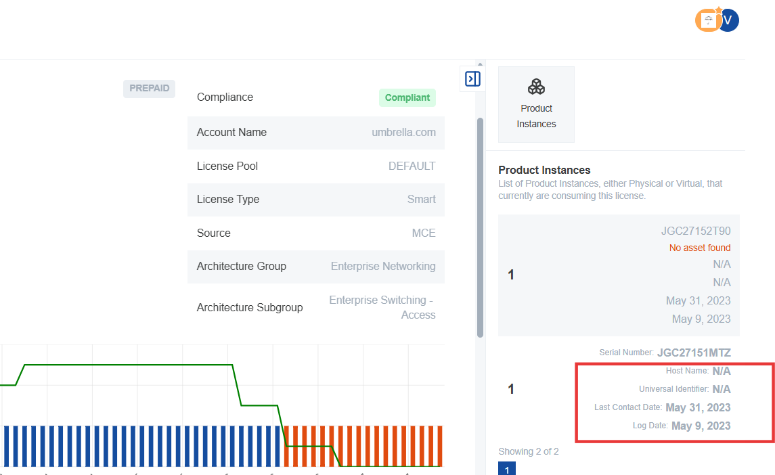
- Last Contact Date: This indicates the last time the device registered with the licensing server as using the license. This can be useful for troubleshooting licensing issues.
- Log Date: This shows the date when the device first started using the license.
License Sources
The License Sources section shows where each license came from — whether it was part of a customer order, an enterprise agreement, or another procurement channel. This helps you trace every license back to its origin, validate coverage dates, and line up your internal order history with what your customer or distributor shows. When renewal season comes around, you can quickly confirm quantities, start dates, and expirations without digging through multiple systems.

- License Sources Section: Scroll to the bottom of the license details page to find information about the sources of your licenses. This section provides information about how you acquired the licenses.
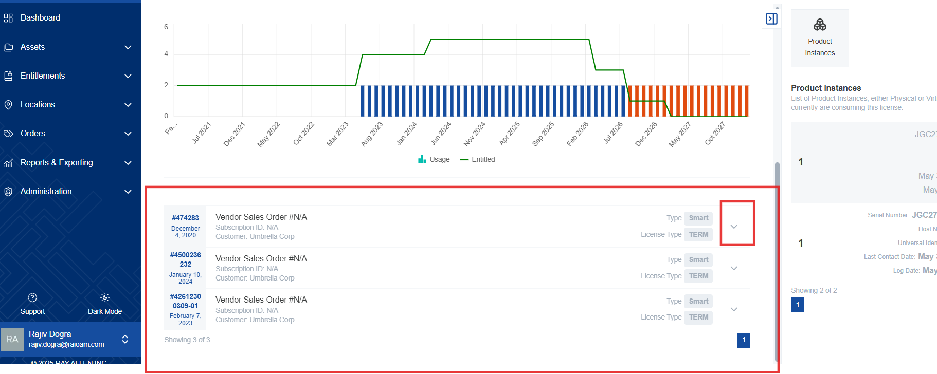

- Order Details: Expand individual sources to view details about the orders in which the licenses were received, including:
  - Order Date: The date the order was placed.
  - License Start Date: The date the licenses became valid.
  - License Expiration Date: The date the licenses will expire and no longer be usable.
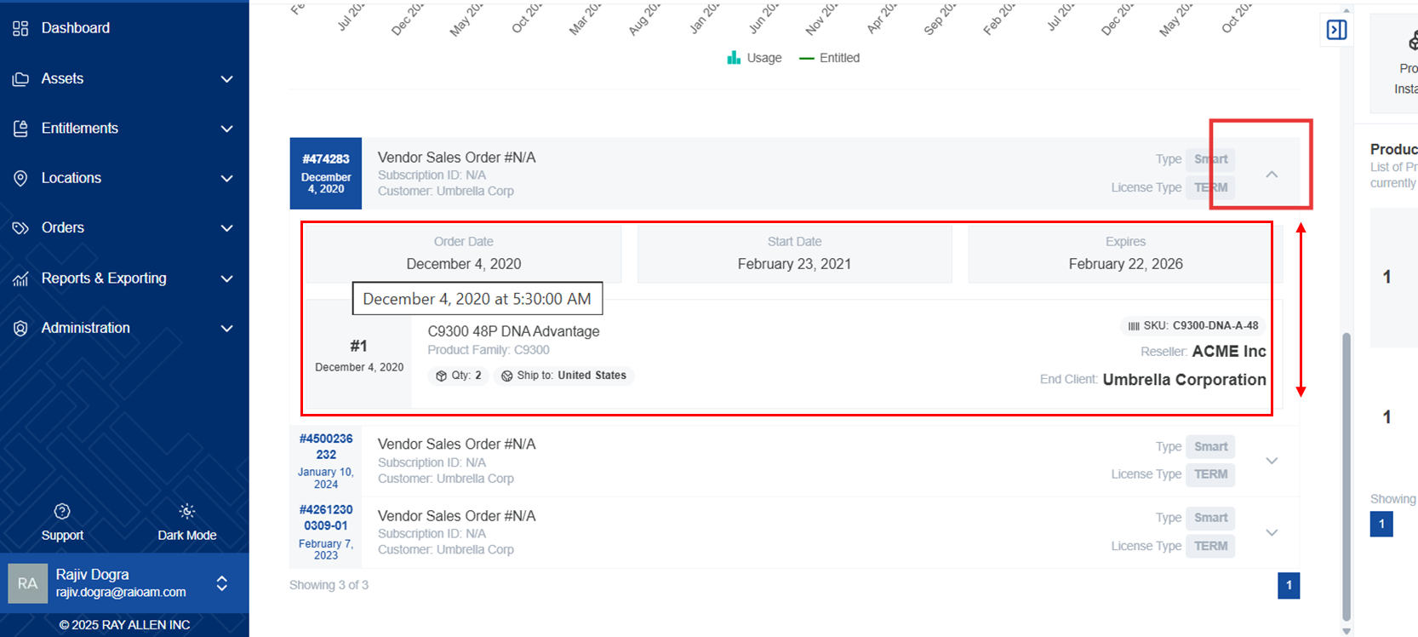
  - SKU Information: The SKU (Stock Keeping Unit) number used to purchase the license is also provided. This is useful for tracking and managing your licenses.
  - Quantity and Country: View the quantity of licenses included in the order and the intended country of use. This information may be needed for taxation or compliance purposes.

License Utilization Chart
The License Utilization Chart gives you a simple, visual way to track how your customers are using the licenses you’ve provided. The green line shows what’s owned, and the blue bars show what’s in use. When the two start to close together, you know it’s time to talk to your customer about renewing or adding more. If the blue bar ever climbs higher than the green line, you can act before it becomes a compliance issue. It’s an easy way to stay proactive and protect both your customer’s operations and your business.

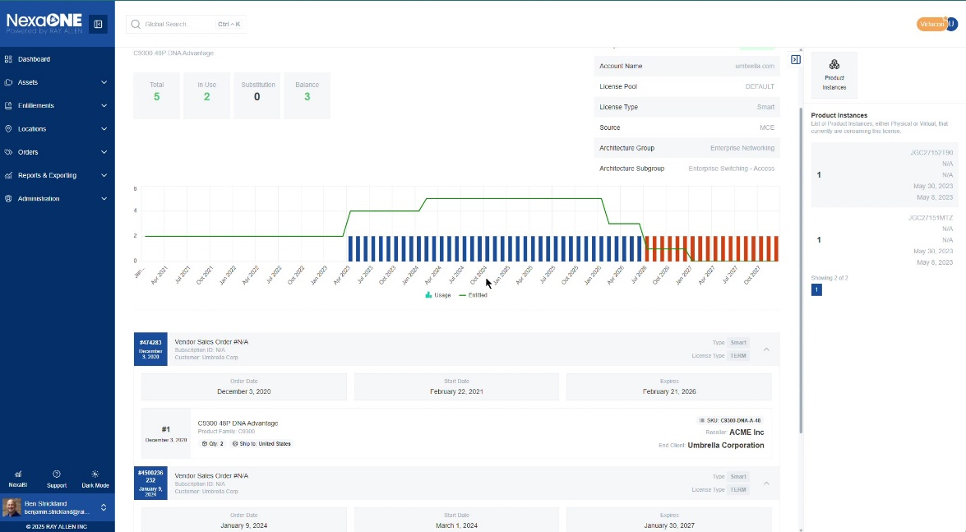
- Green Line (Ownership): The green line indicates the number of licenses you own.
  - This line increases when you place new orders for licenses.
  - This line decreases when licenses expire.
- Blue Bars (Utilization): Blue bars represent the actual number of licenses being used at any given time.
  - As long as the green line is above the blue bars, you have more licenses than you need and are in compliance.
- Out-of-Compliance Indication: If the blue bar exceeds the green line at any point, you are in an out-of-compliance state, meaning you are using more licenses than you own.
- Renewal Alert: The bars will turn orange to indicate that you need to renew your subscriptions or purchase additional licenses before the specified date to avoid service disruptions or compliance issues.

