Asset Management > View Hardware
This guide provides a step-by-step walkthrough of the "View Hardware" page within NexaONE's Asset Management module. It covers how to access hardware information, customize the displayed data, and understand the details associated with each asset. This guide is designed to train new NexaONE users and help them effectively manage their hardware assets.
Accessing View Hardware
Purpose: To navigate to the list of hardware assets within NexaONE.
- In the left sidebar, from the main menu, hover over "Assets".

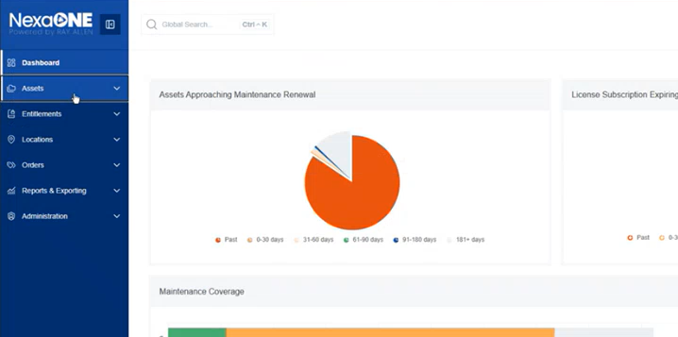

- Click on "View Hardware". This will display a tabular list of all hardware assets in the system.

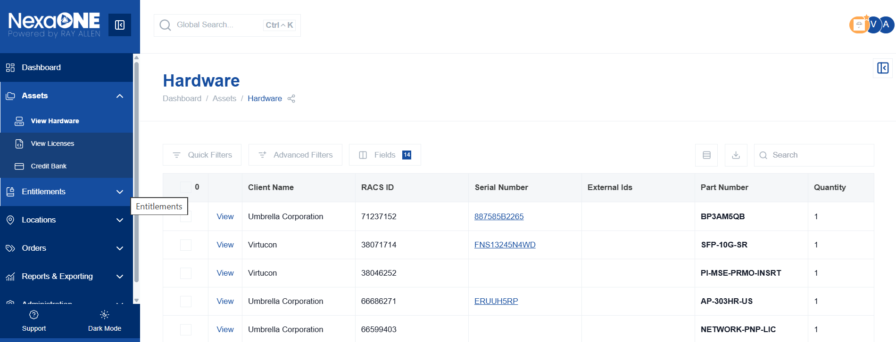

The table is both customizable and filterable.
Hardware List Page Overview
The Hardware List page presents a customizable table of all hardware assets. Below are some of its features/ options and their relevance.
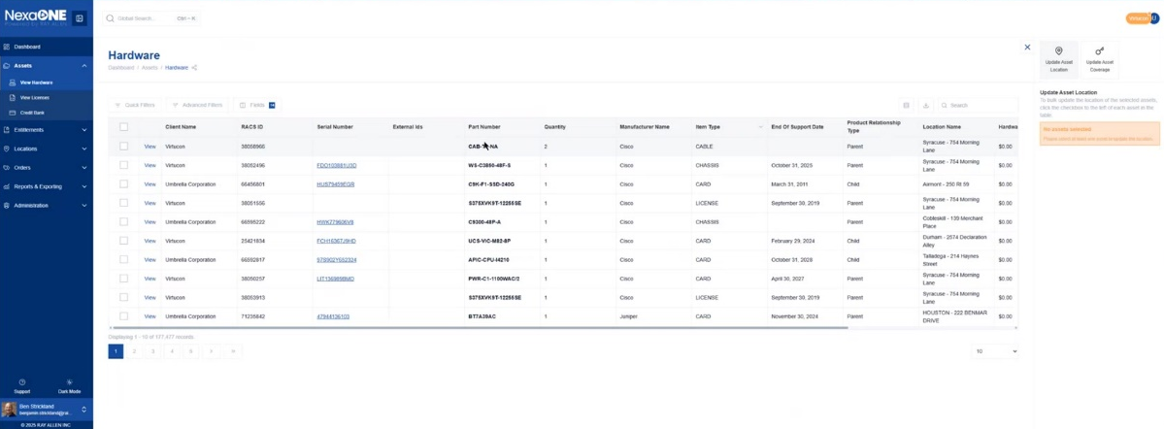

Breadcrumbs
Purpose: To understand the current location of content within the NexaONE system.
- The breadcrumbs at the top of the page show the navigation path: Dashboard > Assets > Hardware.

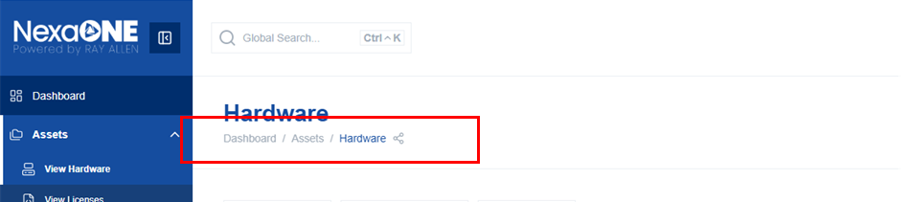

Share Button
Purpose: To generate a direct link to the current page for sharing with other users.
- Click the "Share" button, just after bread crumb menu to create a direct link to the current hardware list view.
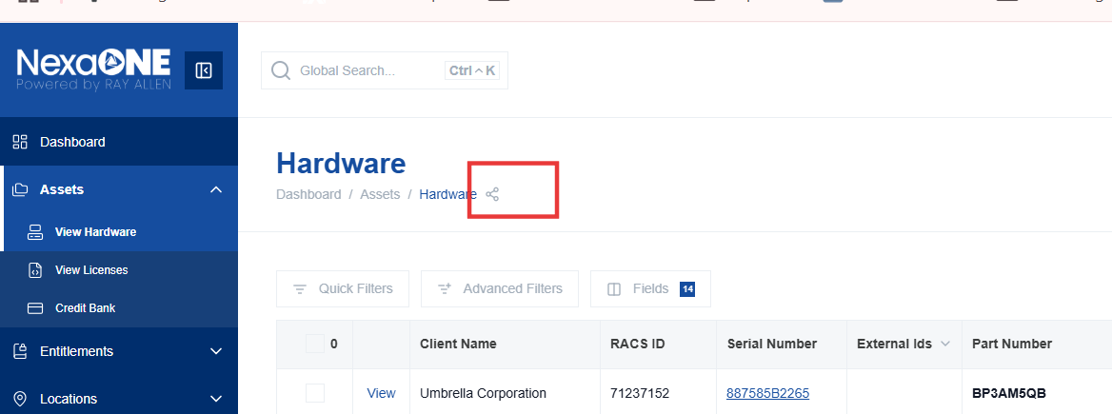

Quick Filters
Purpose: To quickly search for assets based on specific criteria.
- Use the "Quick filters" to search for items based on specific items.
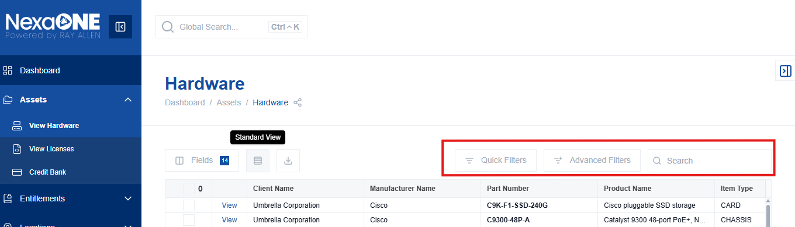

Advanced Filters
Purpose: To create complex filtering rules for searching assets.
- "Advanced filters" allows building complex logical queries based on any field. These filters can be saved as templates for later use.

Fields (Column Customization)
Purpose: To customize the columns displayed in the hardware list.
- Click on "Fields" to open the column customization panel.
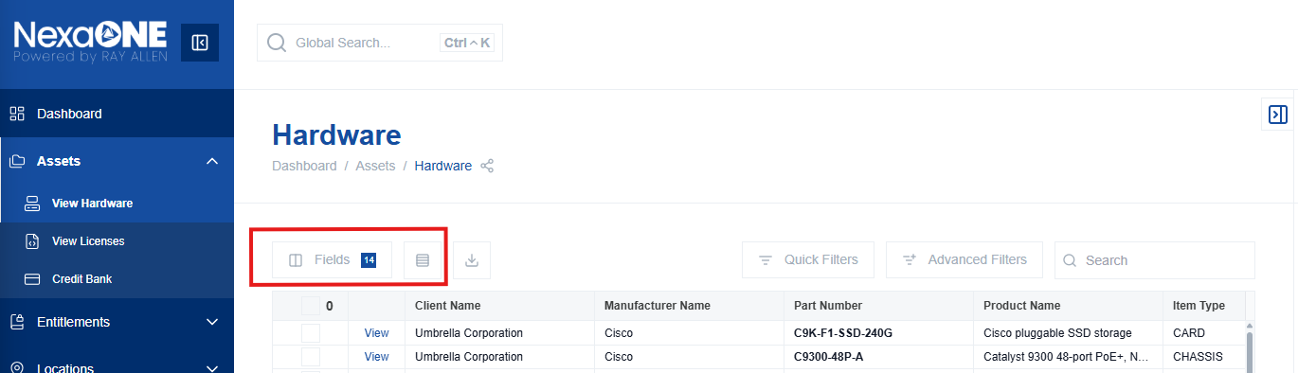

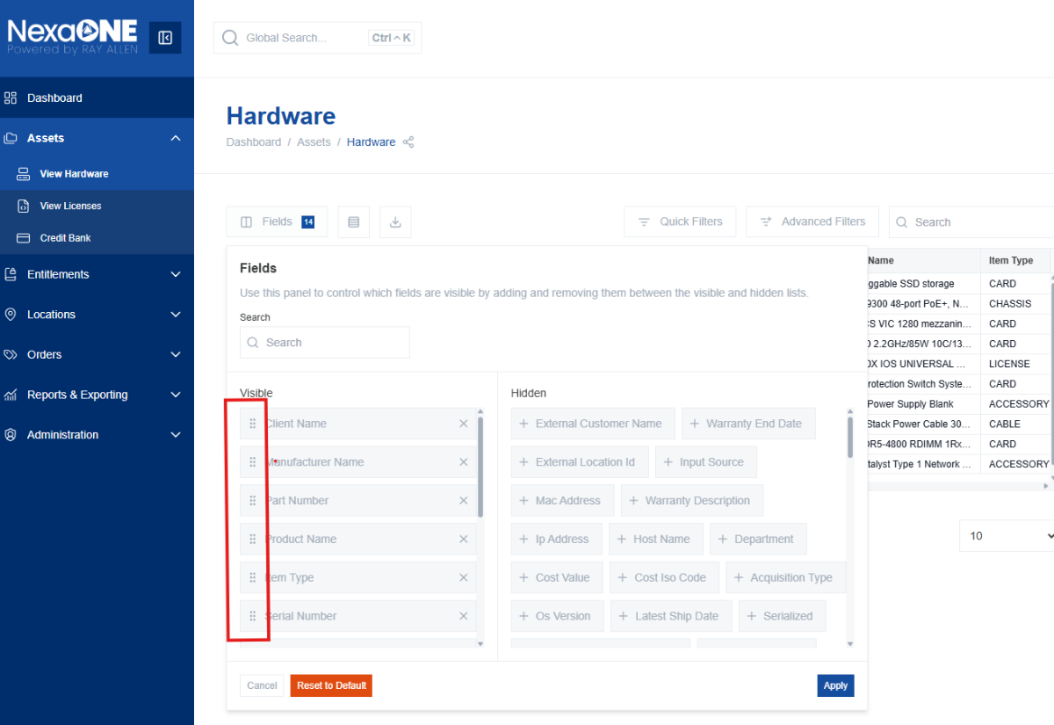
- Rearrange Fields: Click and drag the six dots icon to move a field to a new position in the table.
**Relevance:** This allows you to prioritize the information most relevant to your needs.

- Remove Fields: Click the "X" icon on a field to remove it from the table.

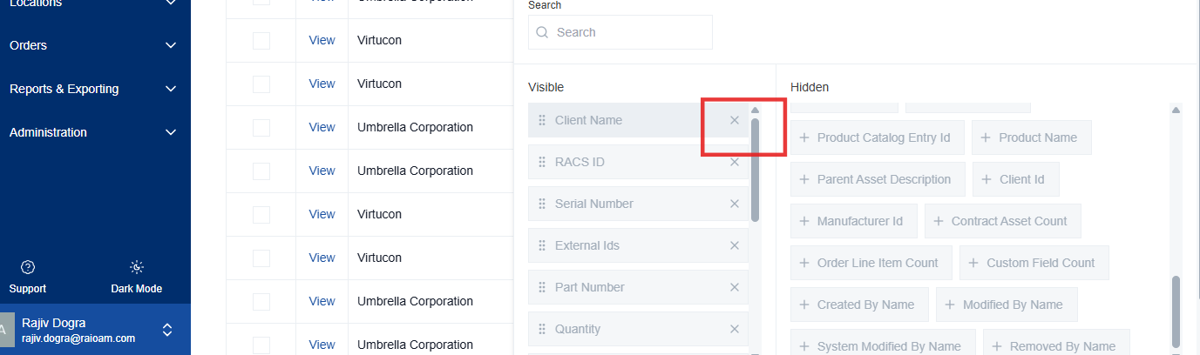

**Relevance:** This declutters the view by removing unnecessary information.
- Add Fields: Click the "+" icon to add a new field to the table.

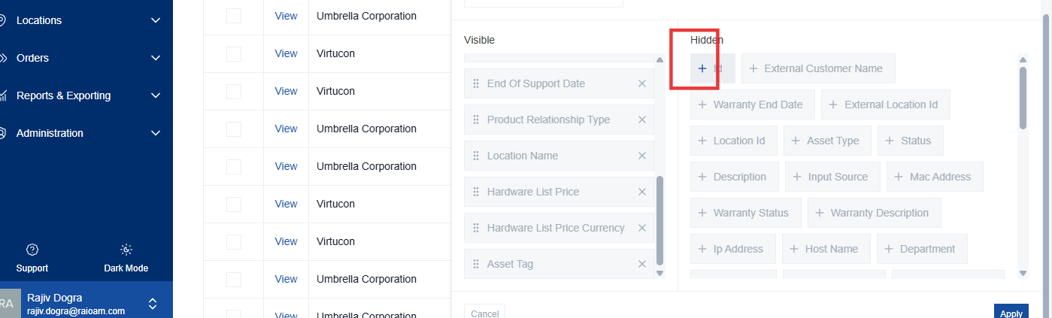

**Relevance:** This allows you to display additional information about the assets.
- Reset to Defaults: Click "Reset to Defaults" to revert to the original column configuration.
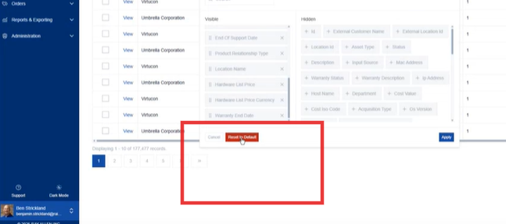
**Relevance:** This is useful if you want to undo your customizations and start over.
- Cancel: Click "Cancel" to discard any changes made.

Applying Changes
Purpose: To save the column customizations.
Steps:
- Click "Apply" to save the changes made to the column configuration.

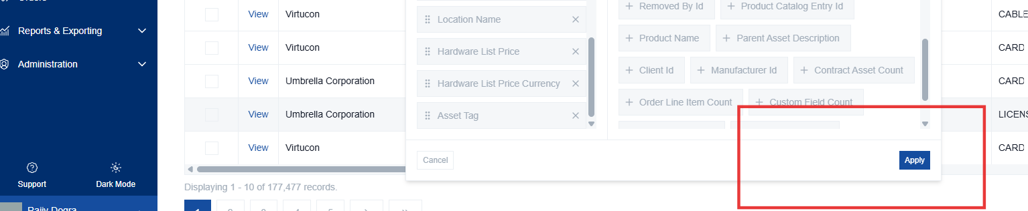
Selecting Items and Display Options
Purpose: To filter and display hardware assets.
Steps:
- Filter Items: Select items by clicking on them.
- Items per page: Choose to display 10, 20, 50, or 100 items per page.
