View Hardware > Fields Customization (Column Customization)
Purpose: To customize the columns displayed in the hardware list.
Click on "Fields" to open the column customization panel.

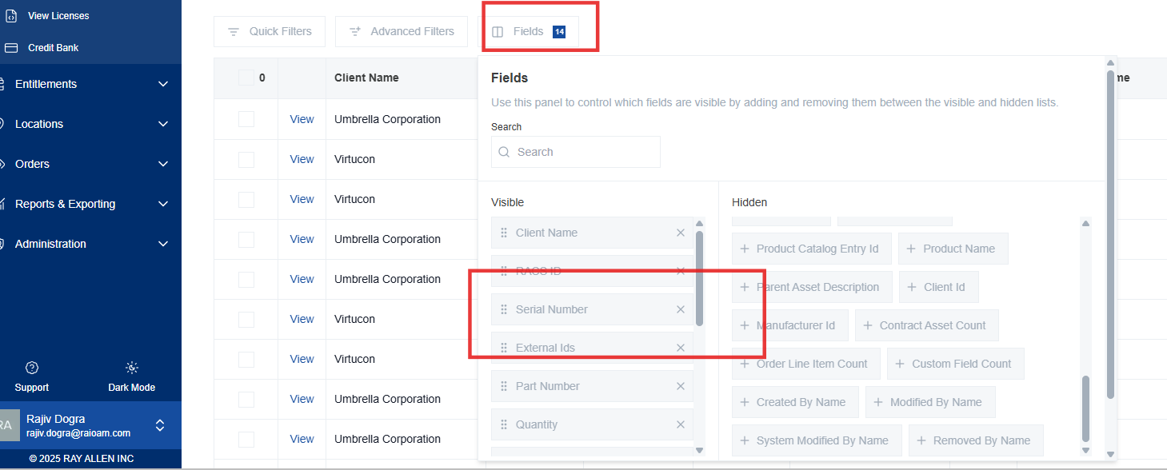
Rearrange Fields: Click and drag the six dots icon to move a field to a new position in the table.
**Relevance:** This allows you to prioritize the information most relevant to your needs.

Remove Fields: Click the "X" icon on a field to remove it from the table.

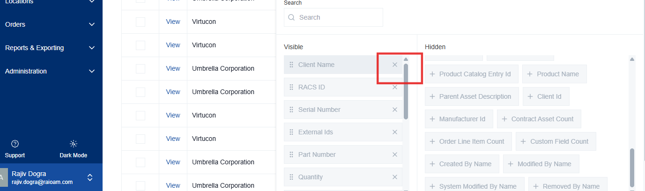

**Relevance:** This declutters the view by removing unnecessary information.

Add Fields: Click the "+" icon to add a new field to the table.

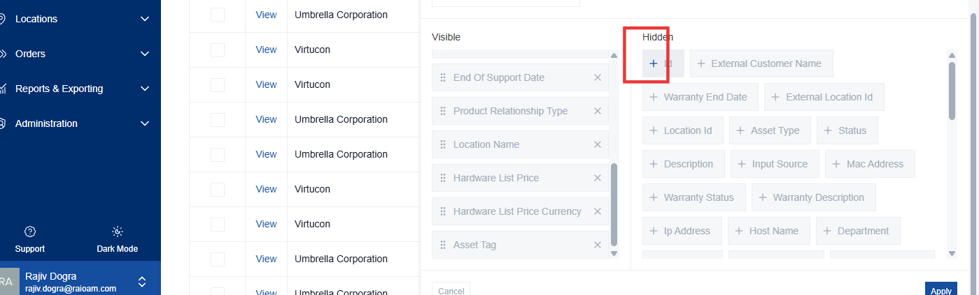
**Relevance:** This allows you to display additional information about the assets.

Reset to Defaults: Click "Reset to Defaults" to revert to the original column configuration.
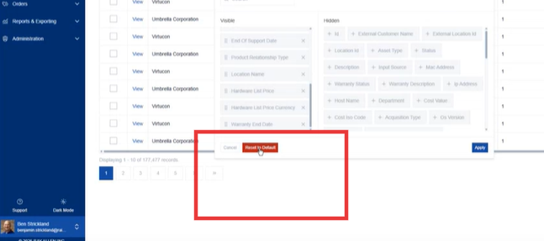
**Relevance:** This is useful if you want to undo your customizations and start over.
Cancel: Click "Cancel" to discard any changes made.

