Asset Management > View Hardware > Details

Purpose: To view detailed information about a specific hardware asset.
Accessing Asset Details
Steps:
- On the side bar click Assets > View Hardware
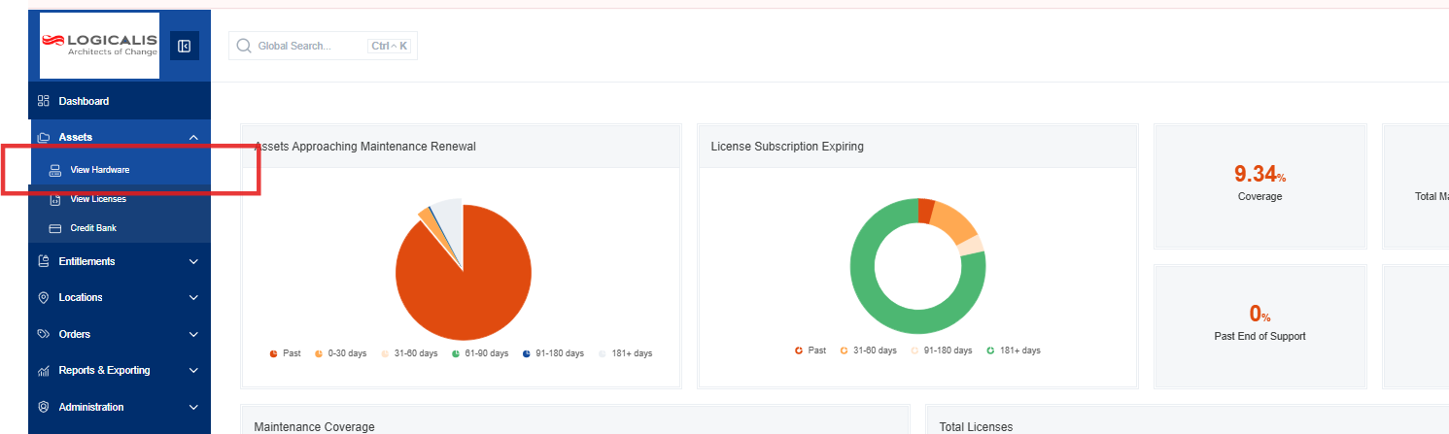
- In the Hardware List, click the "View" button next to the asset you want to inspect.
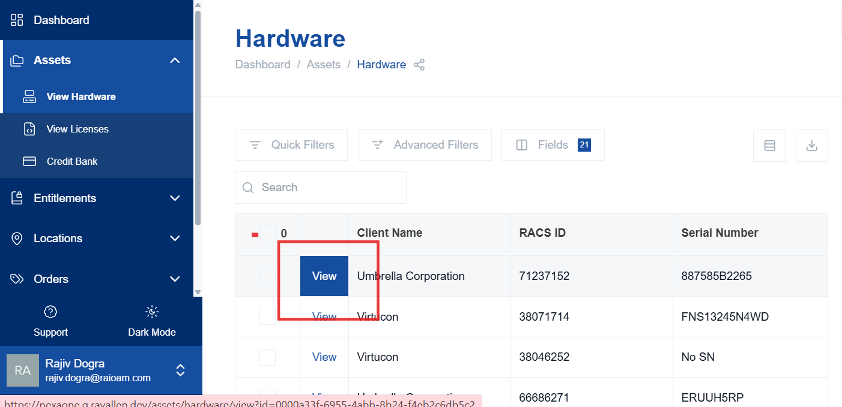
Details Tab
Purpose: To view basic information about the selected asset.
The "Details" tab provides information about the device, including:
- Part Number
- Manufacturer
- Description
- Image (if available)
- Current Status (e.g., in service, out of service)
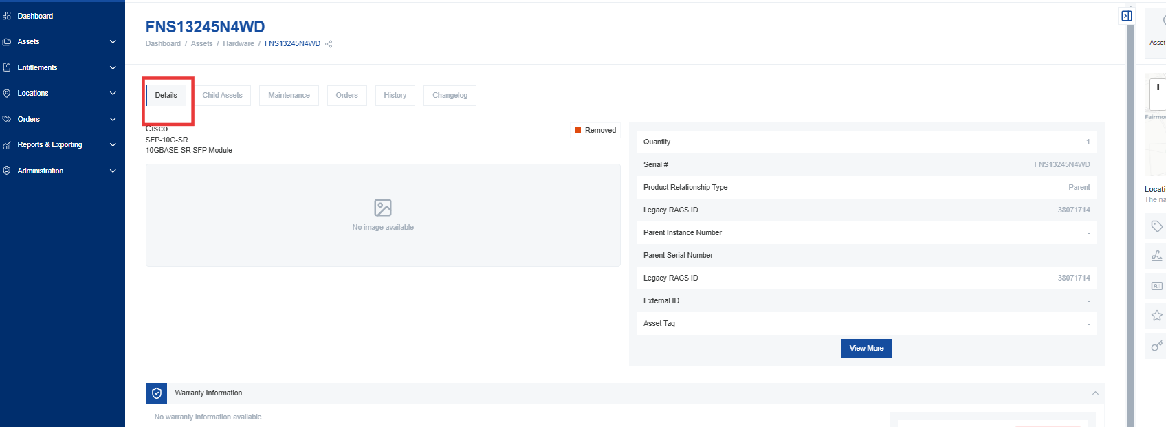
Associated Items
Purpose: To view a list of additional items associated with the device.
The right-hand side of the "Details" tab displays a list of associated items, including:
- Quantity
- Serial Number
- Product Relationship Type (parent, child, or standalone)
- RACS ID (unique identifier within the system)
- Parent Instance ID (link to the parent asset, if applicable)
- Parent Serial Number
- External ID (OEM's unique identifier)
- Asset Tags
- GUID (customer identifier based on the OEM)
- Global Name
- Business Sector
- Cost Accounting Codes
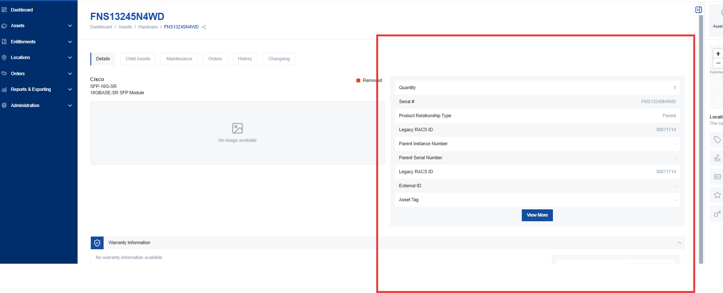

Additional Information
Purpose: To view warranty, networking, cost, and custom field information.
The "Details" tab also includes expandable sections for additional information:
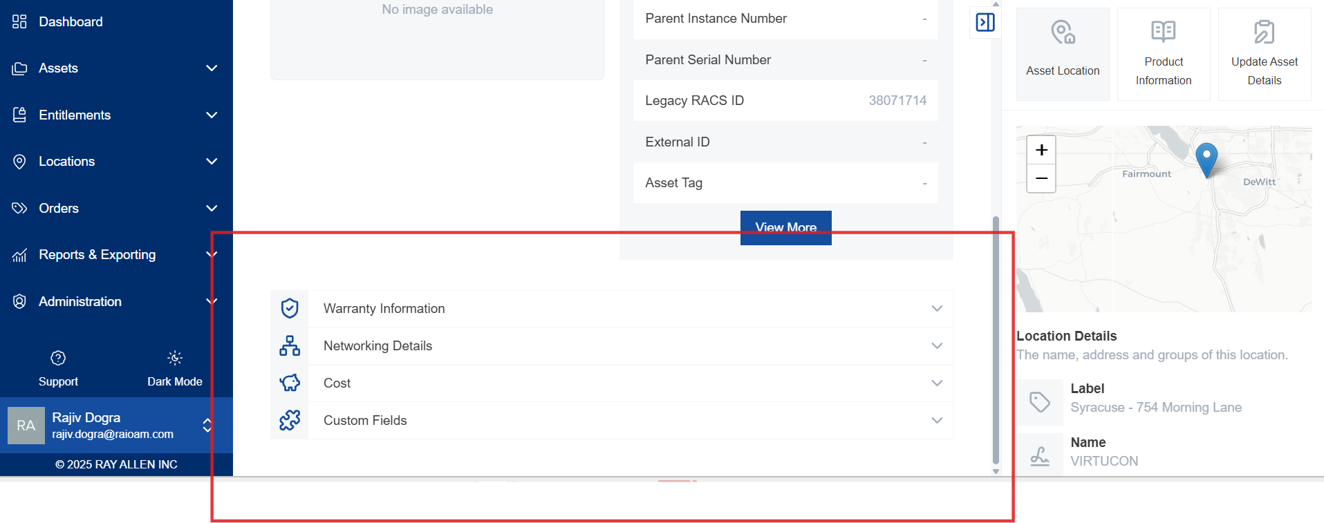
Warranty Information
- Displays the current warranty information for the asset, including the warranty status and end date.
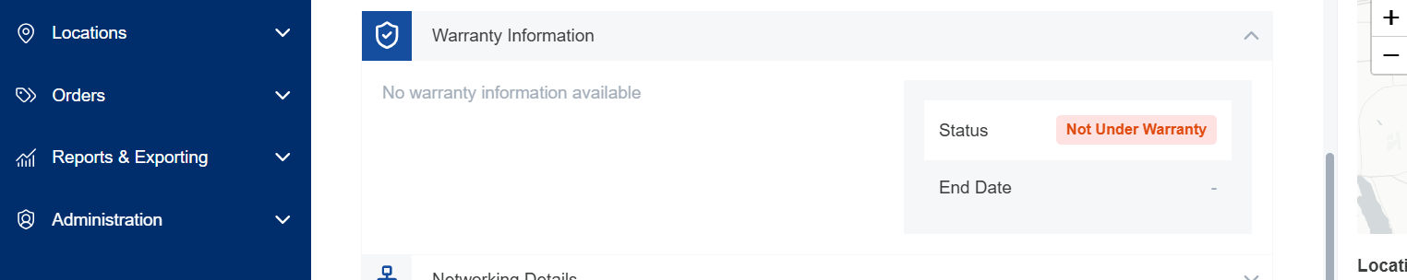
Networking Details
- Displays collector information about the asset, such as DNS name, IP address, and MAC address.
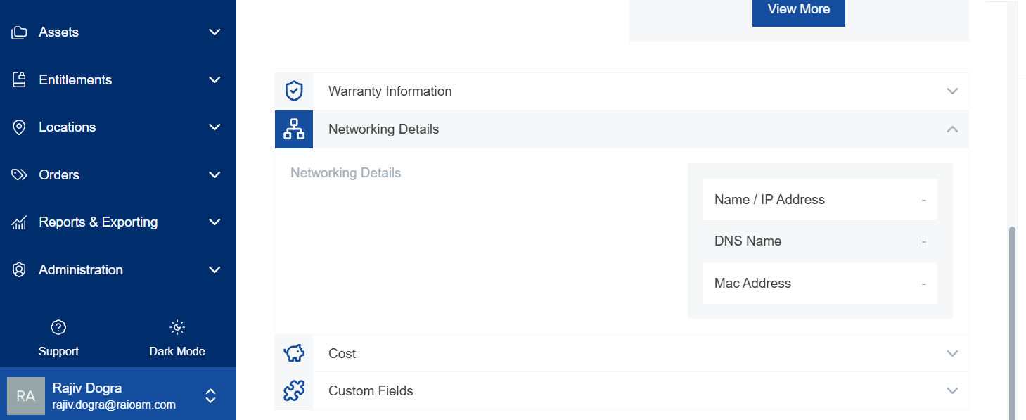
Cost
- Displays any costing details stored for the asset.
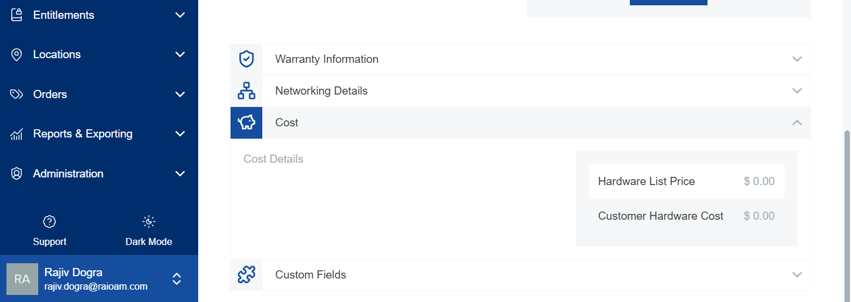
Custom Fields
- Allows you to add additional elements to any asset. Examples include department budget code and department asset retirement date.
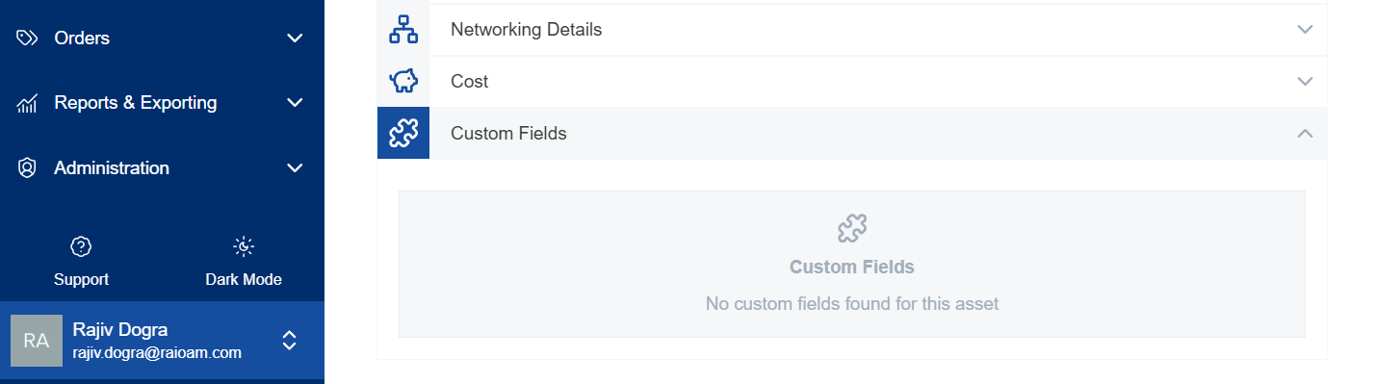
**Relevance:** This allows you to track information specific to your organization's needs.
Asset Location
Purpose: To view the physical location of the device.
- The contextual bar displays a map of where the device is physically located.
- This includes site ID, customer name, physical address, location groups, and external location names.
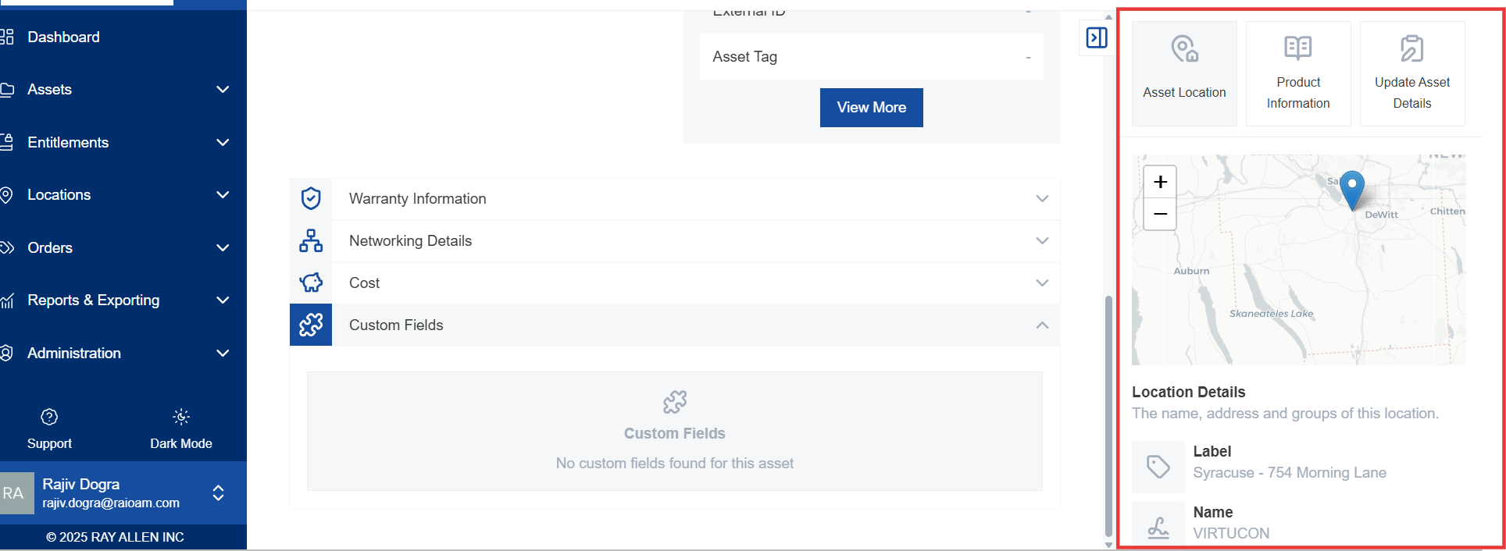

Product Information
Purpose: To view detailed information about the product.
- The "Product Information" tab provides even more information about the product.
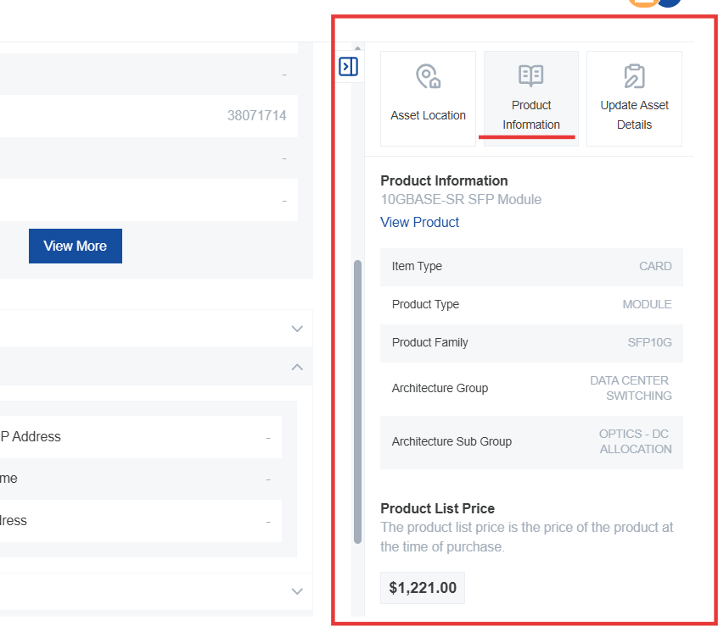

Item Type
- Specifies the type of item, such as chassis, line card, cable, or standalone device.
Product Type
- Provides more information about the type of architecture.
Product Family
- The OEM-defined product family that belongs to this device.
Architecture and Sub-Architecture Group
- Helps in organizing devices. For example, a switch might belong to "enterprise switching" and "enterprise switch access."
End-of-Life Information
- Displays end-of-life dates, including:
  - End of Maintenance Attachment Date: When you can no longer add maintenance to a product.
  - Maintenance Renewal: When you can no longer renew a previously existing maintenance contract.
  - End of Security: When the device no longer receives security vulnerability fixes.
  - End of Software Availability Date: When the device stops getting other maintenance patches or fixes which are not security in nature.
  - End of Software Maintenance Date: When you stop getting patches or bug fixes on that particular product.
  - End of Support Date: When you can no longer call the OEM for support.
  - End of Life Notification Date: When the end-of-life notification was last posted.
  - Link to OEM Page: Direct link to the OEM page discussing the end-of-life information.
  - Notification Number: The notification number for searching purposes.
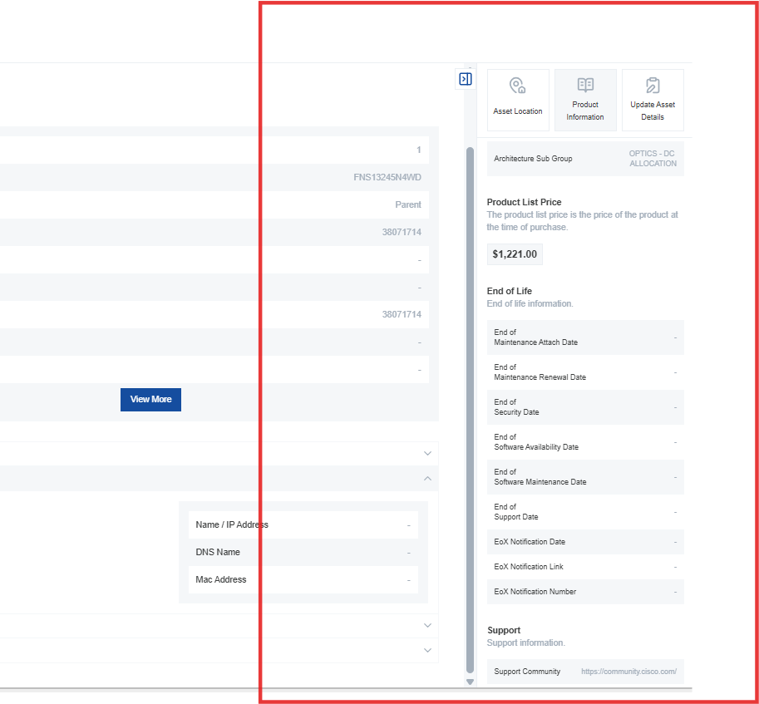

Support Information
Purpose: To access manufacturer's support resources.
- The bottom of the "Product Information" tab provides links to:
  - Manufacturer's Support Community
  - Product Support Page
  - Standard Out-of-the-Box Warranty Information
