Asset Management > View Hardware > Details > Maintenance
From side bar menu navigate to Assets then click Hardware. This will show the hardware list. Click on the view link for the specific asset, this will open the specific asset details.
- Click on the "Maintenance" tab. This tab allows you to see any maintenance contracts linked to the asset.
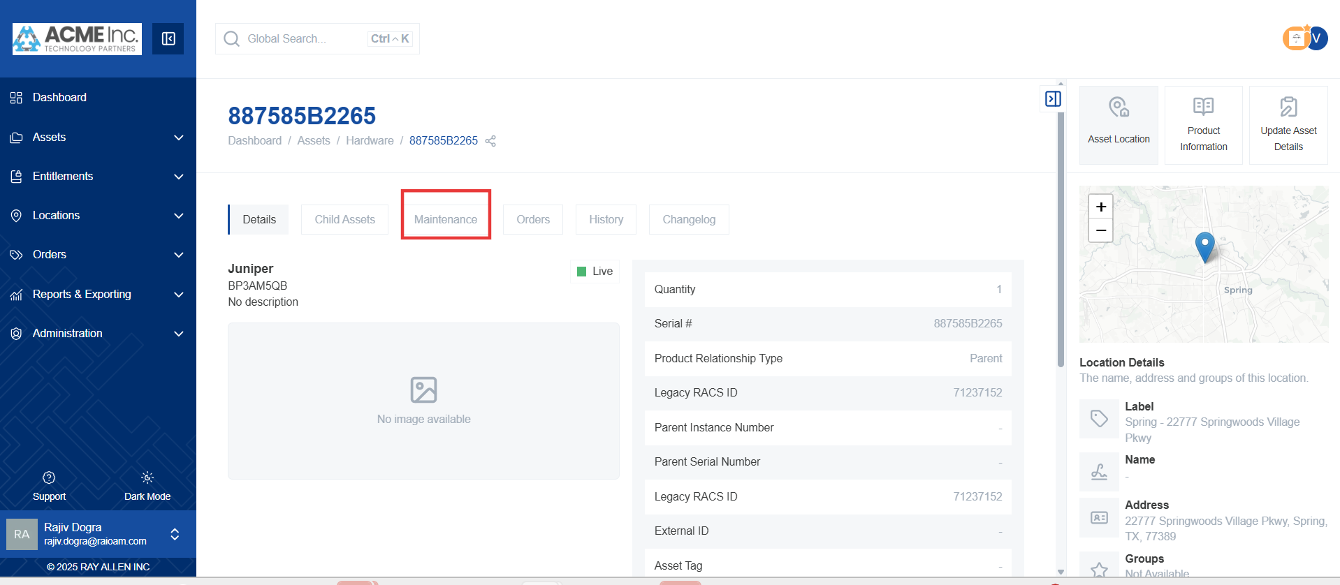

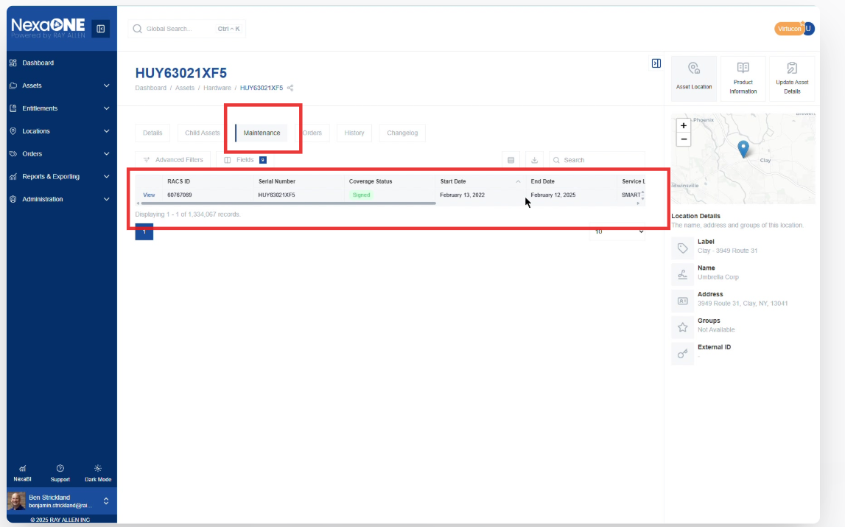
- This tab displays any contracts associated with the asset.
  - Contract start and end dates. These dates define the period the contract is valid.
  - Service level. The service level specifies the level of support provided under the contract.
  - Service type. This specifies the type of service covered by the contract.
  - Service provider. This identifies the company or organization providing the service.
- You can manage the fields as needed. This allows you to update the information related to the maintenance contract.
- You can also export this data. This enables you to create a record of the contract details for offline use.

