Asset Management > View Hardware > Details > History
From side bar menu navigate to Assets then click Hardware. This will show the hardware list. Click on the view link for the specific asset, this will open the specific asset’s details.
- Click on the "History" tab. See history of the changes made for this asset.
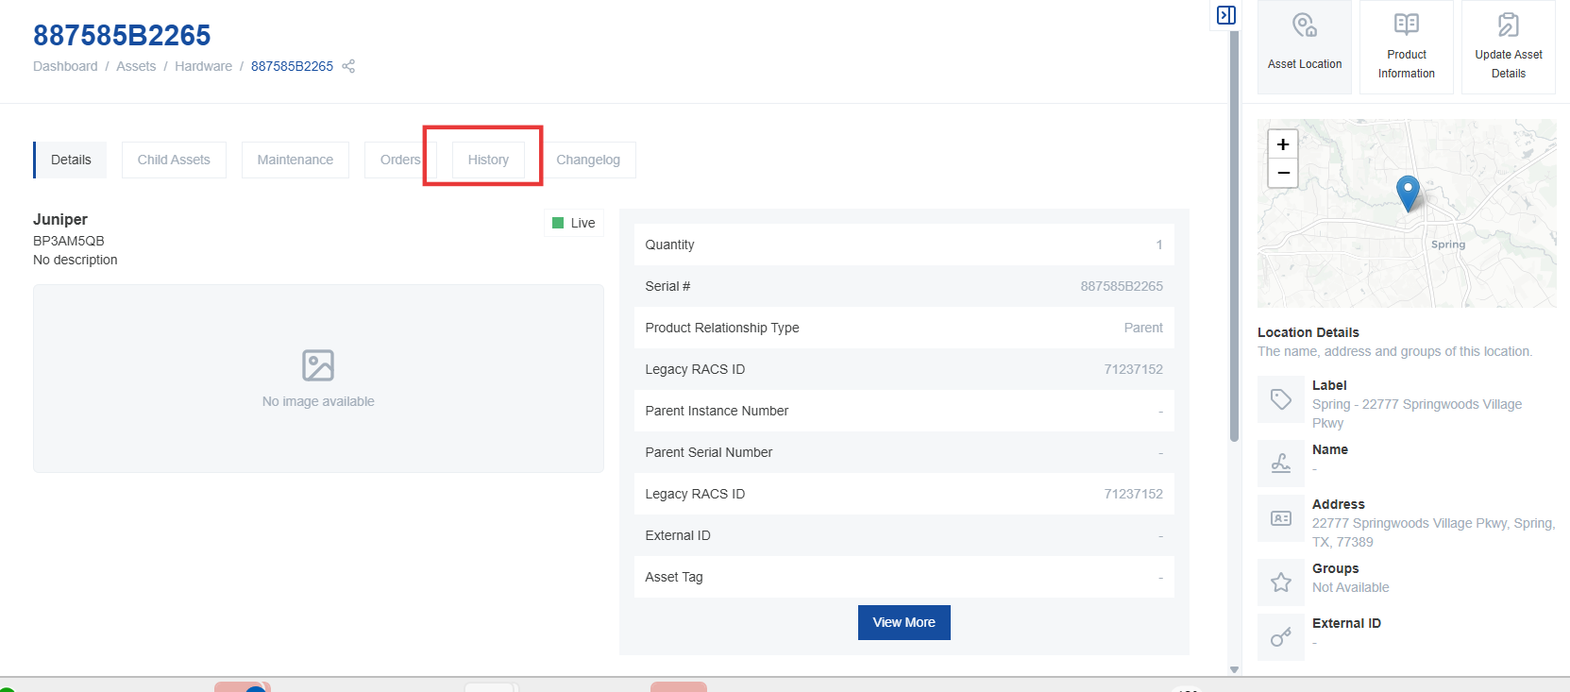
- This tab shows the history of the device and any changes made over time. The change history includes who made the change and when.
