Asset Management > View Hardware > Details > Child Assets
From side bar menu navigate to Assets then click Hardware. This will show the hardware list. Click on the view link for the specific asset, this will open the specific asset details.
- Click on the "Child Assets" sub-tab. This tab allows you to see assets related to the current asset.
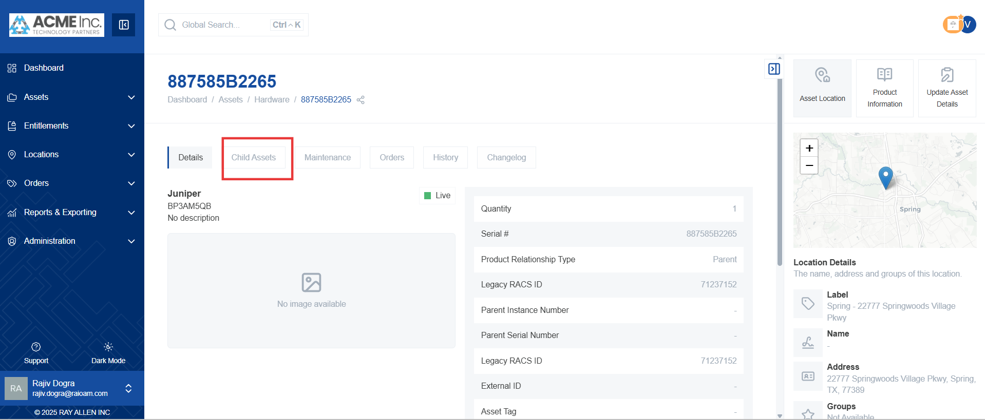
- This will display any assets related to the selected asset. These could be components or associated devices.
  - Example: Power supply, network module, cables. These are examples of assets that might be listed as child assets.
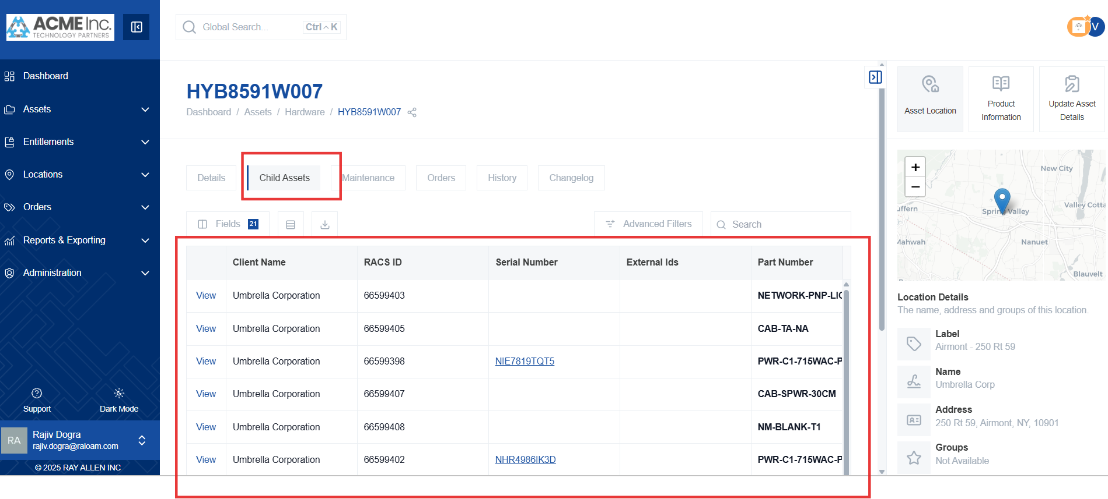
- Click on any of the listed child assets to view its detailed information. This action takes you to the asset detail page for the selected child asset.
