Asset Management > View Hardware > Actions > Update Hardware Location
Bulk
- Navigate to the "View Hardware Assets" table and select the asset you want to modify.
  - Click on the specific asset within the table that you want to update or manage. This will usually involve clicking a row in the table.
- From the "Hardware Asset Management" screen, locate the contextual panel.
  - The contextual panel is usually located on the right-hand side of the screen. It provides options and actions related to the currently selected asset or group of assets.
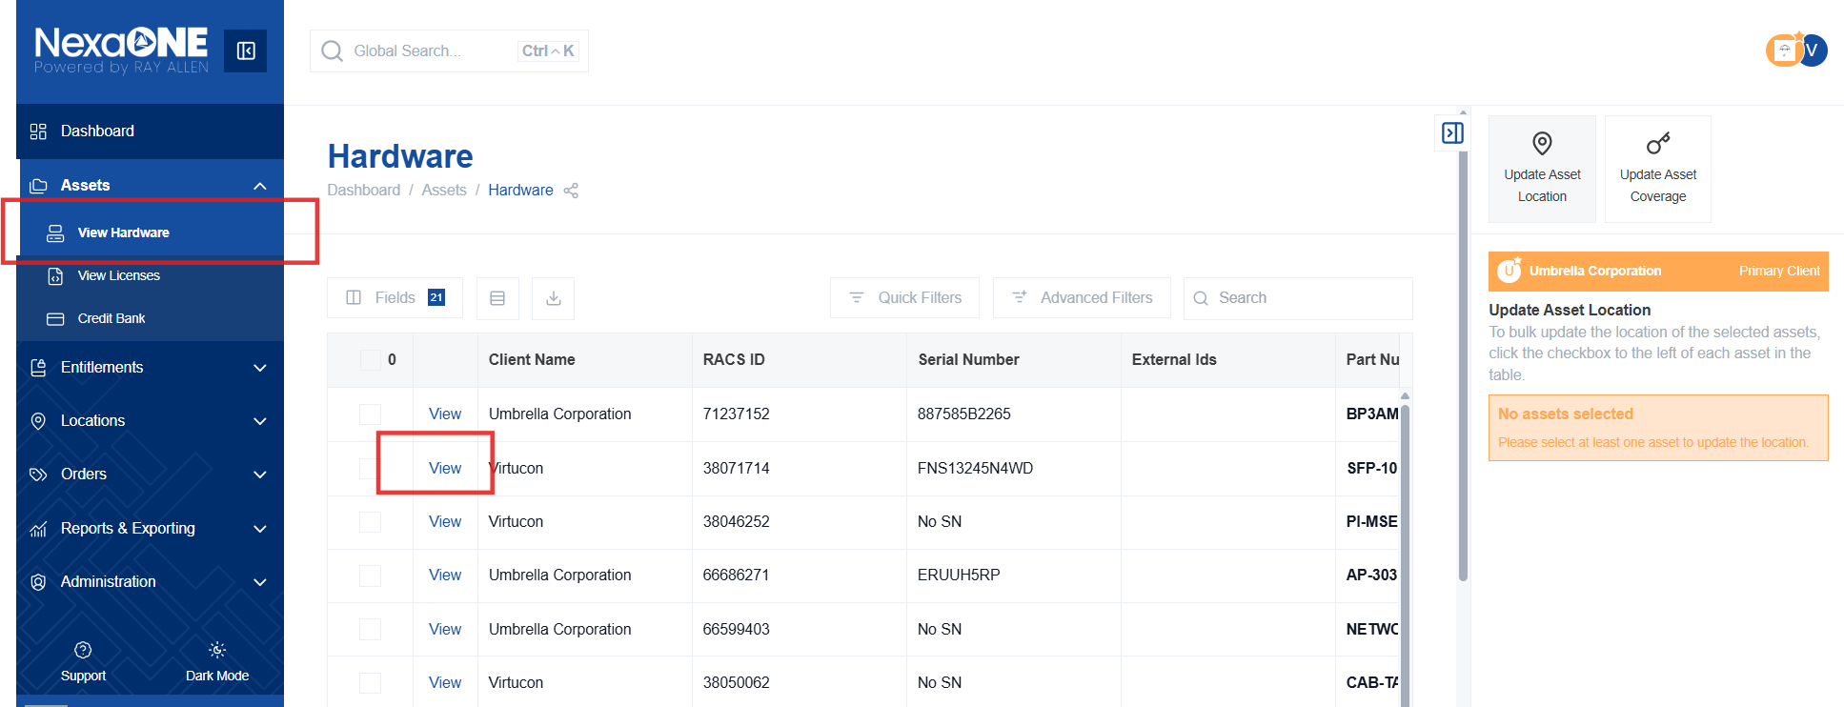

- Click the checkboxes next to the devices you want to update.
  - Select all the devices you want to update the location in bulk by ticking the checkboxes next to each device. You can select one or multiple devices.
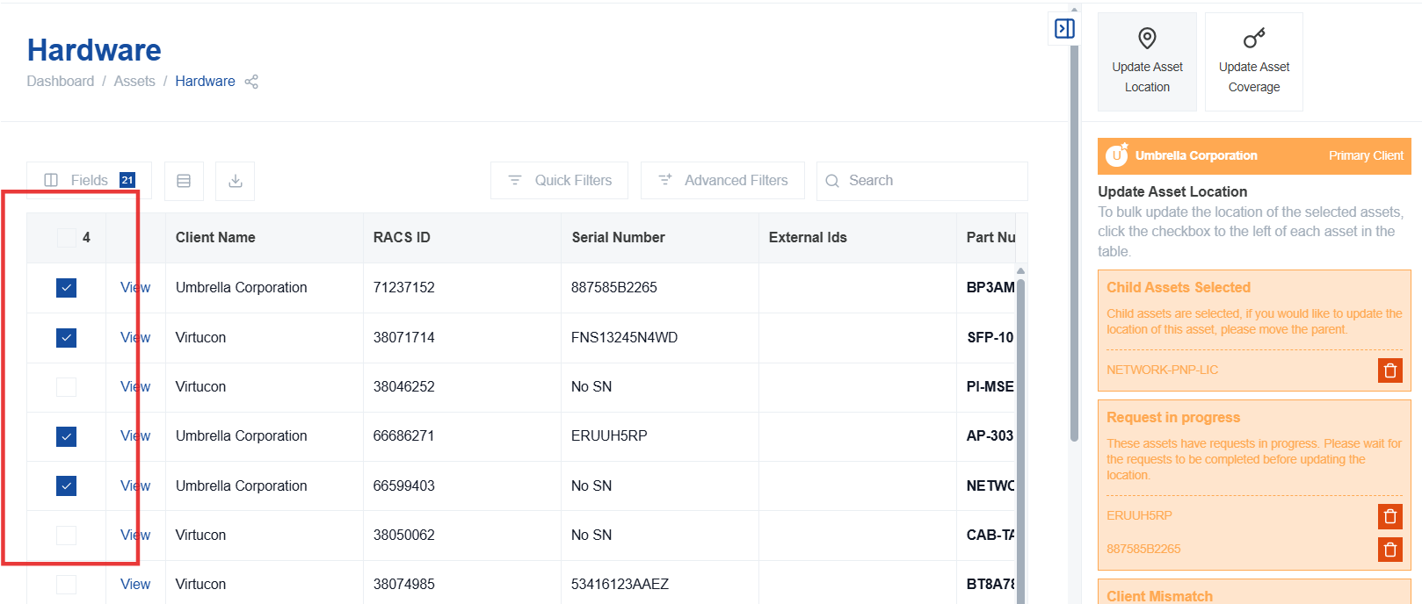

- The selected devices will appear in the contextual panel.
  - After selecting the devices, they will be listed in the contextual panel, confirming your selection.
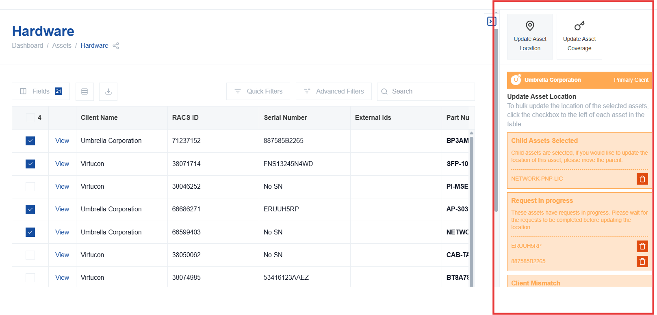
- Select the location group.
  - Choose the appropriate location group from the dropdown menu in the contextual panel. This will filter the available locations in the next step.
- Choose a location within the selected location group.
  - Pick a specific location from the list of locations available in the selected location group. This is the new location you are assigning to the selected assets.
- Click "Update All" to apply the new location to all selected devices.
  - After selecting the location group and the specific location, click the "Update All" button to apply the changes to all of your selected devices.
