Asset Management > View Hardware > Actions > Update Hardware Coverage
Bulk Update
- Navigate to the "View Hardware Assets" table and select the asset you want to modify.
  - Click on the specific asset within the table that you want to update or manage. This will usually involve clicking a row in the table.
- From the "Hardware Asset Management" screen, locate the contextual panel.
  - The contextual panel is usually located on the right-hand side of the screen. It provides options and actions related to the currently selected asset or group of assets.
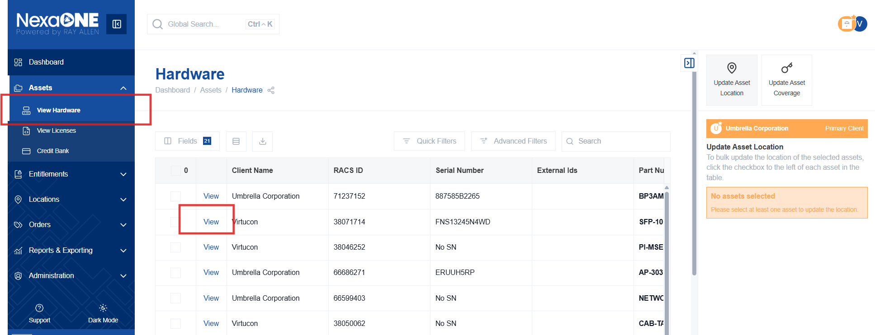
- Click the checkboxes next to the devices you want to update.
  - Select the hardware assets that you want to update the coverage for.
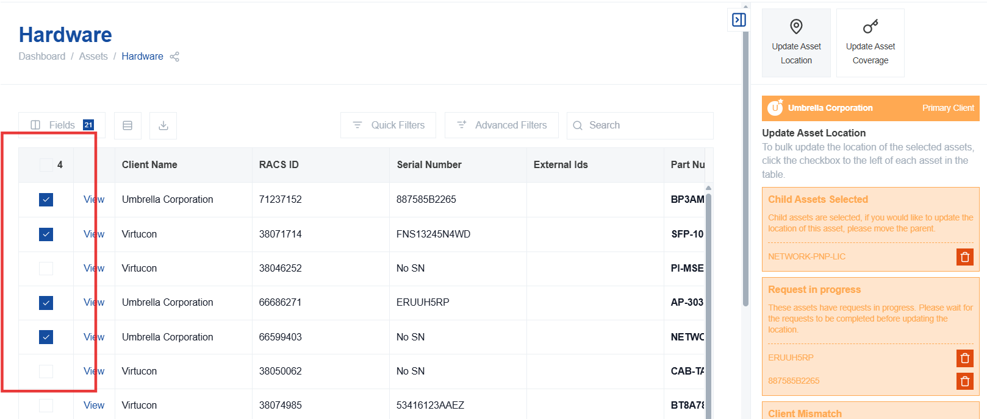
- Select a contract number from the list of valid contracts.
  - Choose the relevant contract number that will provide coverage for the selected assets. The system provides a list of valid contract numbers.
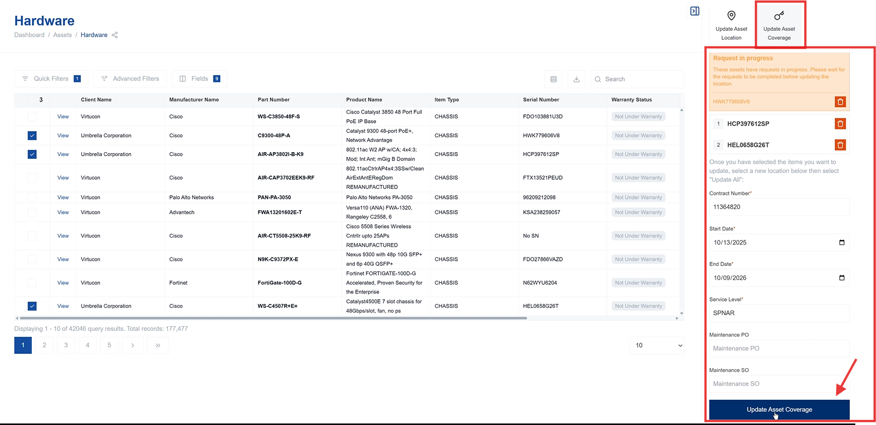

- Enter the contract start date.
  - Specify the date when the coverage for the contract begins.
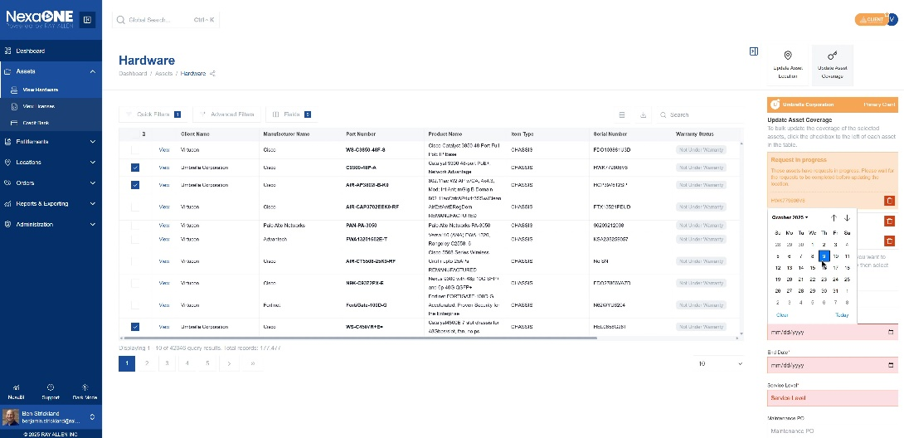
- Select the appropriate service level.
  - Choose the service level that applies to this contract and the selected assets. This could be based on previous service levels.
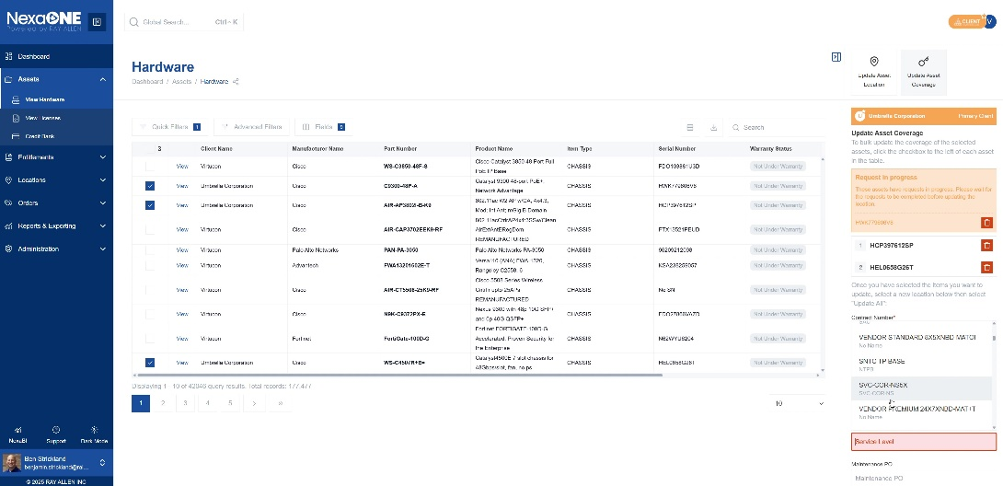

- Enter PO and SO information, if needed.
  - Provide any relevant Purchase Order (PO) and Sales Order (SO) information, if required for the contract.
- Enter the contract end date.
  - Specify the date when the coverage for the contract ends.
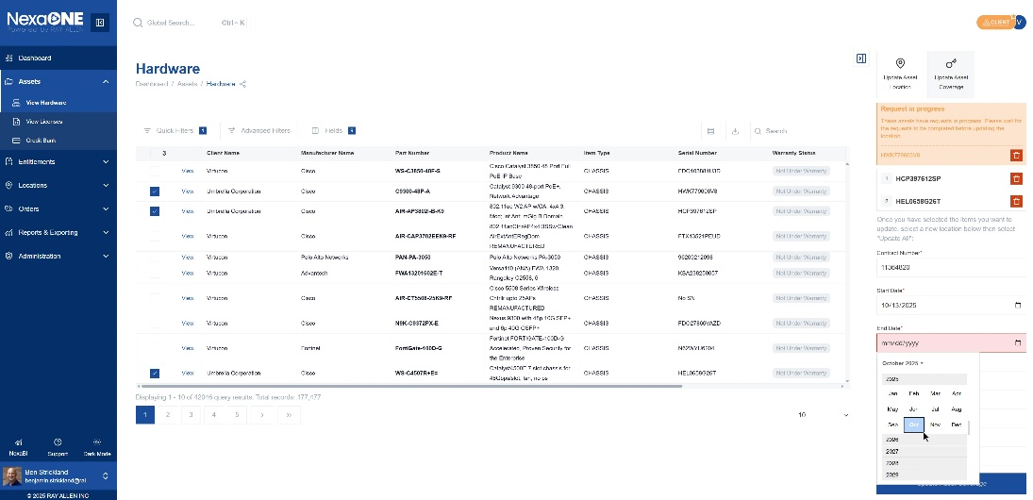
- Click the "Update Asset Coverage" button to complete the update.
  - Clicking this button finalizes the asset coverage update for the selected assets, applying the chosen contract, dates, and service level.
