Asset Management > View Hardware > Actions > Details > Update Hardware Details and Configuration
This guide details how to update asset information within NexaONE, covering modifications to asset details, location, coverage, and configuration.
From the main menu in NexaONE, locate and click on the "Assets" menu and go to the required asset table.
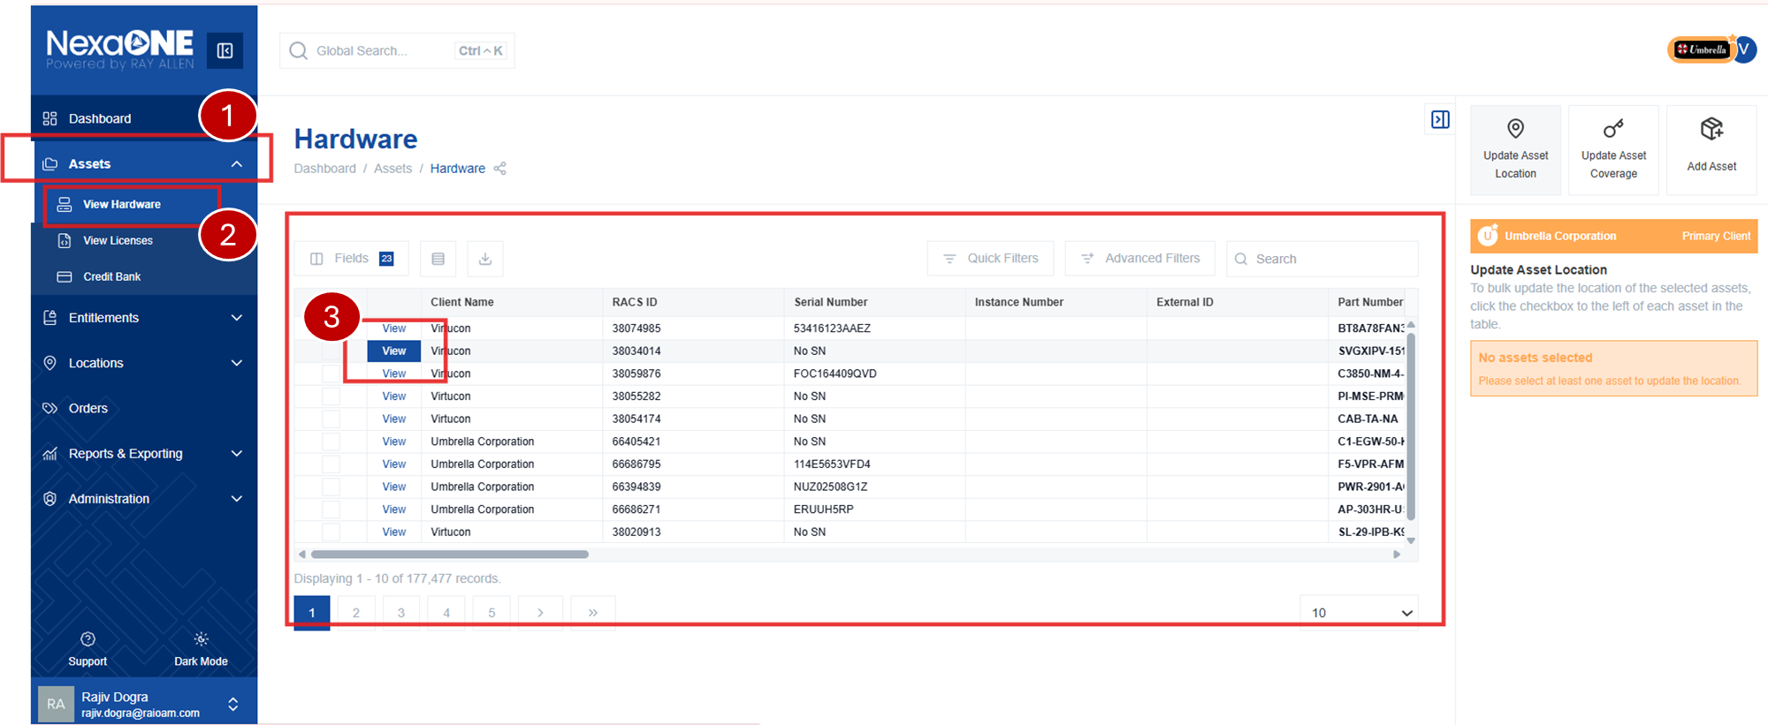
In the specific asset selected from the asset table, the contextual pane is visible on the right sidebar. This pane displays the key details such as location, external IDs, and other information. From here you can update the required information.
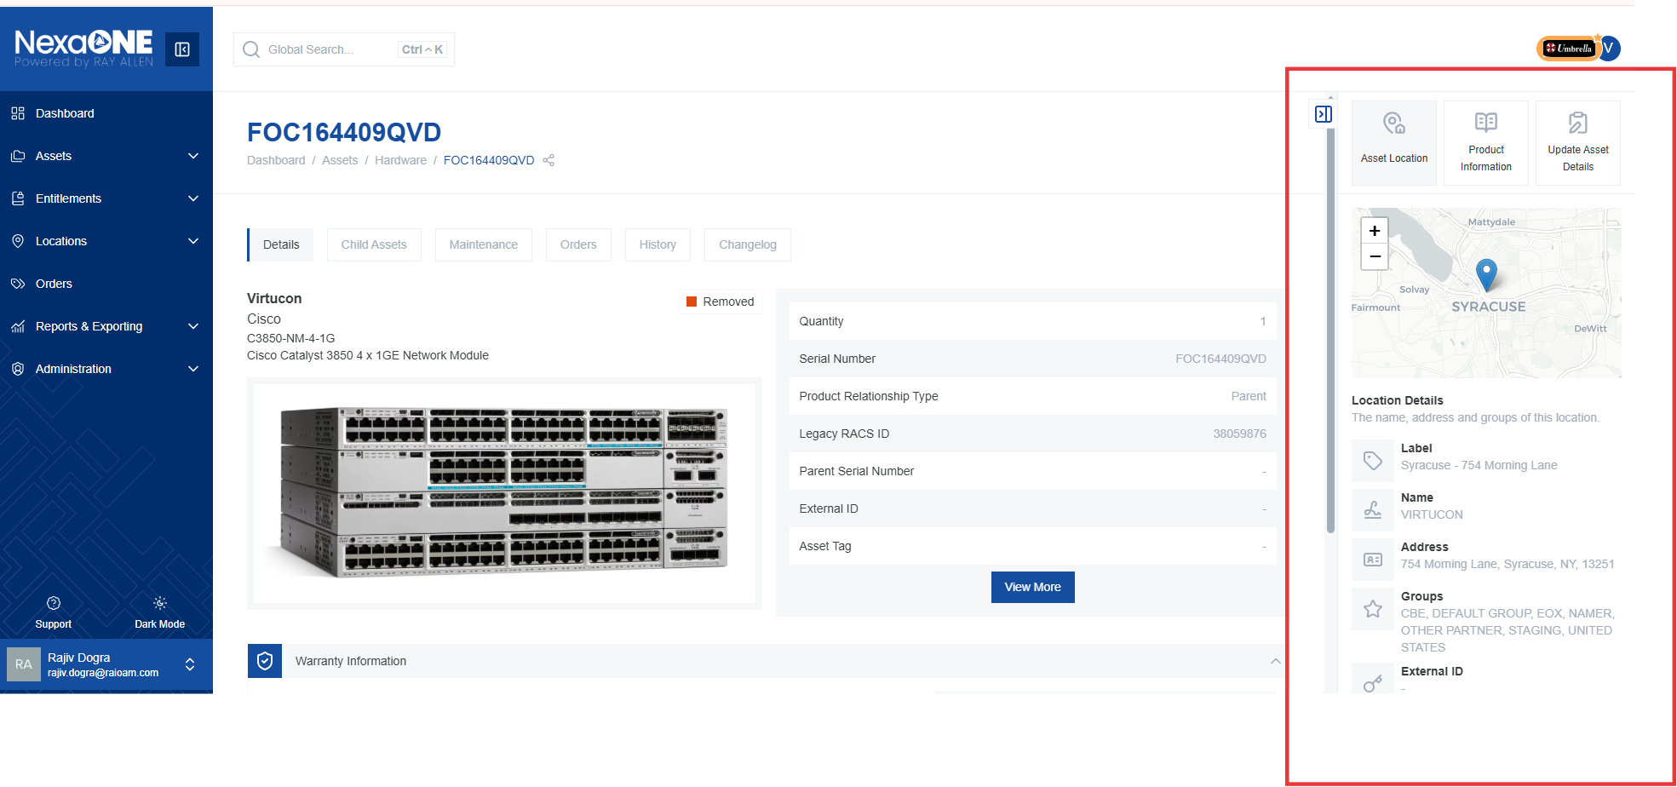

Updating Asset / Hardware Details & Identifiers
For the selected asset, click the "Update Asset Details" button in the contextual pane to view the modification options.
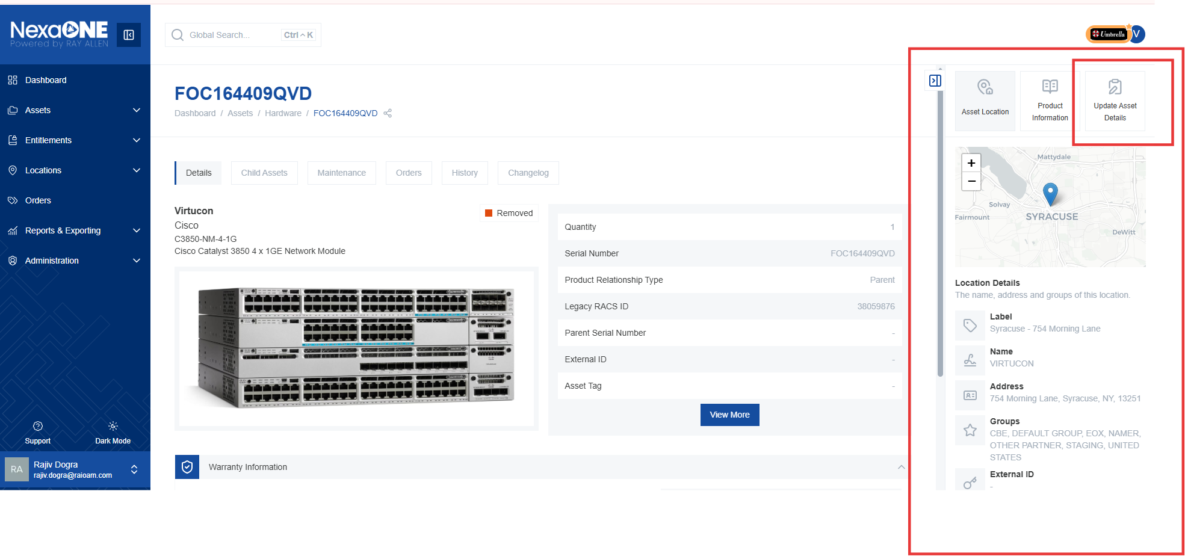

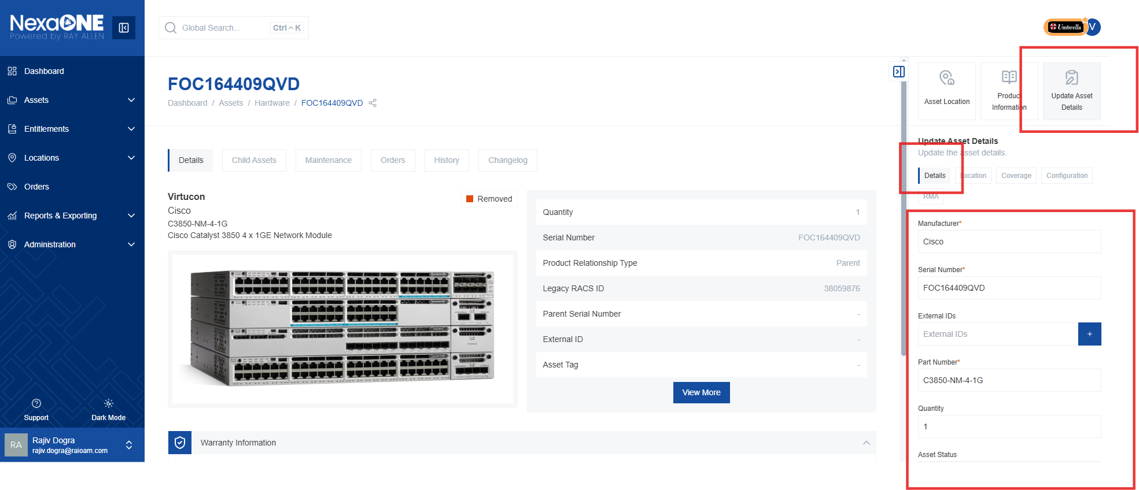
The "Update Asset Details" section allows you to modify various attributes of the asset. Available update options include:
- Serial Number: Correct any typos or mistakes in the serial number.
- External IDs: Add or modify external identification numbers associated with the asset.
- Part Number: Correct any errors in the part number. While generally correct, this option allows for corrections.
- Asset Status: Update the current status of the asset. This can include:
  - Live Environment: The asset is actively in use.
  - Virtual Inventory: The asset is part of the virtual inventory.
  - Removal from Service: The asset is being or has been removed from service.
  - It also provides options to modify/update Asset Identifiers
    - Host Name/DNS Name: This helps in identifying and communicating about the asset.
    - IP Address/MAC Address: Keep these updated for accurate network information.
    - Asset Tags are specific tags for the individual asset.
    - Departmental Tags are related to the department using the asset. These are useful for searching and categorizing assets.
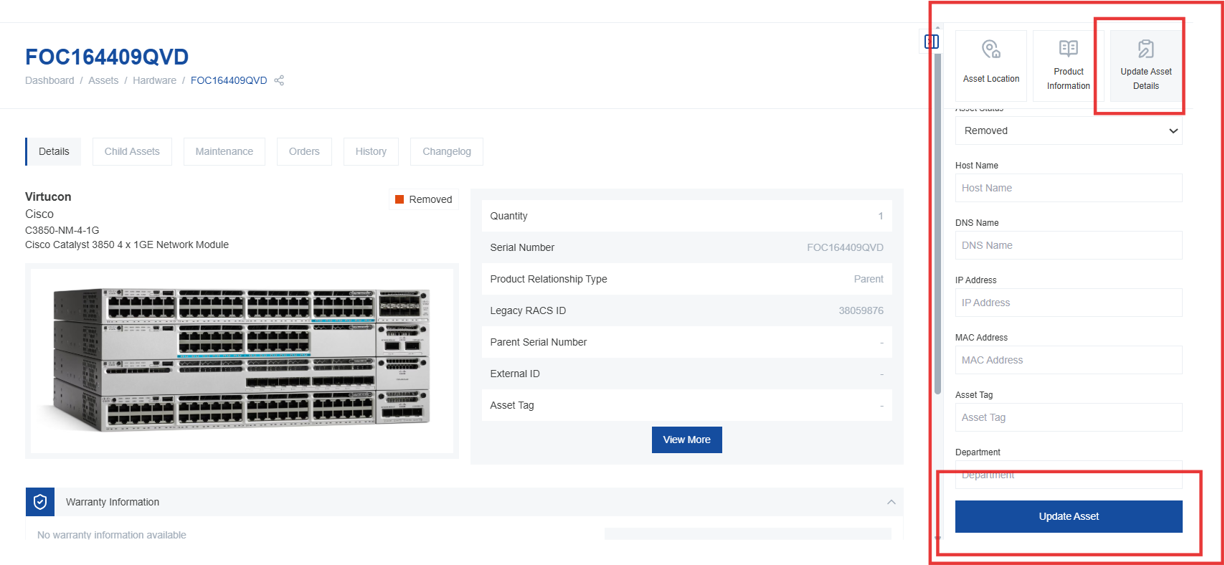
Changing Asset Location
- To change the asset's location, under update Asset Details in contextual pane, select Location sub-tab and then add the desired group and specific location. This updates the physical or virtual location of the asset.
- The number in parentheses next to the location indicates the site ID, is a unique identifier for the location.
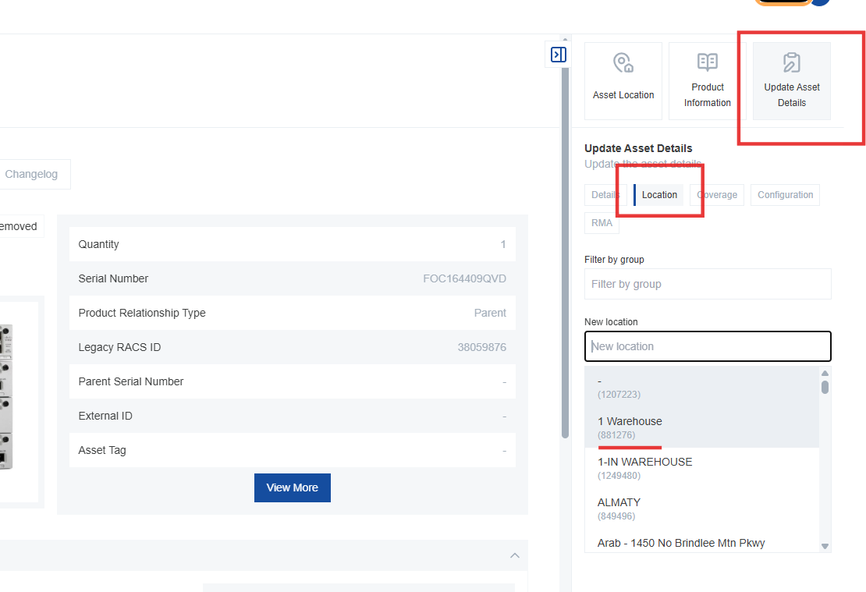
If the desired site is not listed, you may need to update locations in the existing location groups. Navigate to the locations section to manage and add new locations.
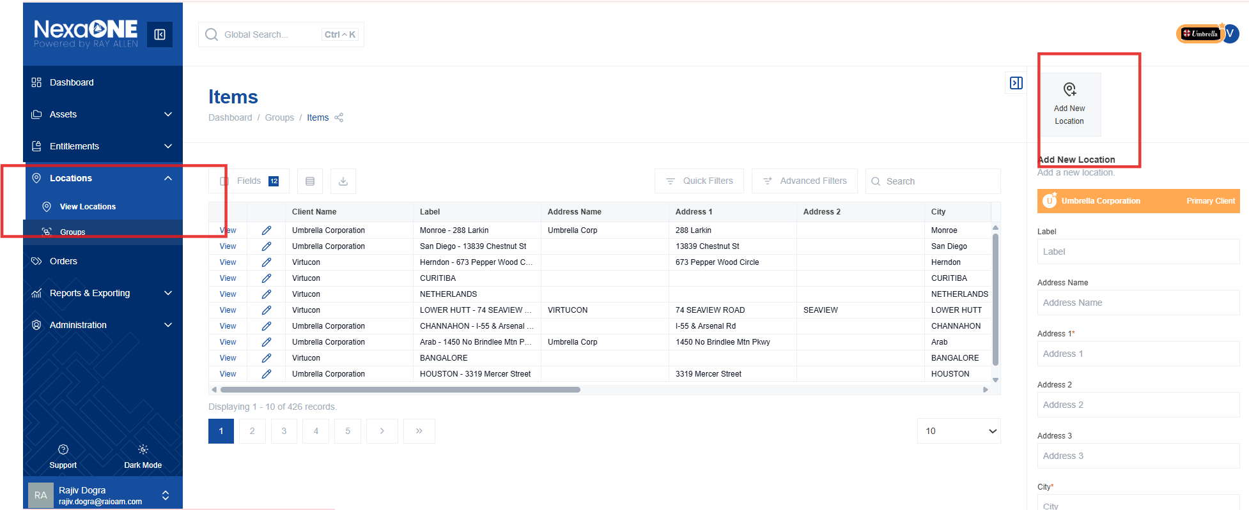
Updating Coverage
- To change the asset's coverage, under update Asset Details, select Coverage sub-tab and update the service contract and service level for the asset. This is useful when an asset's service agreement changes.
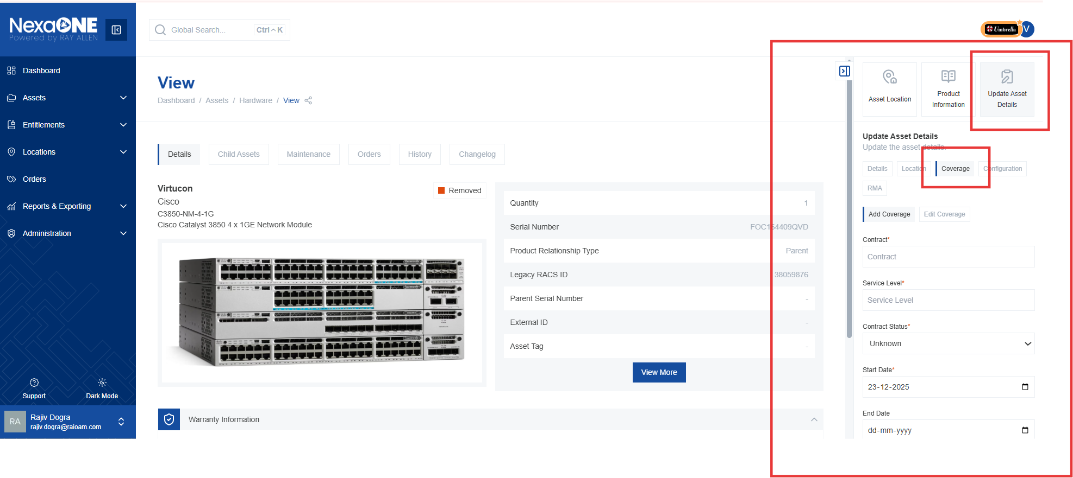
This action initiates the change process for the selected service for the asset. A ticket might be opened to track the service change.

Update Configuration
Configuration options are available under the configuration sub-tab.
Configuration: Linking Child Assets
- In the configuration section, particularly for parent assets, link new child assets. This establishes a relationship between a parent asset and its associated child assets.
- Enter the serial number of the child asset to link it to the parent. This creates the link in the system.
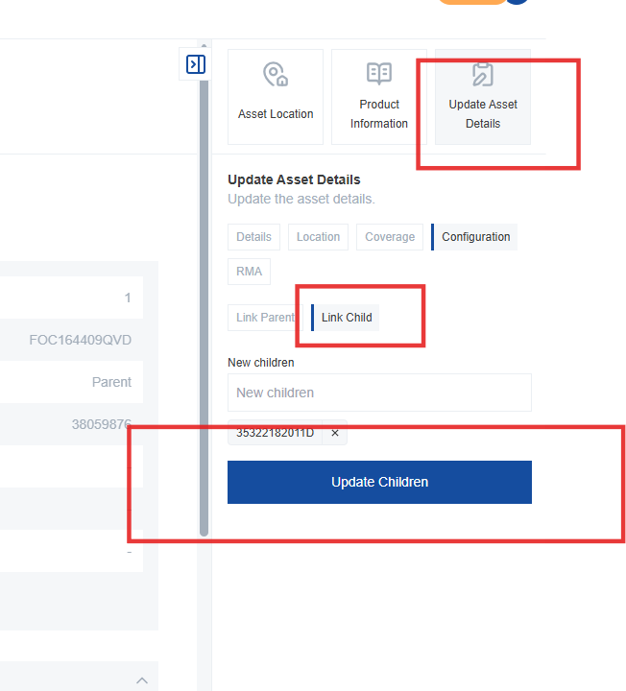

Configuration: Removing Child Assets
- To remove child assets associated with the asset and assign them to a different parent, click on the child assets tab on the Asset details page.
- Find the asset you want to move and click "View". This will display the details of the child asset.
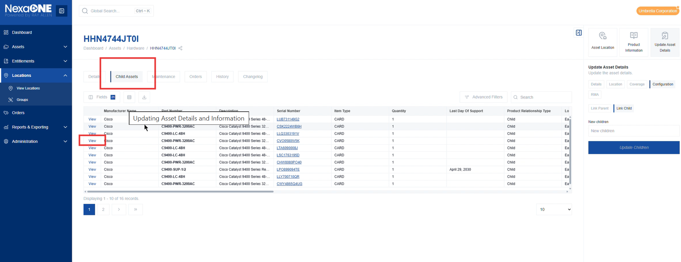
- For the selected child asset, in the contextual pane select configuration option in the Update Asset Detail, then select “Link Parent” option. Enter the new parent's serial number. Start typing the serial number, and the system should suggest matching assets.
Select the correct parent asset from the search results. Click the "Update Parent" button to finalize the change. This completes the reassignment of the child asset to the new parent.
