Asset Management > View Hardware > Actions > Details > Track RMA (Return Merchandise Authorization)
From the asset detail page, under "Update Asset Details," select the "RMA" tab.
Go to the asset's detail page, access the "Update Asset Details" section, and then select the "RMA" tab to manage Return Merchandise Authorizations.
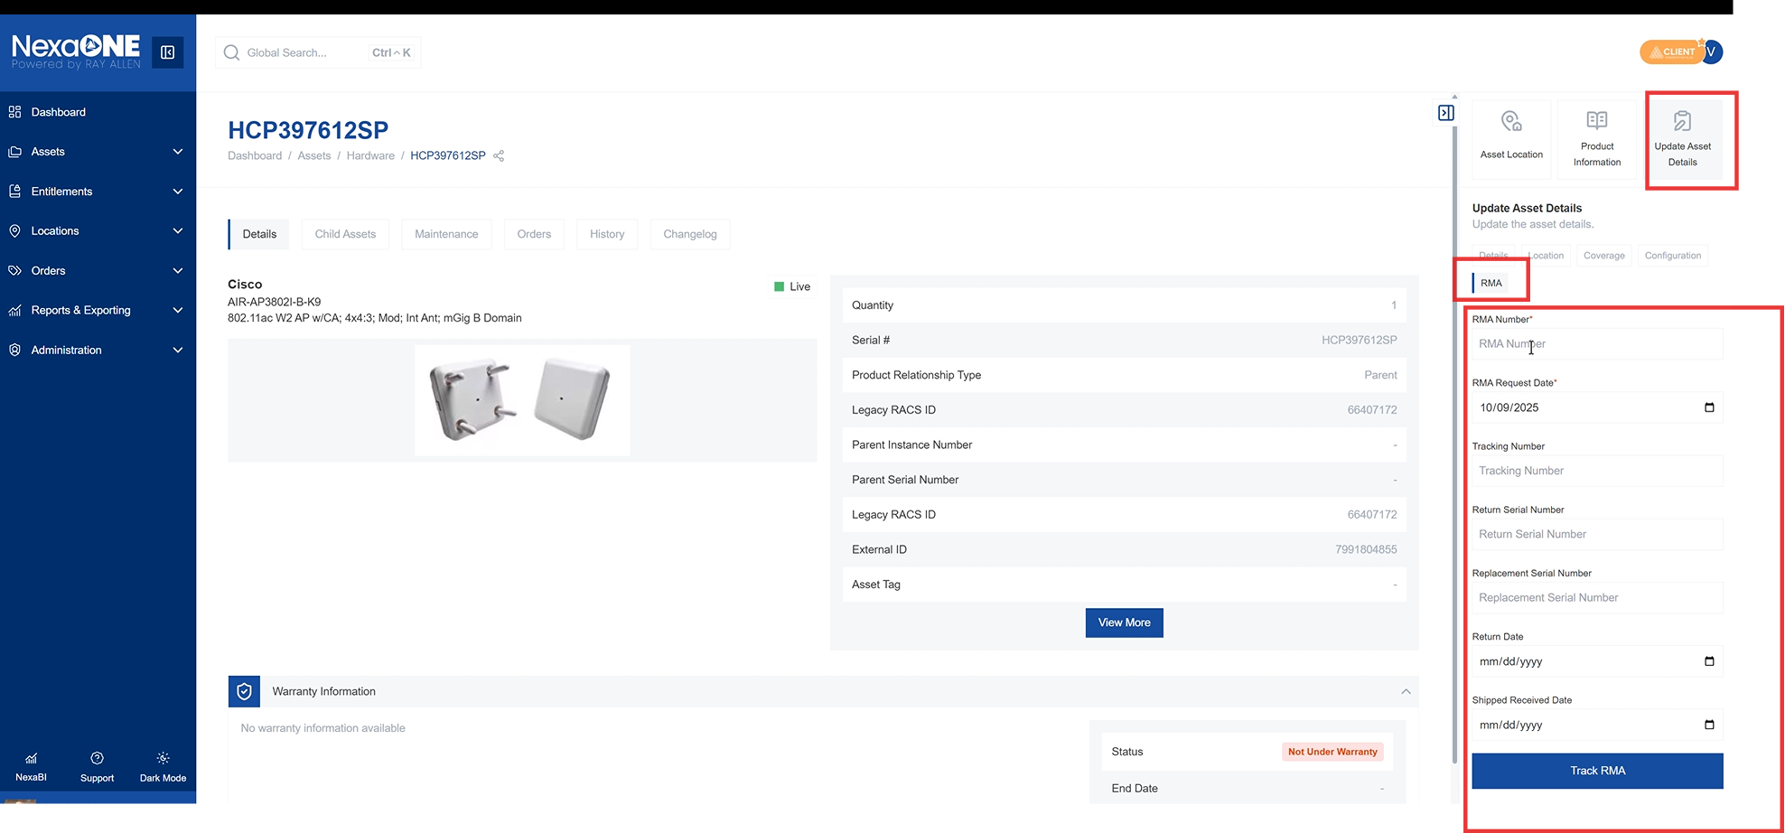
- Enter the RMA number provided by the OEM.
  - Enter the RMA number given to you by the Original Equipment Manufacturer (OEM).
- Enter the RMA date.
  - Specify the date associated with the RMA request.
- If available, enter the tracking number.
  - If the OEM provides a tracking number for the replacement parts, enter it here.
- Enter the return serial number (if provided).
  - If you are returning a defective part with a serial number, enter that serial number here.
- Enter the replacement serial number.
  - Enter the serial number of the replacement part you are receiving.
- Enter the return date and ship date (if you want to track these).
  - Record the date when the defective part was returned and the date when the replacement part was shipped.
- Click the "Track RMA" button.
  - Click this button to initiate the RMA tracking process.
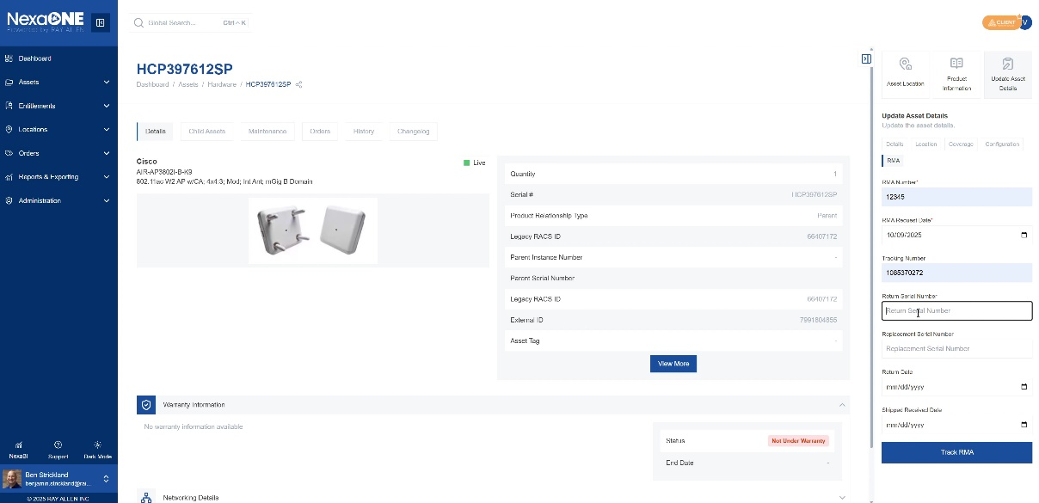
- Confirm the action.
  - A confirmation message will appear; confirm to proceed with tracking the RMA.
  - 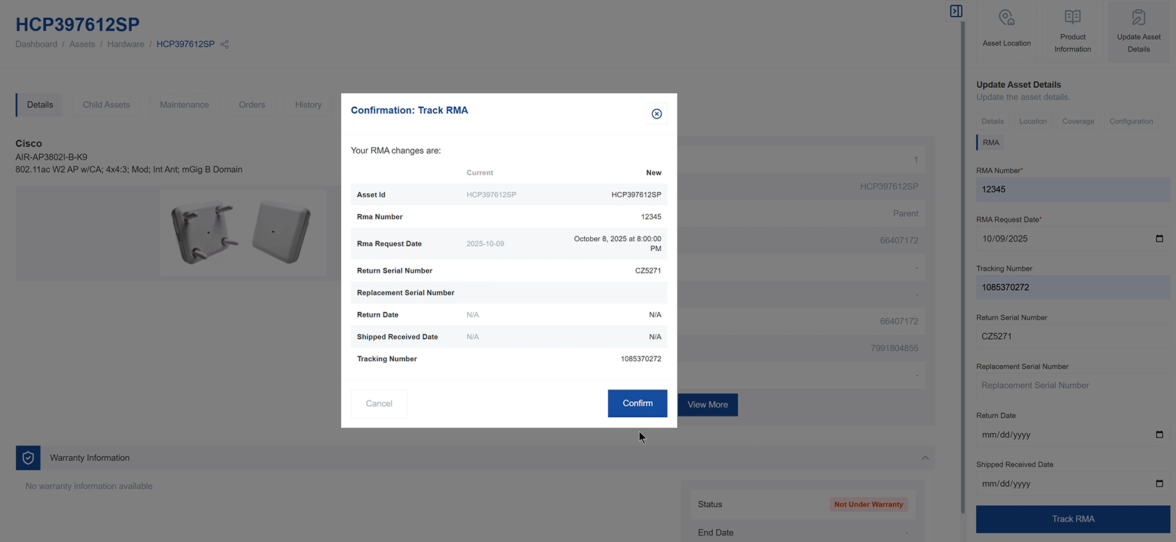
- The RMA is now tracked. You can view the RMA request in the device history.
  - After confirmation, the RMA is tracked within the system, and you can view its history and status.

