Asset Management > Credit Bank > View Credit Bank
Access Credit Bank
This section explains how to access the Credit Bank within NexaOne.
- Navigate to the Assets section: From the main menu in NexaOne, locate and click on the "Assets" section. This section provides access to various asset-related features, including the Credit Bank.
- Within the "Assets" section, find and select "Credit Bank". This action will display a list of all items currently stored in the credit bank. The credit bank interface will then load, presenting you with a table of your credit bank items and associated details.

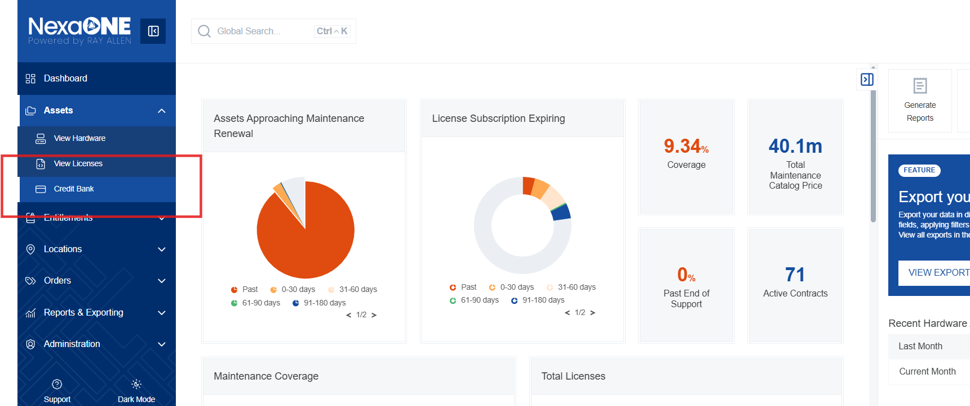

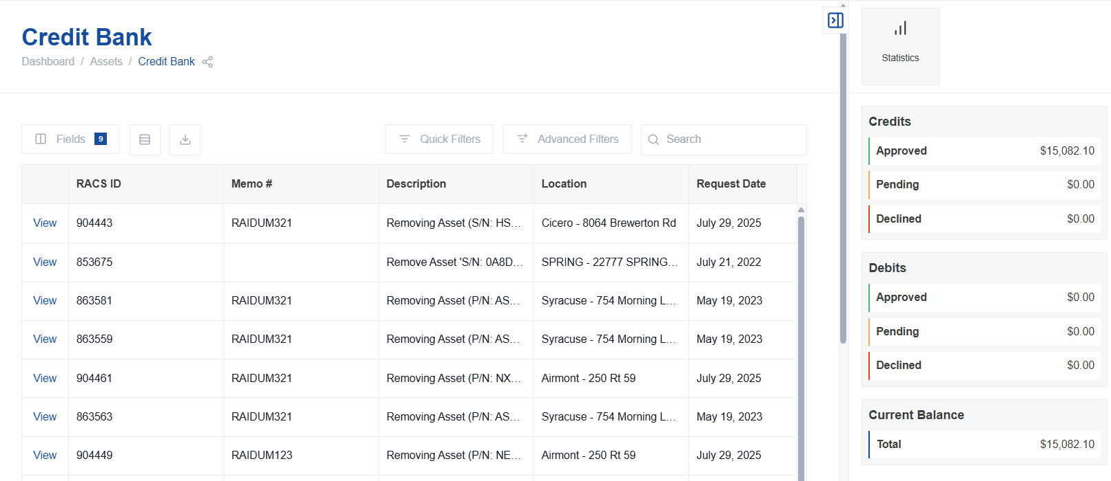

Understanding the Credit Bank
This section explains the purpose of the credit bank and its key functionalities.
- Credit Tracking from Contract Changes: The credit bank primarily functions to track credits that result from contract modifications. Specifically, it manages situations where items are removed from a contract before the contract's natural expiration date. This removal creates a credit that can be used later.
- Applying Credits to Future Contract Additions: The credits stored within the credit bank can be applied to add new items or services to a contract at a later time. Instead of processing a new purchase, you can utilize existing credit.
- Use Case: Traditional vs. CXEA/Maintenance EA Contracts: The credit bank is particularly useful in scenarios involving traditional contracts.
  - Traditional Contracts: These are contracts where items are added and removed individually through separate transactions.
  - CXEA/Maintenance EA Contracts: The credit bank is less critical when Comprehensive Experience Agreements (CXEA) or maintenance agreements are in place, as these typically handle changes differently.
- Benefits of Using the Credit Bank: The credit bank offers several advantages:
  - Centralized Credit Tracking: Provides a central location for monitoring credit creation and consumption.
  - Prevents Credit Loss: Helps ensure that credits are not overlooked or lost over time.
  - Improved Financial Management: Enables better management of financial resources associated with contract modifications.
Navigating the Credit Bank Table
This section describes how to navigate and interact with the credit bank table. The table displays key information related to your credits.
- Filtering Data: The credit bank table provides robust filtering options to help you quickly find the information you need.
  - Quick Filters: Use pre-defined filters to quickly narrow down the displayed data based on common criteria.
  - Advanced Filters: Create custom filters using multiple criteria to perform more specific searches.
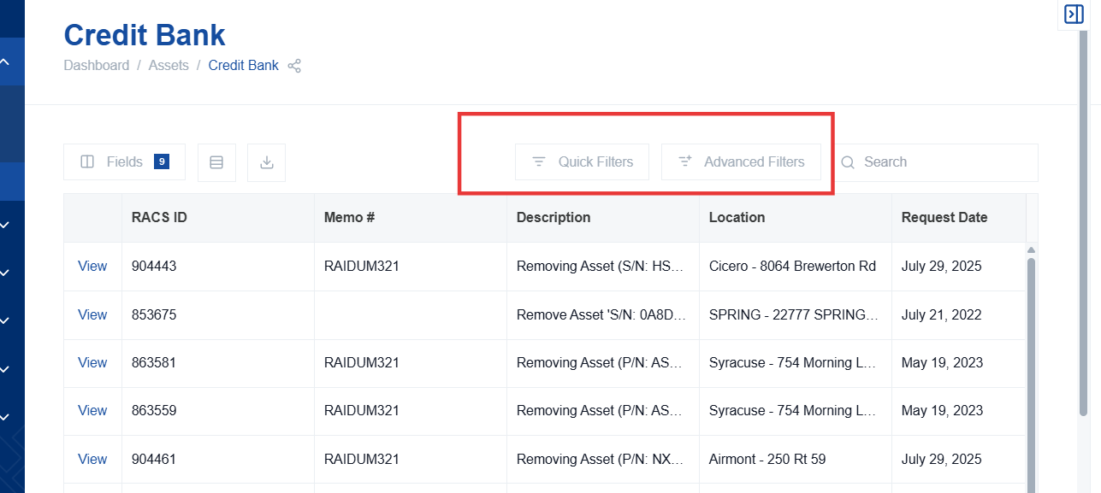

- Customizing Column Visibility: You can customize the columns displayed in the table to focus on the information that is most relevant to you.
  - Accessing Column Customization: Click the "fields" button to open the column customization menu.
  - Selecting Visible Columns: Choose which columns you want to be visible in the table.
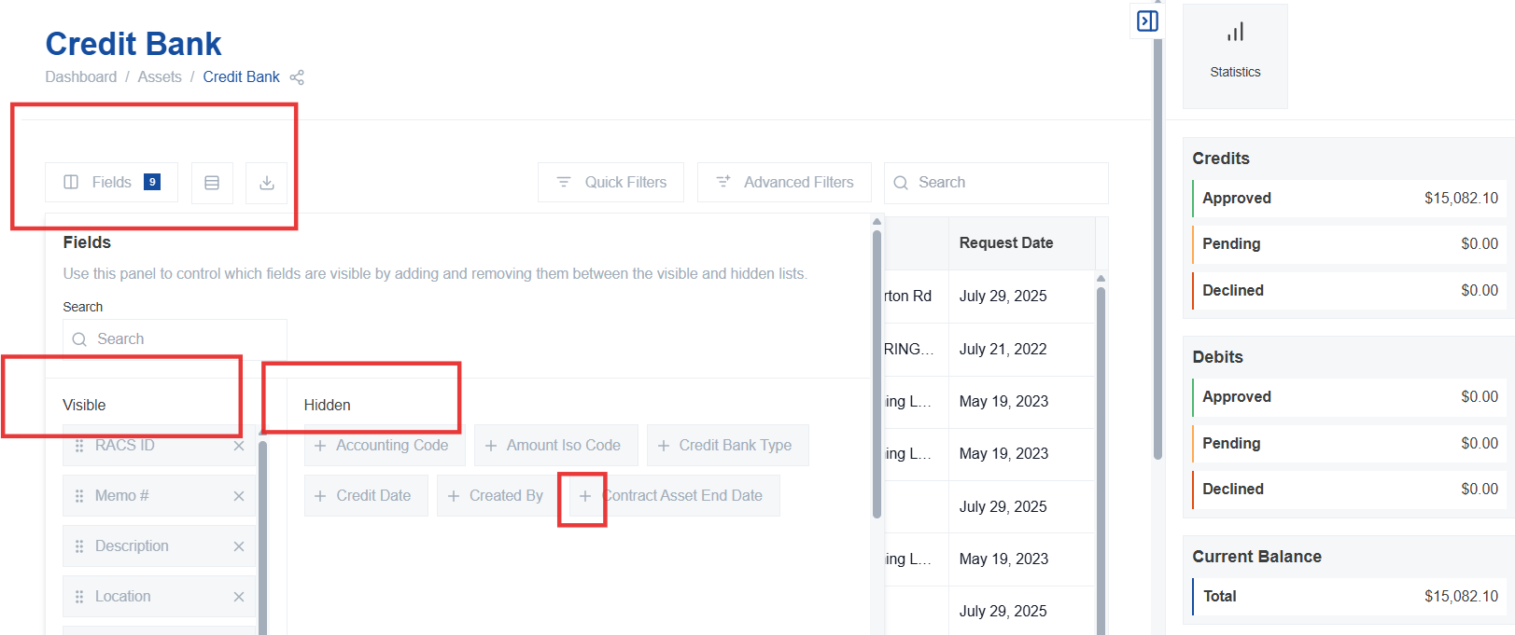

  - Reorganizing Columns: Drag and drop columns to change their order in the table display.
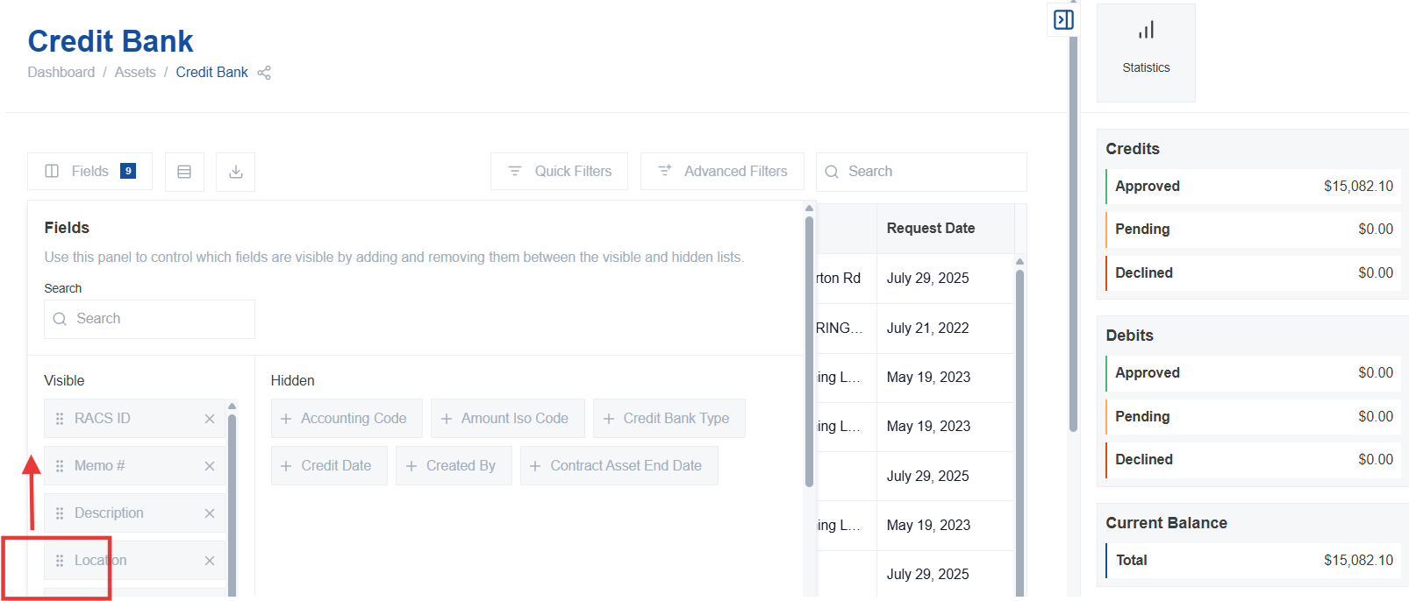

- Downloading Data: The credit bank table supports exporting the displayed data for offline analysis or reporting.
  - Click the download button to export the entire credit bank data into a common file format (e.g., CSV, Excel).

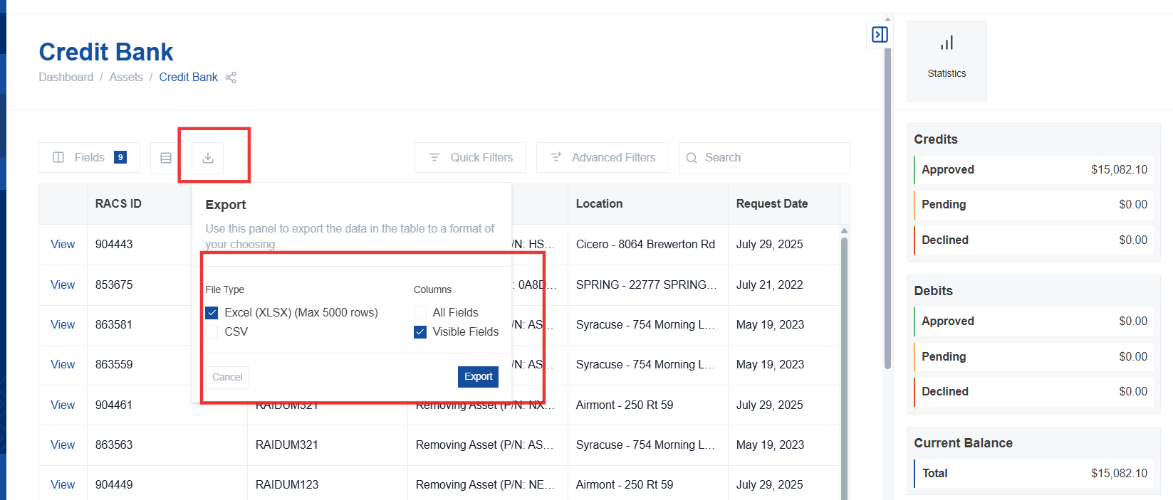

- Searching for Specific Credits: Use the search bar to quickly locate specific credits within the credit bank.
  - Enter keywords related to the credit you are looking for, such as:
    - Description
    - Serial number
    - Other relevant details
