Asset Management > Credit Bank > Statistics
This section explains the statistics displayed on the right-hand side of the credit bank interface. These statistics provide a summary of your credit activity.

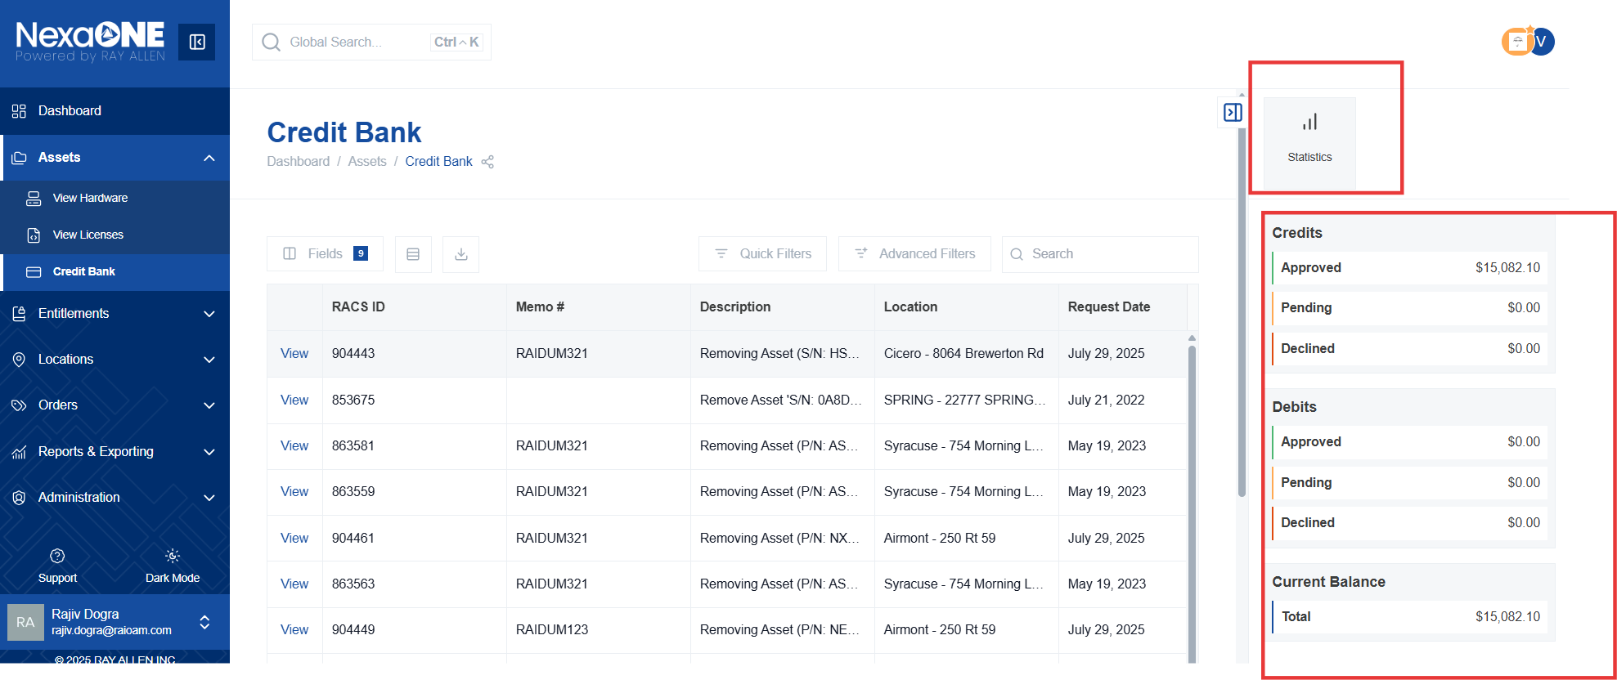
- Approval Status: This section displays a breakdown of credits based on their approval status.
  - Approved: The total amount of credits that have been approved for use.
  - Pending: The total amount of credits that are awaiting approval.
  - Declined: The total amount of credits that have been declined.
- Debits: This displays the total value of debits (credits used) against the credit bank. This represents the amount of credit that has already been applied to contracts.
- Current Balance: This shows the overall remaining balance of credits available in the credit bank. This is the total amount of credit you can currently use.

