Asset Management > Credit Bank > Details
This section explains how to view detailed information about individual items within the credit bank.
- Accessing Details: To view detailed information about a specific credit bank item, zoom in or click on the item. This will open a detailed view of the selected item.
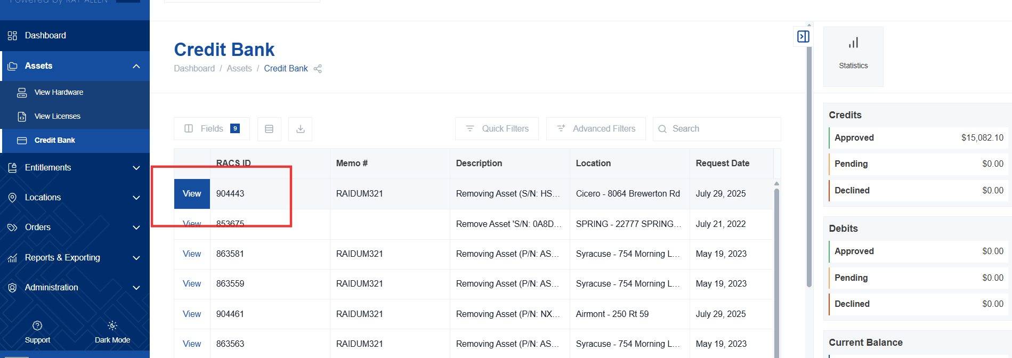
- General Request Information: The initial view displays general information about the credit request. This includes:
  - Request details
  - Current status of the request
