Administration > Request Management > Request Search
The request module is where changes to data within the NexaONE are tracked. This is crucial for maintaining the Unified Source of Truth, especially when managing data originating from external systems to ensure consistency within NexaONE.
Primary Dashboard Status
The primary NexaONE dashboard also displays a quick overview of status of existing requests.
- Locate the tab on the far right of the primary dashboard. This tab is specifically designed to provide insights into request statuses.
  - Outstanding Requests: The total number of requests that are currently in progress or awaiting action.
  - Opened vs. Blocked Requests: A comparison showing how many requests are actively being processed versus how many are currently blocked due to various reasons.

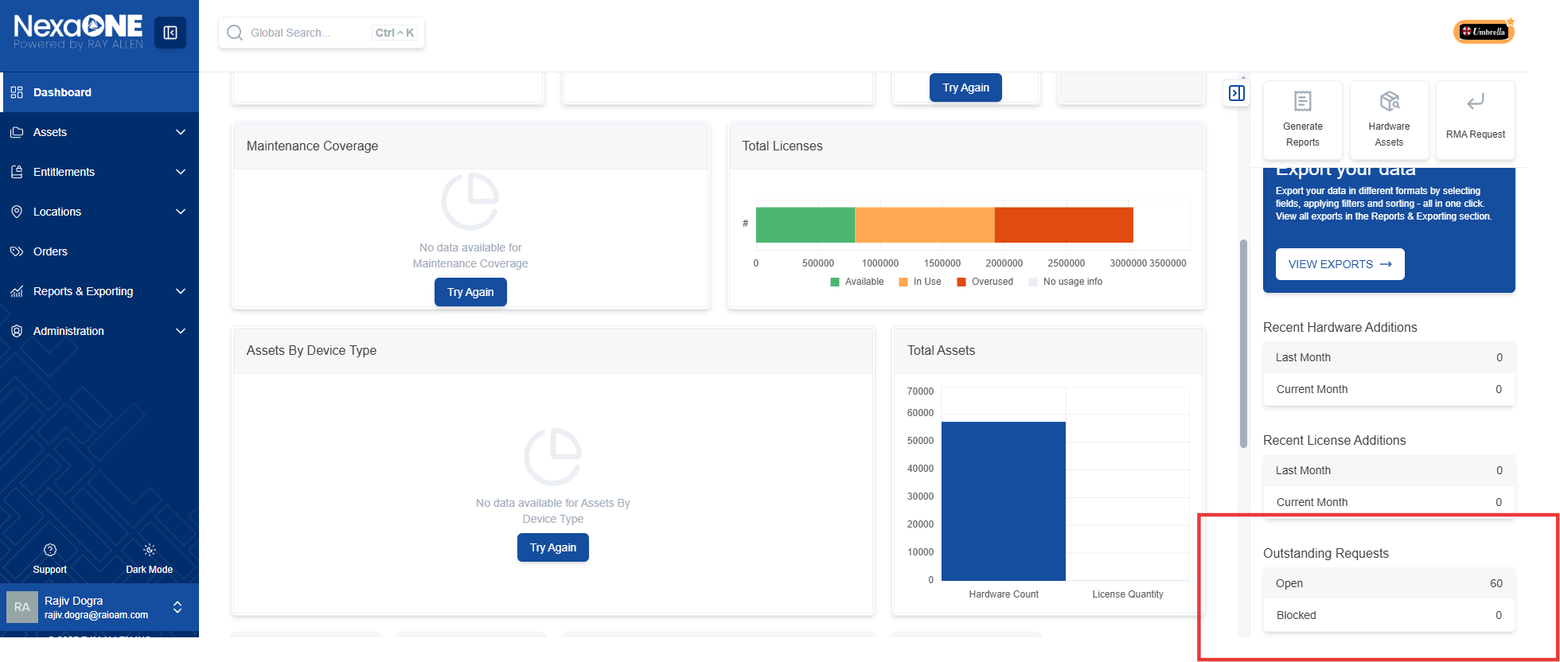
Accessing the Request Search
To view and manage requests, you need to access the request search feature within the administration panel.
- Navigate to the administration panel in NexaONE.
- Look for the "request search" option in the menu.
- Click on "request search" to access the request management interface.
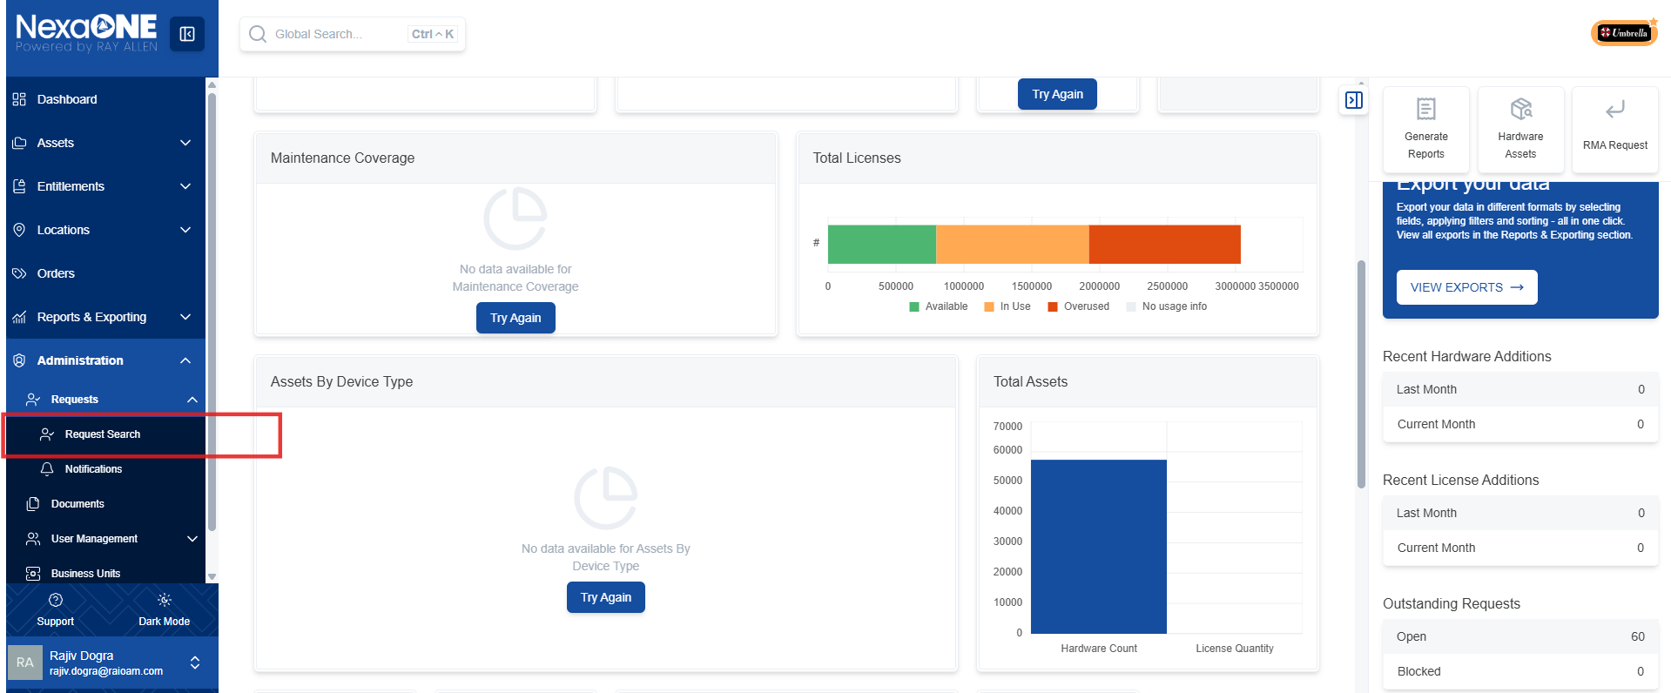

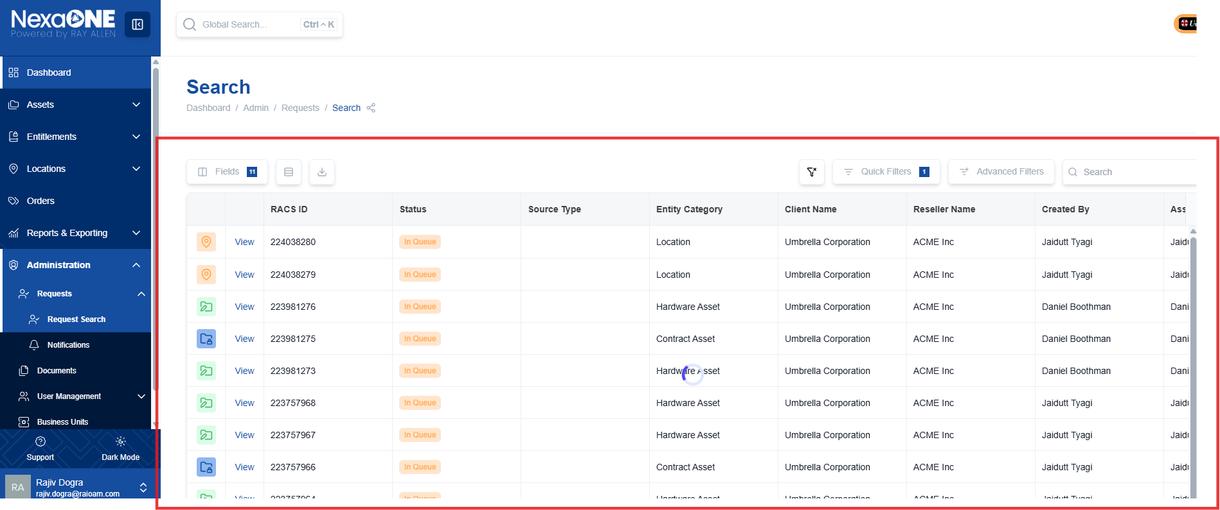

The request table is customizable, allowing you to tailor the displayed information to your specific needs.
- Update and Manage Fields: You can modify the fields displayed in the table to show only the information relevant to you.
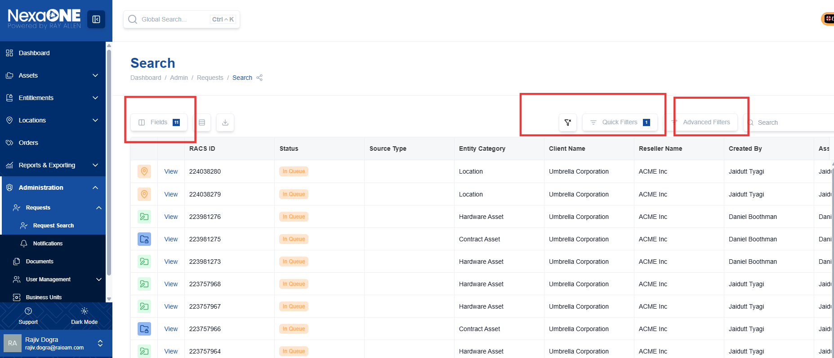
- Change the Order of Fields:
  - Click the "Fields" button located within the request table interface.
  - Drag and drop the fields to rearrange the order in which they are displayed in the table. This helps prioritize the most important data for your workflow.
- Choose Standard or Compact View:
  - The request table typically offers different view options to suit your preferences.
  - Select either the "standard" view for a more detailed presentation of each request or the "compact" view to display more requests on a single screen.
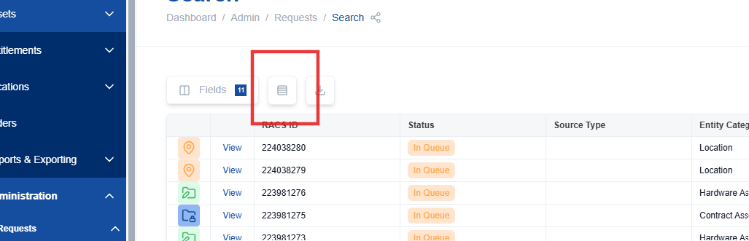
- Export the List of Requests:
  - Look for an "Export" button or option within the request table interface.
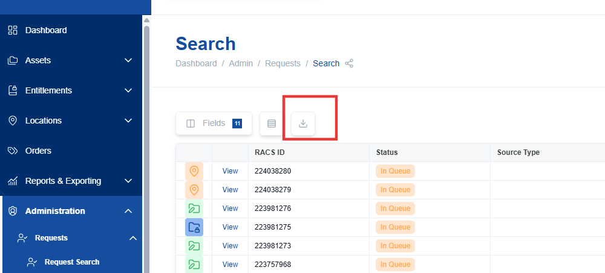
  - Choose your desired export format (e.g., CSV, Excel) and save the file to your computer.
Filtering Requests
By default, the "open request" checkbox is usually selected, which means only open requests are displayed.
- Locate the "open request" checkbox within the request search interface.
- If you want to view closed requests as well, simply uncheck the "open request" box. This will display all requests, regardless of their status.
- Open request checkbox: Toggles the display of closed requests.
Apply Quick Filters:
  - Quick filters allow you to narrow down the list of requests based on specific criteria.
  - Common quick filters include status, request type, and date range.
  - Select the desired filter options to display only the requests that match your criteria.
Request Types
Common request types and their corresponding icons include:
  - Hardware move location: Indicates a request to move hardware to a new location.
  - Add contract asset: Represents a request to add a new asset to an existing contract.
  - Add location: Signifies a request to add a new location to the system.
  - RMA for a particular asset: Denotes a request for a Return Merchandise Authorization (RMA) for a specific asset.
