Administration > Request Management > Request Search > Details
Viewing Request Details
To access more detailed information about a specific request, click the "View" button associated with that request.
- Locate the request you want to view in the request table.
- Click the "View" button next to the request to open the request details screen.
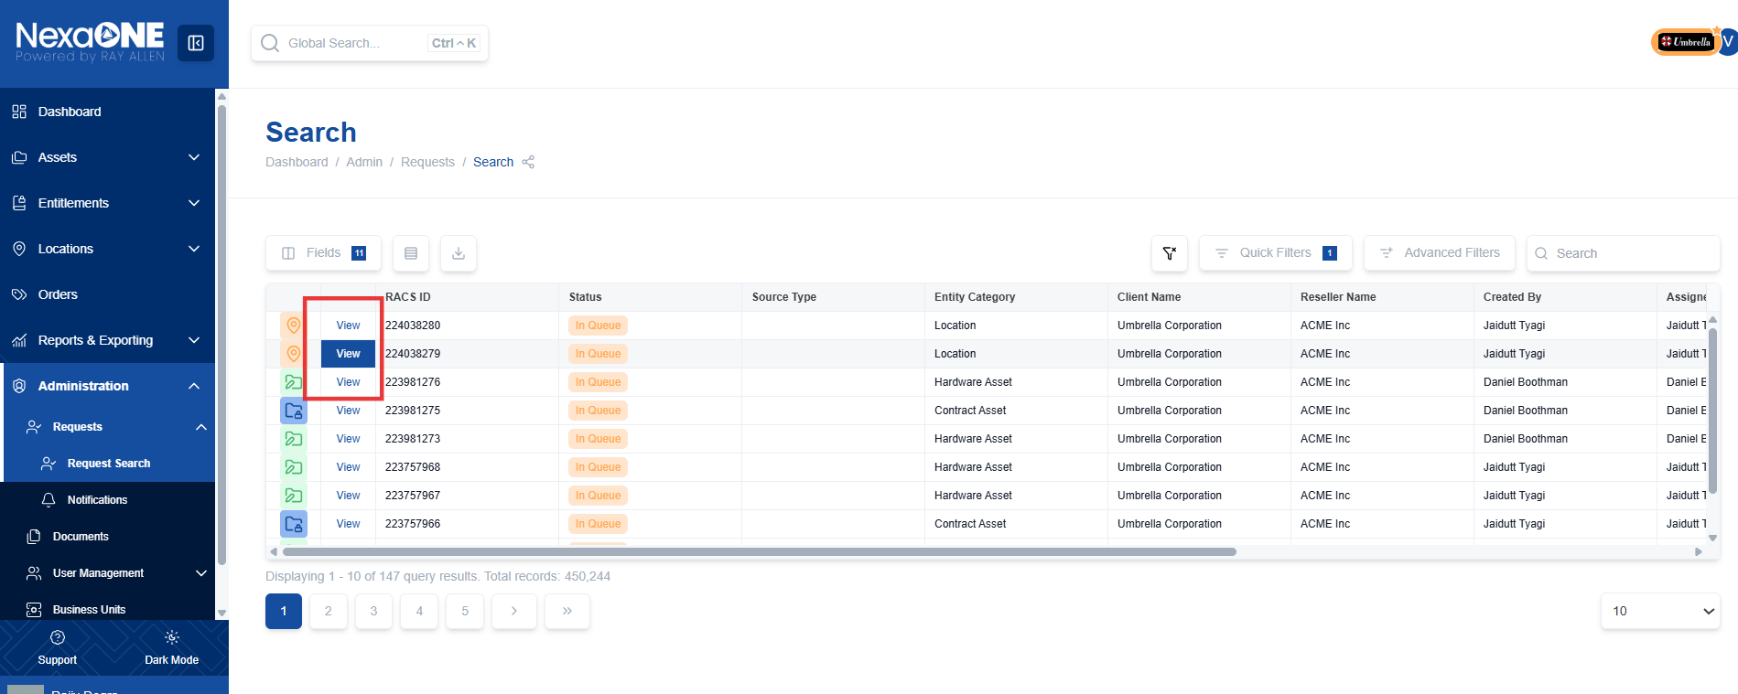

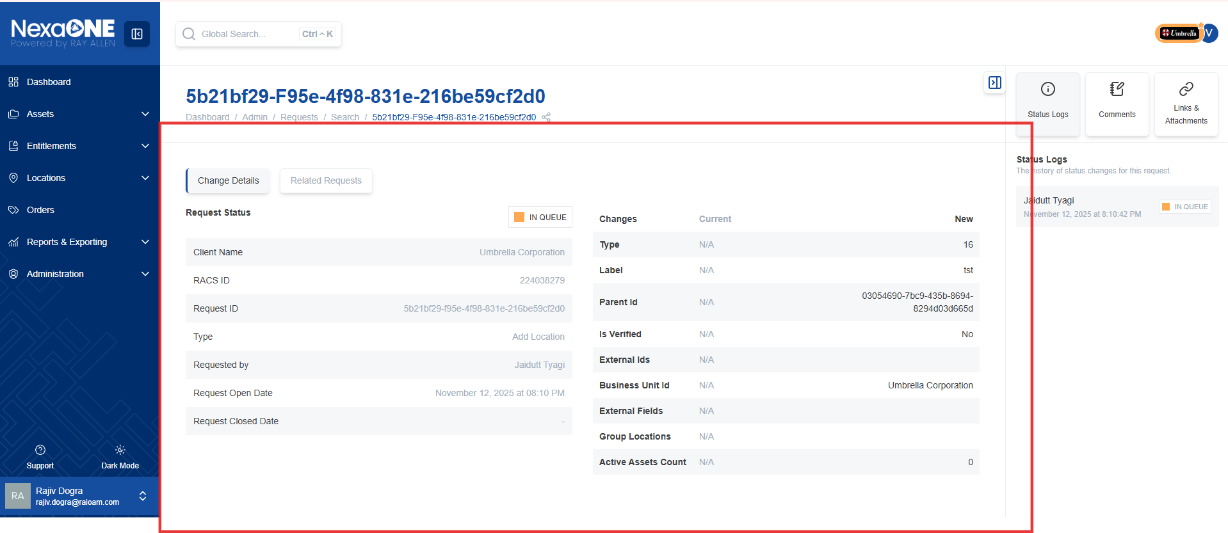

Change Details
The "Changes" section is a critical part of the request details screen, as it shows the specific changes that have been requested.
- Navigate to the "Changes" section of the request details screen.
- Review the information presented in this section, including:
  - Field name: The name of the field that is being changed.
  - Current value: The current value of the field before the change (or "not available" if the field was previously blank).
  - New value: The value that the field will be changed to as part of this request.
