Administration > Request Management > Request Search > Details > Links & Attachments
Status Logs, Links and Attachments
The request details screen provides access to status history, links, and attachments related to the request. View the steps below to review and update.
- Navigate to the request screen -> view details.
- Go to tabs labelled "Status Logs" or "Links & Attachments."
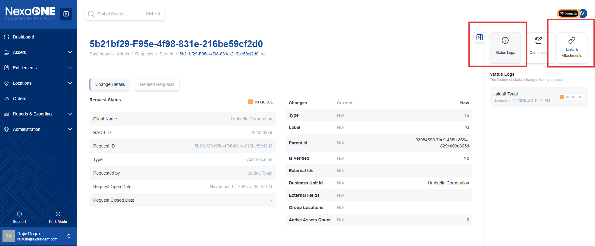
- Status History: Click the "Status Logs" tab to view a chronological history of the request's status changes.
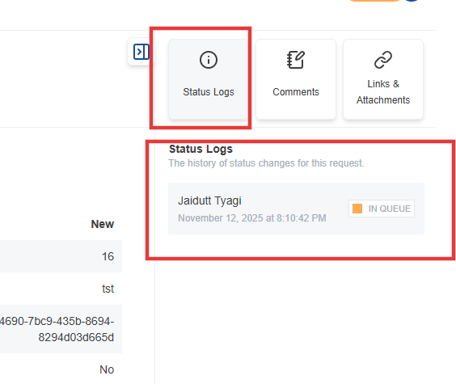
- Links:
  - Click the "Links" tab to add or view links related to the request.
  - Use the "Add Link" button to add a new link.
  - Provide the URL and a descriptive label for the link.
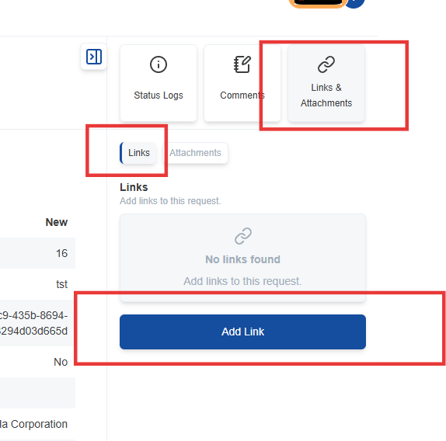

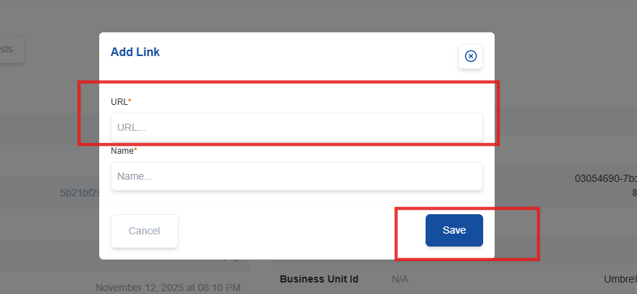

- Attachments:
  - Click the "Attachments" tab to add or view attachments related to the request.
  - Use the "Add Attachment" button to upload a file from your computer.
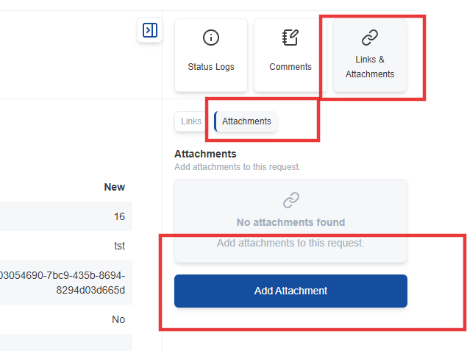

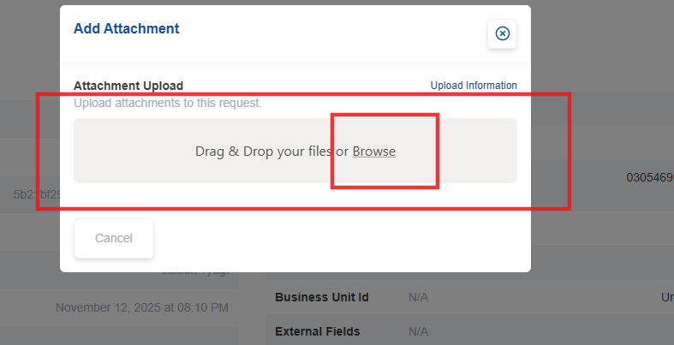
  - Provide a descriptive name for the attachment and click upload
