Administration > Documents > Download File
Viewing Document Details
To get more information about a specific file uploaded to Documents section, in the documents table view, each uploaded document has a "View" button located next to it. Clicking this button will display detailed information about the document, such as its name, upload date, file size, and any other relevant metadata.
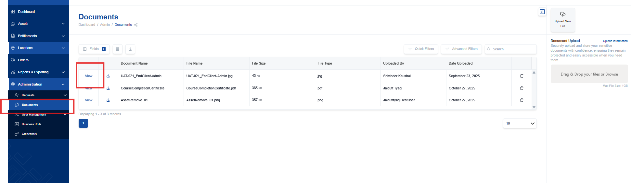
Downloading Documents
If you need to download a copy of a document to your computer:
- Next to each document, you'll find a "Download" icon. Click this button to initiate the download process.
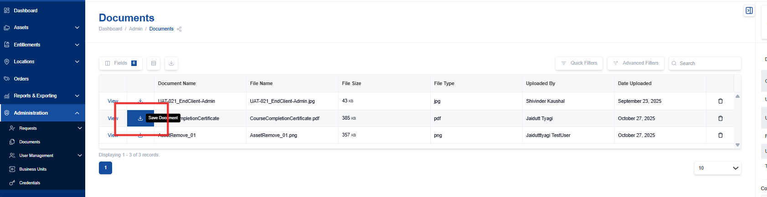
- Alternatively, for each document, once you click “view” on a document within the document table, in the right-side bar, you will see a download button. Click this button to initiate the download process.
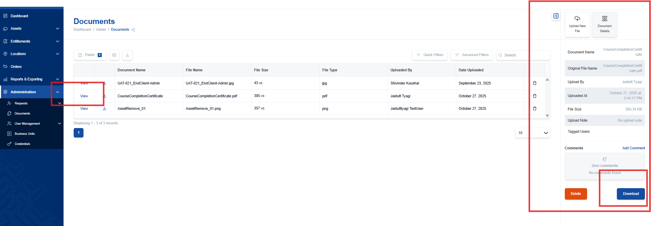

Deleting Documents
If a document is no longer needed or was uploaded in error, you can easily delete it:
- Click "Delete": Find the "Delete" icon (the trash can symbol) next to the document you want to remove and click on it.
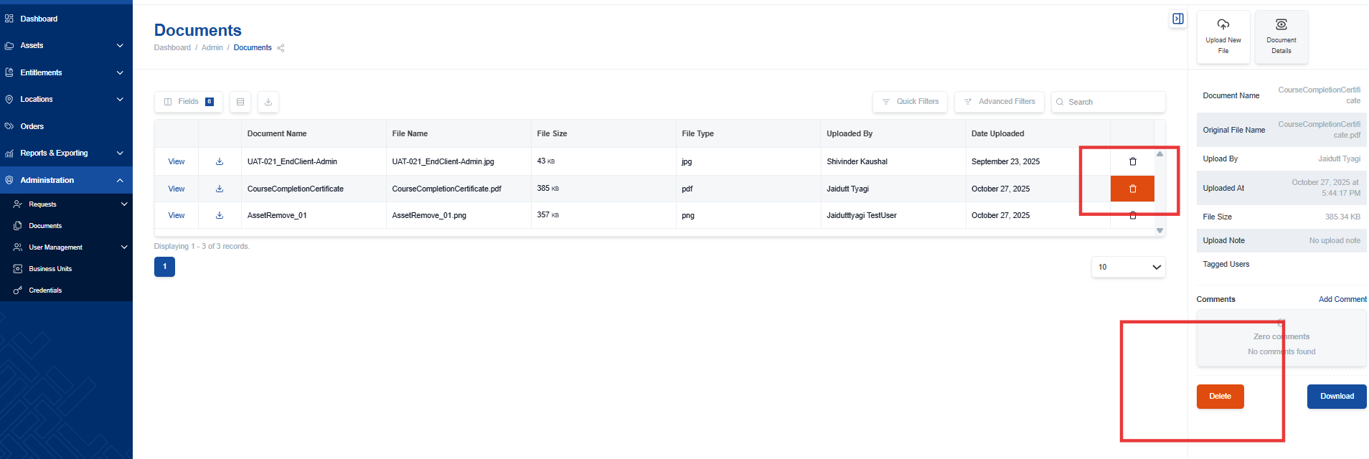
- Confirm Deletion: A confirmation dialog box will appear, asking you to confirm that you want to permanently delete the document. Click "OK" or "Confirm" to proceed.
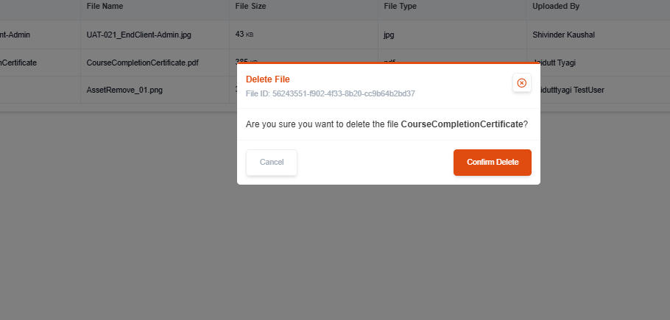
- Document Deleted: Once you confirm, the document will be permanently deleted from the NexaONE system and will no longer be accessible.

