Administration > Documents > Add File
Uploading Documents
Once you have accessed the Documents section, you can upload any relevant files that you want to associate with the selected customer's account. Here's how:
- Enter the Documents Section: Select desired Client, proceed to the "Administration" section and click on "Documents." This will take you to the page where you can manage files for that specific customer.
- Upload Files: Locate the file you wish to upload from your computer. Simply drag the file from its location on your computer and drop it into the designated area within the NexaOne Documents section. The application will recognize the file and prepare it for upload. Alternatively, you can also browse for the file by clicking ‘browse’ instead of dragging and dropping.
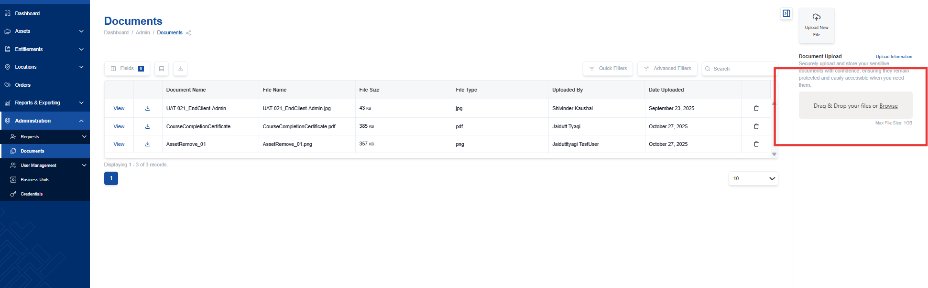
- Name the File: After dragging and dropping, you'll be prompted to give the file a descriptive name. This name will help you and others easily identify the document later. For example, if you are uploading a set of work instructions, name the file "Work Instructions" or something similar that clearly describes its content.
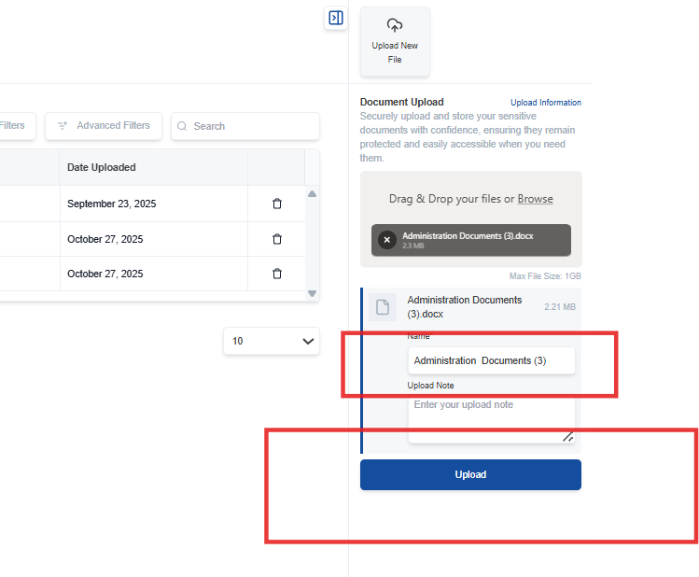
- Upload the File: Once you have named the file, click the "Upload" button, which is located near the file name field. Clicking this button initiates the upload process, and the file will be saved to the customer's document section.
After the upload is complete, the document is securely saved and associated with the specific customer you selected. You can upload and save as many documents as needed for each customer.
