NexaONE Login Process Guide
1. Introduction
This guide will walk you through the NexaONE login process, including initial login and multi-factor authentication. No specific materials are needed other than your NexaONE login credentials and access to your multi-factor authentication method.

2. Overview
The NexaONE login process involves several key steps:
- Accessing the Login Screen: Navigate to the NexaONE URL to reach the login page. This is the starting point for accessing the platform.
- Entering Credentials: Input your user ID and password. Accurate credentials are required for successful authentication.
- Multi-Factor Authentication (MFA): Verify your identity using a one-time password or another method like a recovery code or authenticator app. MFA adds an extra layer of security to your account.

3. Detailed Steps
Step 1: Accessing the Login Screen
- Open your web browser and enter the NexaONE URL in the address bar.
- Press Enter to navigate to the NexaONE login page.
- You should see the NexaONE login screen.
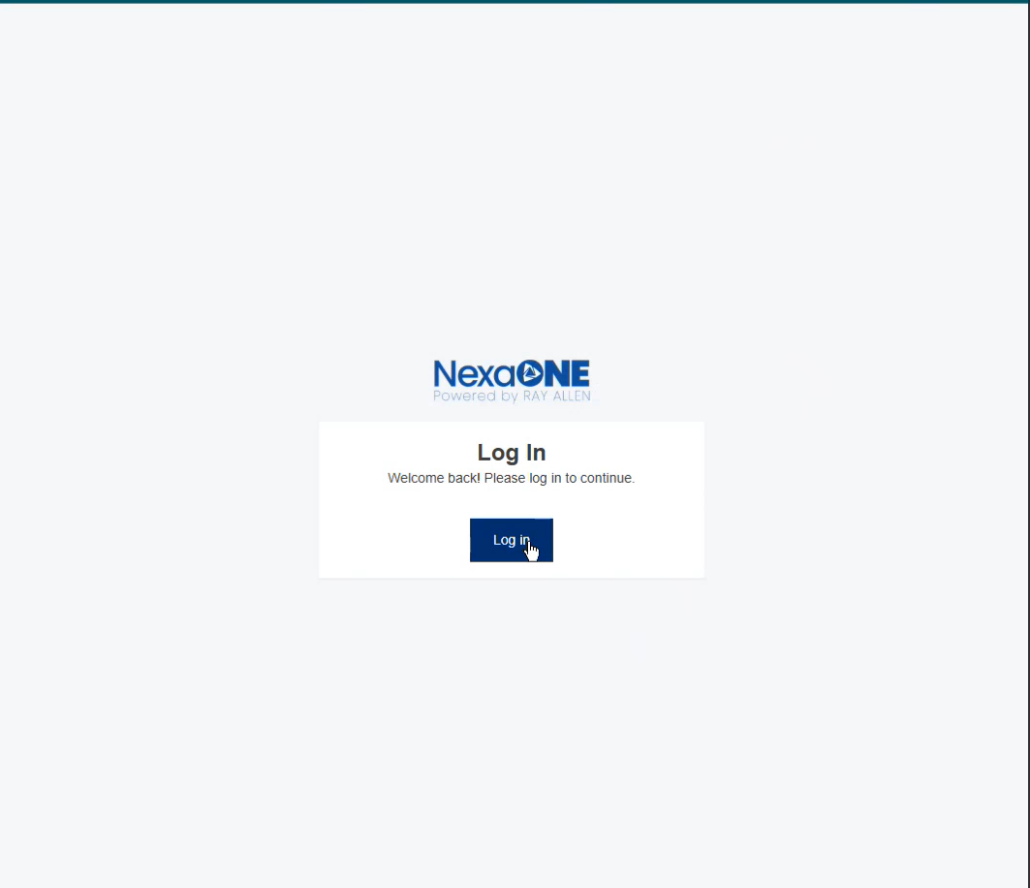
*Purpose:* This step ensures you are at the correct location to begin the login process.
Step 2: Entering Your Credentials
- On the login screen, locate the fields for User ID and Password.
- Type your User ID into the corresponding field.
- Type your Password into the corresponding field.
- If desired, click the "Show Password" option to view the password you are typing.
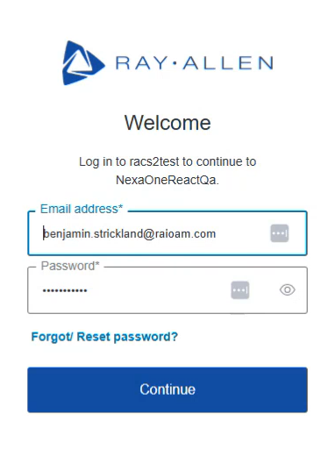
*Purpose:* This step allows you to input your personal login information to access your account. The "Show Password" feature helps prevent typos.
Step 3: Multi-Factor Authentication (MFA)
- After entering your credentials, click the "Continue" button.
- You will be prompted to verify your identity using multi-factor authentication.
- Choose your preferred method:
  - One-Time Password: Enter the one-time code generated by your authenticator app.
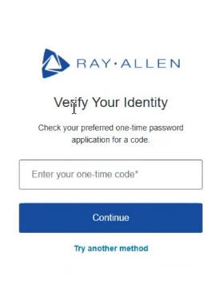
  - You may choose “Try another method” if you cannot access your authenticator app. This will show option to use a “Recovery code”
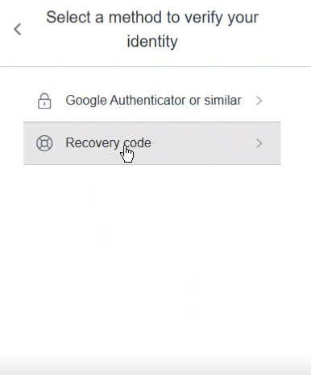

- Click "Continue" after entering the code.
Purpose: MFA adds an extra layer of security by requiring a second form of verification in addition to your password.

- This will open your view of NexaONE
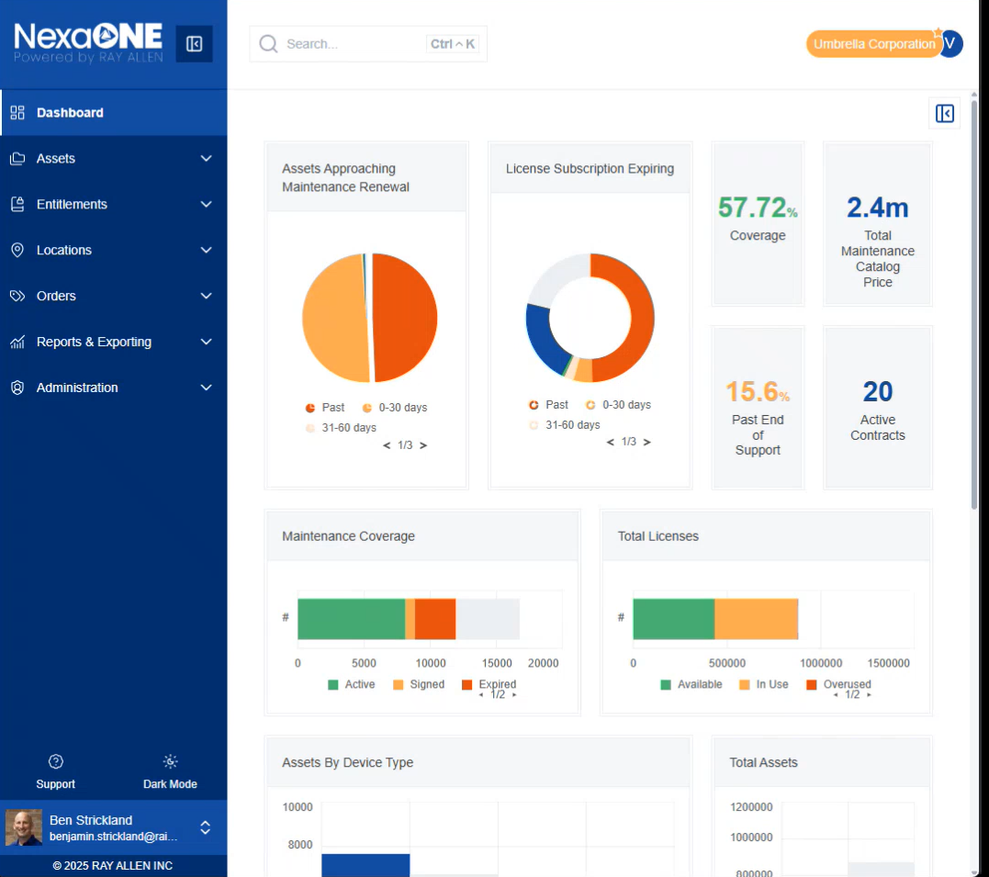

Additional Multi-Factor Authentication (MFA) Access Details:
To log into the NexaOne platform, choose the appropriate authenticator application that is appropriate for your business needs. You can use any standard Time-Based One-Time Password (TOTP) authenticator apps such as:
- Auth0 Guardian (Google Play / App Store)
- Authy (Google Play / App Store)
- Google Authenticator (Google Play / App Store)
- Microsoft Authenticator (Google Play / App Store)
*Note*: If you are unsure on what authentication application to use, please contact your organization’s technology support department to inquire on your organization’s preferred authentication application(s).

