NexaONE Password Reset Guide
Use password reset option to regain access to your account if you have forgotten your password.
- On the login screen, click the "Forgot/Reset Password" link.
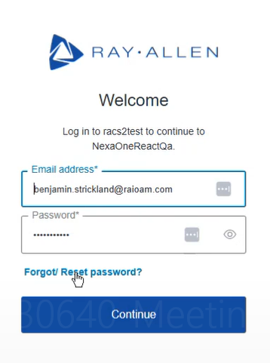
- Enter your User ID in the provided field
- Click "Continue".
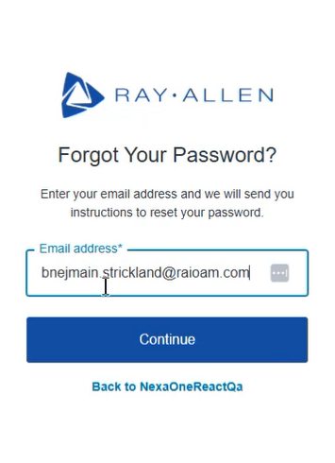
- Check your email inbox for a password reset email from NexaONE.
- Follow the instructions in the email to reset your password.

