NexaONE Logout Guide
This guide will walk you through the steps to logout from NexaONE to secure your session when you are finished. Once logged in you will have view like this:
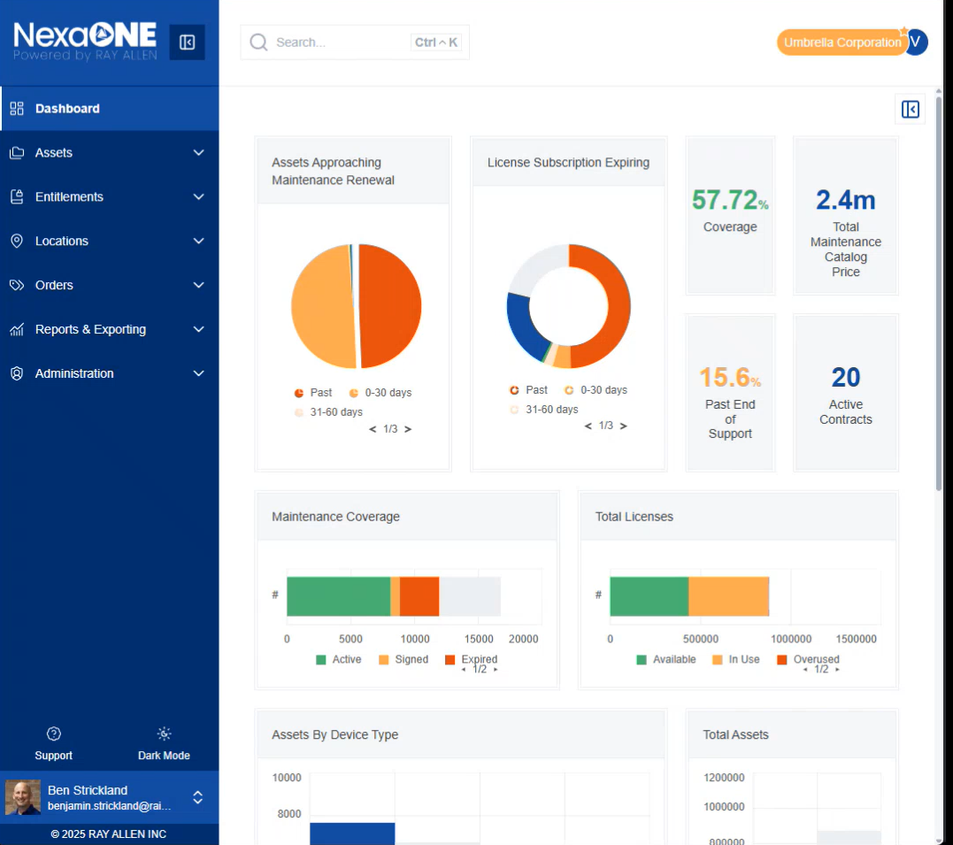

Logging Out Process
- Once logged in, locate your name or profile icon on the dashboard (usually at the bottom left-hand side).
- Click on your name/profile icon.
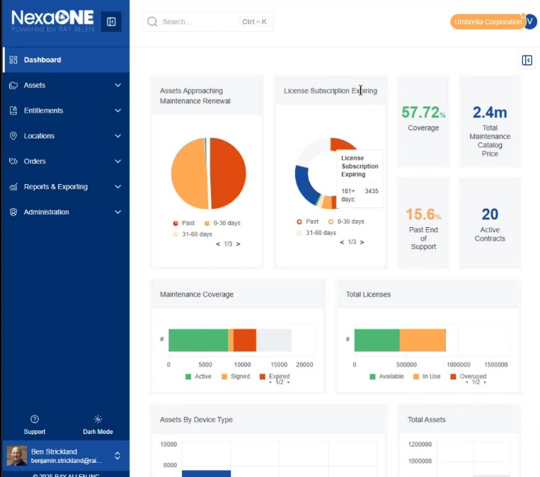
- A menu will appear; find and click the "Logout" button.
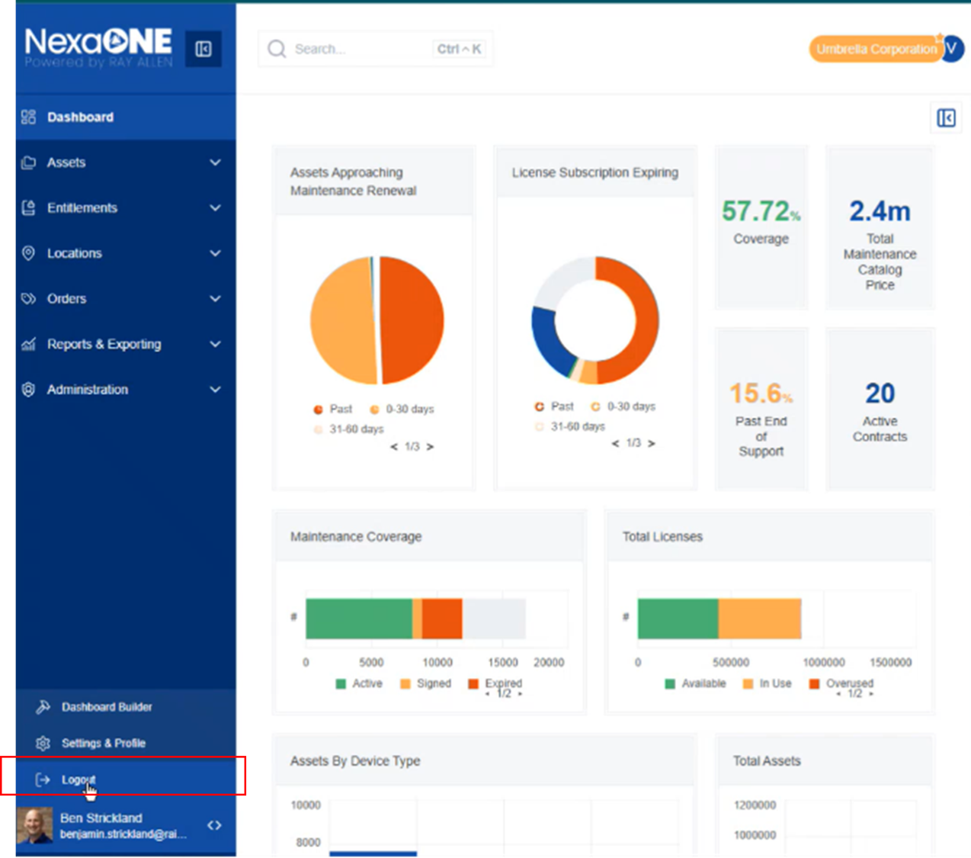
- You will be redirected to the login screen, confirming that you have successfully logged out. Purpose: Logging out ensures that your session is closed and prevents unauthorized access to your account.

